Family Math Studio Lesson 9.4 · Session 2 · 6.AT.11

Apply Two-Variable Relationships to Solve Problems
Start from a goal and work backward with an equation to find the input.
Name Date

Tonight's spark
A band earns $26 for each poster it sells. Its goal is $1,300. How many posters must the band sell to reach the goal? Guess first: more than 30 posters, or fewer?
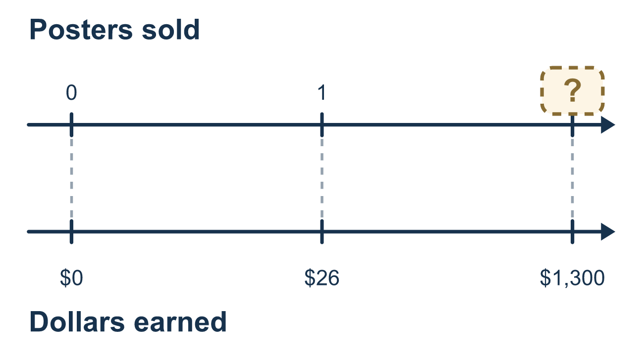
Our class model: work backward from the goal

Try it
Work it out on paper. Write one answer on each line.
- In e = 26n, the goal is e = 130. Which equation do you solve?
A. 26n = 130 B. 26 + n = 130 C. n = 130 × 26 D. e = 26
My answer
- Solve 26n = 130.
A. 104 B. 5 C. 156 D. 3,380
My answer
- What undoes multiplying by 9?
A. Adding 9 B. Subtracting 9 C. Dividing by 9 D. Multiplying by 9
My answer
- A savings plan is s = 12w and the goal is $96. Which equation finds the weeks w?
A. 12 + w = 96 B. w = 96 + 12 C. 96w = 12 D. 12w = 96
My answer
- Solve 12w = 96.
A. 84 B. 8 C. 108 D. 1,152
My answer

Talk about it
What is your goal, and where did you put it in the equation? Which operation undid the multiplication?

Home mission
Pretend you save $4 each week toward a $48 goal. Can your student write 4w = 48 and undo the multiplying? Then put the answer back: do that many weeks of $4 really make $48?

If we get stuck, ask
- What is the goal, and where does it go in the equation?
- What was done to the variable? What undoes that?
- Put your answer back in. Does it reach the goal?

Do it on a screen

Scan or type the link. Same lesson, with hints. eduwonderlab.com/lessons/9-4-part2/homework.html
How did it feel? (optional) ☐ Tricky ☐ Getting there ☐ Got it

Family Math Studio · For grown-ups Lesson 9.4 · Session 2 · 6.AT.11

Answers and talk notes
Apply Two-Variable Relationships to Solve Problems

What your student is learning
Tonight we start from the GOAL and work backward. Put the target in place of the output, then undo the operations one at a time to find the input that reaches it.

Answers
Ask your student to explain before you look.
- A. 26n = 130. 26n = 130, because the goal goes where the output was.
- B. 5. n = 5, because 130 ÷ 26 = 5.
- C. Dividing by 9. Dividing by 9 undoes multiplying by 9.
- D. 12w = 96. 12w = 96, because the goal replaces s.
- B. 8. w = 8, because 96 ÷ 12 = 8.

Talk about it
What is your goal, and where did you put it in the equation? Which operation undid the multiplication?

When they are stuck, ask
- What is the goal, and where does it go in the equation?
- What was done to the variable? What undoes that?
- Put your answer back in. Does it reach the goal?

Try not to say
- Just multiply the two numbers in the problem.
- Guess a number and see if it works — keep guessing.
- The bigger number always gets divided by the smaller one.

Home mission
Pretend you save $4 each week toward a $48 goal. Can your student write 4w = 48 and undo the multiplying? Then put the answer back: do that many weeks of $4 really make $48?

