Family Math Studio Lesson 9.4 · 6.AT.11

Apply Two-Variable Relationships to Solve Problems
Write an equation for two connected quantities, then use it to solve a real problem.
Name Date

Tonight's spark
A car plant makes 2.5 cars every hour. A new order ticket asks for 1,000 cars. How many hours must the plant run to fill the order? Guess first: more than 100 hours, or fewer?
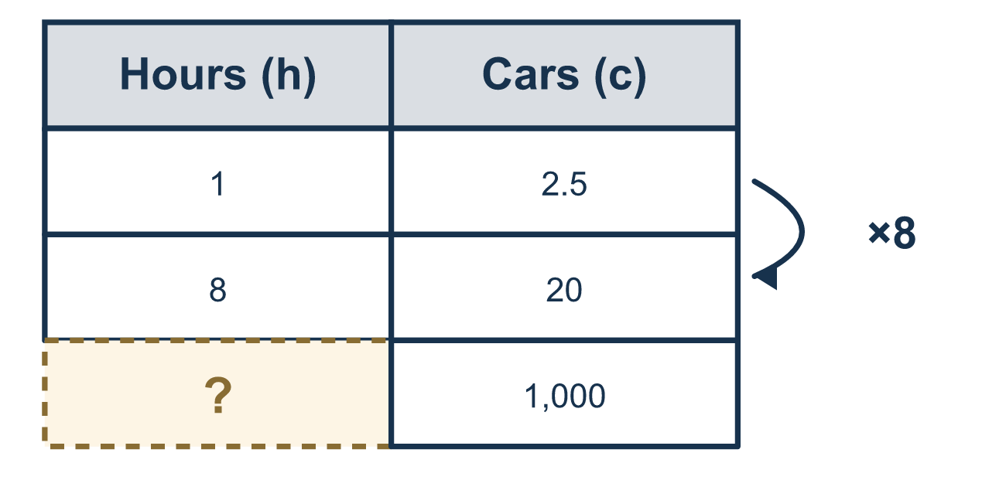
Our class model: the four-step equation plan

Try it
Work it out on paper. Write one answer on each line.
- The equation c = 4n gives the cost c of n tickets. What is c when n = 6?
A. 10 B. 24 C. 46 D. 2
My answer
- Using c = 4n, find n when c = 20.
A. 80 B. 16 C. 5 D. 24
My answer
- To solve 4n = 20, what is the first step?
A. Divide both sides by 4 B. Add 4 to both sides C. Multiply both sides by 4 D. Subtract 20 from both sides
My answer
- In y = x + 8, what is y when x = 7?
A. 56 B. 1 C. 87 D. 15
My answer
- A gym charges $9 per visit: m = 9v. You have $45. How many visits can you pay for?
A. 36 B. 5 C. 54 D. 405
My answer

Talk about it
Each hour makes more than 1 car. Should the hours be more or fewer than 1,000?

Home mission
Find a pitcher and see how many cups it holds. Pretend you pour 2 cups each time. Can your student write an equation like 2p = the pitcher size, solve for p, and say what it means?

If we get stuck, ask
- What does the equation say in words?
- Which number do you already know?
- What does your answer mean in the story?

Do it on a screen

Scan or type the link. Same lesson, with hints. eduwonderlab.com/lessons/9-4/homework.html
How did it feel? (optional) ☐ Tricky ☐ Getting there ☐ Got it

Family Math Studio · For grown-ups Lesson 9.4 · 6.AT.11

Answers and talk notes
Apply Two-Variable Relationships to Solve Problems

What your student is learning
Tonight we use an equation to answer a real question: write it, substitute the number we know, solve, and explain what the answer means.

Answers
Ask your student to explain before you look.
- B. 24. c = 24, because 4 × 6 = 24.
- C. 5. n = 5, because 20 ÷ 4 = 5.
- A. Divide both sides by 4. Divide both sides by 4, because dividing undoes multiplying by 4.
- D. 15. y = 15, because 7 + 8 = 15.
- B. 5. 5 visits, because 45 ÷ 9 = 5.

Talk about it
Each hour makes more than 1 car. Should the hours be more or fewer than 1,000?

When they are stuck, ask
- What does the equation say in words?
- Which number do you already know?
- What does your answer mean in the story?

Try not to say
- Just divide the two numbers and move on.
- You do not need to check your answer.
- The units are not important.

Home mission
Find a pitcher and see how many cups it holds. Pretend you pour 2 cups each time. Can your student write an equation like 2p = the pitcher size, solve for p, and say what it means?

