UNIT 1 · LESSON 1 STANDARD 6.NOS.4

Prime Factorization
Student Notes Packet
Name: ______________________ Date: ____________ Period: ________

Today's Goals
Content: I can write a number as a product of its prime factors using a factor tree.
Language: I can explain how I broke a number down using the words prime number, composite number, factor, and exponent.

Key Vocabulary
Look at the picture, read the word, then read what it means.
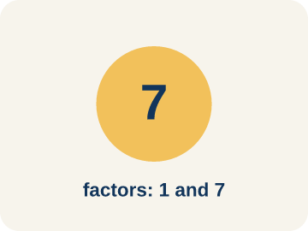 | Prime number Número primo  A number bigger than 1 that you can only divide by 1 and itself.  Example: 7 has only two factors: 1 × 7. So 7 is prime.
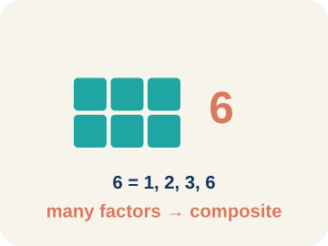 | Composite number Número compuesto  A number bigger than 1 that you can divide by more than just 1 and itself.  Example: 12 = 1 × 12, 2 × 6, 3 × 4 — six factors, so 12 is composite
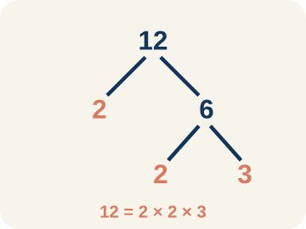 | Prime factorization Factorización prima  Writing a number as prime numbers multiplied together.  Example: 36 = 2 × 2 × 3 × 3 = 2² × 3²
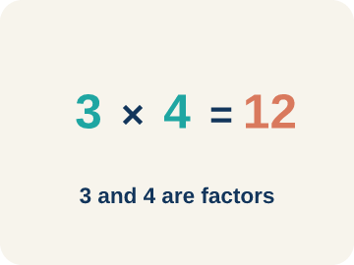 | Factor Factor  A number that divides evenly into another number, with no remainder.  Example: Factors of 12: 1, 2, 3, 4, 6, 12 — each divides 12 evenly.
 | Factor tree Árbol de factores  A picture that splits a number into its prime numbers, step by step.  Example: 24 → 4 × 6 → (2 × 2) × (2 × 3) → 2 × 2 × 2 × 3
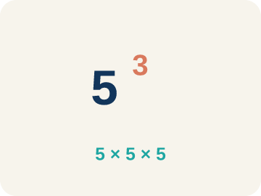 | Exponent Exponente  A small number that tells how many times to multiply a number by itself.  Example: 2³ means 2 × 2 × 2 = 8

Guided Notes
Fill in each blank as we go. Use the Word Bank to help you.
WORD BANK
Prime number • Composite number • Prime factorization • Factor • Factor tree • Exponent

1. A whole number greater than 1 with exactly two factors, 1 and itself, is a ___ number.
2. A whole number greater than 1 that has more than two factors is a ___ number.
3. __________ — Writing a number as prime numbers multiplied together.
4. A number that divides evenly into another number is called a ___.
5. I can break a number into its prime factors step by step using a ___.
6. In 2³, the small number 3 is the ___ and it shows 2 is multiplied 3 times.

Worked Example

Watch & Read I Do — follow along with your teacher
Space Station Cargo Breakdown
The space station received 60 supply crates. Mission Control needs to break this quantity into its prime components so the sorting robots can distribute them into equally sized pods. Help the crew find the prime factorization of 60!

Think about:
• What number are we breaking down into factors?
• What's the difference between a factor and a prime factor?
• How many different ways can we start breaking 60 apart?
• Will we always get the same prime factors no matter how we start?

Solved Example I Do — watch each step
Problem: Which of the following is a prime number?
A) 17
B) 15
C) 21
D) 9
Step 1: 17 has exactly two factors: 1 and 17.
Step 2: 15 = 3 × 5, 21 = 3 × 7, and 9 = 3 × 3, so they are all composite.
Answer: A. 17

Practice — Level 0

One Step at a Time extra support — you can do this
Take your time. Some steps are started for you.
1. Which number is a prime number?
A) 7
B) 8
Circle the answer that is correct.
2. Finish the factor tree for 12.
Step 1: 12 = 2 × 6
Step 2:

Step 3:

3. A number with exactly two factors, 1 and itself, is a __________ number.
Hint: Starts with the letter “p”.

4. Breaking a number into a product of prime numbers is called prime __________.
Hint: Starts with the letter “f”.

Exit Ticket
Answer on your own. This shows what you learned today.
★ What is the prime factorization of 40?
A) 2 × 2 × 2 × 5
B) 4 × 10
C) 5 × 8
D) 2 × 20

