UNIT 1 · LESSON 1 STANDARD 6.NS.4

Prime Factorization (Flagship)
Student Notes Packet
Name: ______________________ Date: ____________ Period: ________

Today's Goals
Content: I can write a number as a product of its prime factors using a factor tree.
Language: I can explain how I broke a number down using the words prime number, composite number, factor, and exponent.

Key Vocabulary
Look at the picture, read the word, then read what it means.
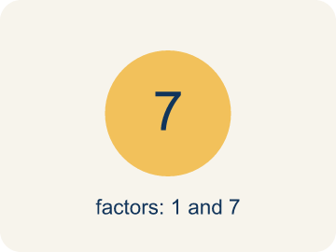 | Prime number Número primo  A number bigger than 1 that you can only divide by 1 and itself.  Example: 7 has only two factors: 1 × 7. So 7 is prime.
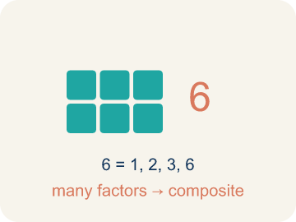 | Composite number Número compuesto  A number bigger than 1 that you can divide by more than just 1 and itself.  Example: 12 = 1 × 12, 2 × 6, 3 × 4 — six factors, so 12 is composite
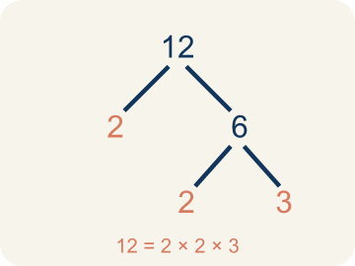 | Prime factorization Factorización prima  Writing a number as prime numbers multiplied together.  Example: 36 = 2 × 2 × 3 × 3 = 2² × 3²
 | Factor tree Árbol de factores  A picture that splits a number into its prime numbers, step by step.  Example: 24 → 4 × 6 → (2 × 2) × (2 × 3) → 2 × 2 × 2 × 3
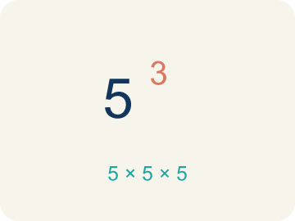 | Exponent Exponente  A small number that tells how many times to multiply a number by itself.  Example: 2³ means 2 × 2 × 2 = 8

Guided Notes
Fill in each blank as we go. Use the Word Bank to help you.
WORD BANK
Prime number • Composite number • Prime factorization • Factor tree • Exponent

1. A whole number greater than 1 with exactly two factors, 1 and itself, is a ___ number.
2. A whole number greater than 1 that has more than two factors is a ___ number.
3. __________ — Writing a number as prime numbers multiplied together.
4. I can break a number into its prime factors step by step using a ___.
5. In 2³, the small number 3 is the ___ and it shows 2 is multiplied 3 times.

Worked Example

Watch & Read I Do — follow along with your teacher
Space Station Cargo Breakdown
The space station received 60 supply crates. Mission Control needs to break this quantity into its prime components so the sorting robots can distribute them into equally sized pods. Help the crew find the prime factorization of 60!

Think about:
• What number are we breaking down into factors?
• What's the difference between a factor and a prime factor?
• How many different ways can we start breaking 60 apart?
• Will we always get the same prime factors no matter how we start?

Solved Example I Do — watch each step
Problem: Which of the following is a prime number?
A) 17
B) 15
C) 21
D) 9
Step 1: 17 has exactly two factors: 1 and 17.
Step 2: 15 = 3 × 5, 21 = 3 × 7, and 9 = 3 × 3, so they are all composite.
Answer: A. 17

Guided Practice

Solve Together We Do — work with your class
Problem: What is the prime factorization of 30?
A) 2 × 3 × 5
B) 5 × 6
C) 2 × 15
D) 3 × 10
Step 1:

Step 2:

Answer:

A party planner has 72 balloons and wants to know every possible way to arrange them in equal rows. She uses prime factorization to find all the factors of 72.
How does prime factorization help the planner find all the ways to arrange the balloons?

Sentence frame: The prime factorization of 72 is ___, which helps me find all factors by ___.

Turn & Talk discuss with a partner
1. [Launch] The freighter docks with 48 cargo containers, and each storage pod only holds groups built from prime-numbered units. Is 48 prime or composite, and how can you tell before building a factor tree?
Start with: 48 is a ___ number because it has ___.
48 es un número ___ porque tiene ___.
Word bank: prime number, composite number, factor, divisible, factor tree
2. [Explore] Look at your factor tree for 48. How did you decide which numbers to break apart first, and how did you know when to stop?
Start with: I broke 48 into ___ first because ___.
Separé 48 en ___ primero porque ___.
Word bank: prime number, composite number, factor, factor tree, prime factorization
3. [Connect] The cafeteria has 84 apples to arrange into equal rows. How does the prime factorization of 84 help the manager find every possible equal-row display?
Start with: The prime factorization of 84 is ___.
La factorización prima de 84 es ___.
Word bank: prime factorization, factor, exponent, composite number, product
4. [Reflect] Why does every composite number have exactly one prime factorization, no matter how you start the factor tree?
Start with: No matter how I start the tree, I always end with ___ because ___.
No importa cómo empiece el árbol, siempre termino con ___ porque ___.
Word bank: prime number, composite number, prime factorization, factor tree, product
5. [Practice] During practice on Prime Factorization, what strategy did you use when a problem felt tricky?
Start with: I broke 48 into ___ first because ___.
Separé 48 en ___ primero porque ___.
Word bank: Prime number, Composite number, Prime factorization, Factor tree

Independent Practice

On Your Own You Do — show your work
Solve each problem. Show your thinking in the work box.
1. What is the prime factorization of 18?
A) 2 × 3 × 3
B) 2 × 9
C) 3 × 6
D) 6 × 3

2. Which of these numbers is composite?
A) 27
B) 23
C) 29
D) 31

3. Two students found different factor trees for 60. Student A started with 2 × 30. Student B started with 6 × 10. Which statement is true?
A) Both get the same prime factorization: 2 × 2 × 3 × 5
B) Only Student A gets the correct prime factorization
C) Only Student B gets the correct prime factorization
D) They will get different prime factorizations

4. Lock 1 — Access clue: A whole number greater than 1 with exactly two factors (1 and itself) is called what?
A) A prime number
B) A composite number
C) A factor tree
D) An exponent

Exit Ticket
Answer on your own. This shows what you learned today.
★ What is the prime factorization of 40?
A) 2 × 2 × 2 × 5
B) 4 × 10
C) 5 × 8
D) 2 × 20

Answer Key & Teacher Guide
Teacher reference — remove or fold back before distributing to students.

Guided Notes (Fill-in)
Notes 1: Prime number
Notes 2: Composite number
Notes 3: Prime factorization
Notes 4: Factor tree
Notes 5: Exponent

Worked Notes (I Do / We Do)
I Do: A. 17
We Do: A. 2 × 3 × 5

Independent Practice
1. A) 2 × 3 × 3 — 18 = 2 × 9 = 2 × 3 × 3. Both 2 and 3 are prime, so 2 × 3 × 3 is the prime factorization.
2. A) 27 — 27 = 3 × 9 = 3 × 3 × 3, so it has more than two factors. 23, 29, and 31 are all prime.
3. A) Both get the same prime factorization: 2 × 2 × 3 × 5 — The Fundamental Theorem of Arithmetic says every composite number has exactly one prime factorization. No matter how you start the factor tree, you always end with 2 × 2 × 3 × 5.
4. A) A prime number — A prime number has exactly two factors: 1 and itself. A composite number has more than two factors.

Exit Ticket
A) 2 × 2 × 2 × 5 — 40 = 2 × 20 = 2 × 2 × 10 = 2 × 2 × 2 × 5. All factors (2, 2, 2, 5) are prime.

