UNIT 1 · LESSON 7 STANDARD 6.NS.3

Divide Decimals
Student Notes Packet
Name: ______________________ Date: ____________ Period: ________

Today's Goals
Content: I can divide with decimals by making the divisor a whole number first.
Language: I can explain my work using the words dividend, divisor, quotient, and equivalent division.

Key Vocabulary
Look at the picture, read the word, then read what it means.
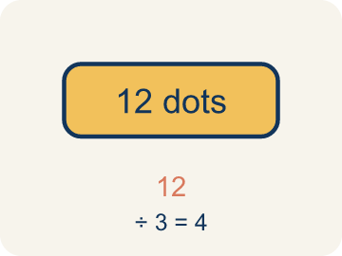 | Dividend Dividendo  The number you are splitting up in a division problem.  Example: In 8.4 ÷ 2.1 = 4, the dividend is 8.4 — it is the total being split
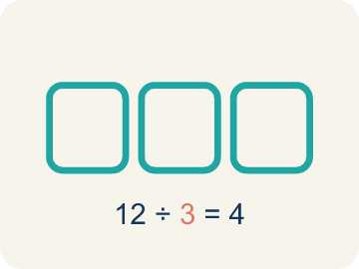 | Divisor Divisor  The number you split by in a division problem.  Example: In 8.4 ÷ 2.1 = 4, the divisor is 2.1 — it is the size of each group
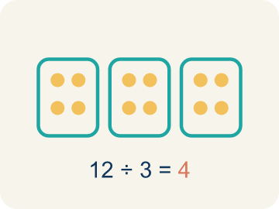 | Quotient Cociente  The answer when you divide.  Example: In 8.4 ÷ 2.1 = 4, the quotient is 4 — there are 4 groups
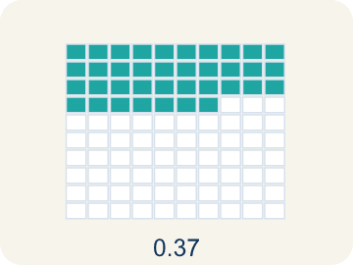 | Decimal division División decimal  Dividing with decimals. First make the number you divide by a whole number.  Example: 8.4 ÷ 2.1 → multiply both by 10 → 84 ÷ 21 = 4
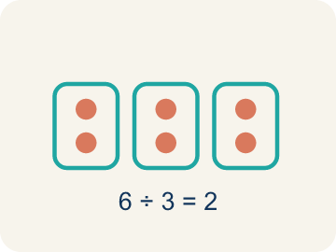 | Equivalent division División equivalente  Multiplying both numbers by 10 or 100 gives the same answer.  Example: 7.56 ÷ 0.12 = 756 ÷ 12 = 63 (both multiplied by 100)

Guided Notes
Fill in each blank as we go. Use the Word Bank to help you.
WORD BANK
Dividend • Divisor • Quotient • Decimal division • Equivalent division

1. In a division problem, the number being divided is the ___.
2. In a division problem, the number we divide by is the ___.
3. The answer to a division problem is the ___.
4. Dividing numbers that include a decimal point is called ___.
5. Multiplying both the dividend and divisor by the same power of 10 creates an ___ that is easier to solve.

Worked Example

Watch & Read I Do — follow along with your teacher
Space Station Pod Splitter
The space station has 18.9 kilograms of a rare mineral sample that must be divided equally among 6.3-kilogram storage pods. How many pods can be completely filled?

Think about:
• What total amount is being divided?
• What is the size of each pod?
• How do you divide when the divisor is a decimal?
• Can you turn this into a whole number division problem?

Solved Example I Do — watch each step
Problem: What is 14.4 ÷ 1.2?
A) 12
B) 1.2
C) 120
D) 0.12
Step 1: Multiply both by 10: 144 ÷ 12 = 12.
Answer: A. 12

Guided Practice

Solve Together We Do — work with your class
Problem: What is 3.78 ÷ 0.6?
A) 6.3
B) 63
C) 0.63
D) 0.063
Step 1:

Step 2:

Answer:

A ribbon is 16.8 feet long. You need to cut it into pieces that are each 2.4 feet long for a craft project.
How does decimal division help you figure out how many pieces you can cut?

Sentence frame: I can cut ___ pieces because 16.8 ÷ 2.4 = ___.

Turn & Talk discuss with a partner
1. [Launch] The station has 18.9 kilograms of mineral to divide into 6.3-kilogram pods. Why can't you divide by the decimal 6.3 directly the same way you divide by a whole number?
Start with: I make the divisor 6.3 into a ___ before dividing.
Convierto el divisor 6.3 en un ___ antes de dividir.
Word bank: dividend, divisor, quotient, decimal division, equivalent division
2. [Explore] When you divided 18.9 by 6.3, how did you use equivalent division to make the divisor a whole number?
Start with: I moved both decimal points ___ place, changing it to ___ ÷ ___.
Moví ambos puntos decimales ___ lugar, cambiándolo a ___ ÷ ___.
Word bank: dividend, divisor, quotient, decimal division, equivalent division
3. [Connect] A ribbon is 16.8 feet long and you cut pieces that are each 2.4 feet. How does decimal division tell you how many pieces you can cut?
Start with: I can cut ___ pieces because I divided 16.8 by ___.
Puedo cortar ___ piezas porque dividí 16.8 entre ___.
Word bank: dividend, divisor, quotient, decimal division, equivalent division
4. [Reflect] Why does making the divisor a whole number first make dividing by a decimal so much easier?
Start with: Making the divisor a whole number helps because ___.
Convertir el divisor en un número entero ayuda porque ___.
Word bank: dividend, divisor, quotient, decimal division, equivalent division
5. [Practice] During practice on Divide Decimals, what strategy did you use when a problem felt tricky?
Start with: I moved both decimal points ___ place, changing it to ___ ÷ ___.
Moví ambos puntos decimales ___ lugar, cambiándolo a ___ ÷ ___.
Word bank: Dividend, Divisor, Quotient, Decimal division

Independent Practice

On Your Own You Do — show your work
Solve each problem. Show your thinking in the work box.
1. What is 8.4 ÷ 0.7?
A) 12
B) 1.2
C) 120
D) 0.12

2. What is 15.6 ÷ 1.3?
A) 12
B) 1.2
C) 120
D) 13

3. A ribbon is 16.8 feet long. You cut it into pieces that are each 2.4 feet long. How many pieces do you get?
A) 7 pieces
B) 8 pieces
C) 6 pieces
D) 14.4 pieces

4. What is 4.8 ÷ 0.6?
A) 8
B) 0.8
C) 80
D) 4.2

Exit Ticket
Answer on your own. This shows what you learned today.
★ What is 19.2 ÷ 0.8?
A) 24
B) 2.4
C) 240
D) 0.24

Answer Key & Teacher Guide
Teacher reference — remove or fold back before distributing to students.

Guided Notes (Fill-in)
Notes 1: Dividend
Notes 2: Divisor
Notes 3: Quotient
Notes 4: Decimal division
Notes 5: Equivalent division

Worked Notes (I Do / We Do)
I Do: A. 12
We Do: A. 6.3

Independent Practice
1. A) 12 — 8.4 ÷ 0.7 = 84 ÷ 7 = 12.
2. A) 12 — Multiply both by 10: 156 ÷ 13 = 12.
3. A) 7 pieces — 16.8 ÷ 2.4: multiply both by 10 → 168 ÷ 24 = 7 pieces.
4. A) 8 — Multiply both by 10: 48 ÷ 6 = 8.

Exit Ticket
A) 24 — Multiply both by 10: 192 ÷ 8 = 24.

