UNIT 2 · LESSON 1 STANDARD 6.NS.1

Interpret Division of Fractions (Flagship)
Student Notes Packet
Name: ______________________ Date: ____________ Period: ________

Today's Goals
Content: I can use models to interpret what it means to divide by a fraction.
Language: I can explain a fraction division using the words dividend, divisor, quotient, reciprocal, and unit fraction.

Key Vocabulary
Look at the picture, read the word, then read what it means.
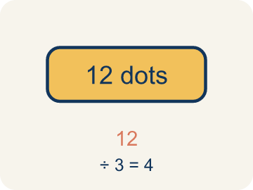 | Dividend Dividendo  The number you are splitting up in a division problem.  Example: In 3 ÷ 1/4 = 12, the dividend is 3 — it is the total being split
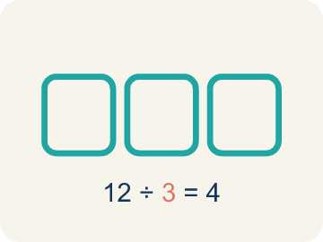 | Divisor Divisor  The number you split by in a division problem.  Example: In 3 ÷ 1/4 = 12, the divisor is 1/4 — it is the size of each piece
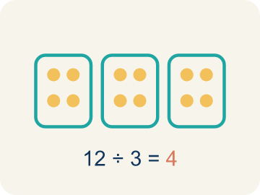 | Quotient Cociente  The answer when you divide.  Example: In 3 ÷ 1/4 = 12, the quotient is 12 — there are 12 quarter-size pieces in 3
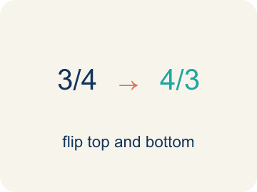 | Reciprocal Recíproco  A fraction turned upside down.  Example: The reciprocal of 1/4 is 4/1 = 4. Multiplying by the reciprocal gives the same result as dividing.
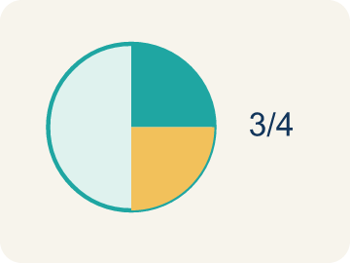 | Unit fraction Fracción unitaria  A fraction with 1 on top, like 1/4.  Example: 1/2, 1/3, 1/4, 1/5 — each represents one equal part of a whole

Guided Notes
Fill in each blank as we go. Use the Word Bank to help you.
WORD BANK
Dividend • Divisor • Quotient • Reciprocal • Unit fraction

1. In 6 ÷ 1/2, the number 6 being divided is the ___.
2. In 6 ÷ 1/2, the number 1/2 we divide by is the ___.
3. The answer to a division problem is the ___.
4. The fraction you get by flipping the numerator and denominator is the ___.
5. A fraction with a numerator of 1, like 1/5, is a ___.

Worked Example

Watch & Read I Do — follow along with your teacher
Detective Agency Case File
Agent Reyes finds a 3-foot strip of tape at the crime scene. The lab needs the tape cut into 1/4-foot sections for analysis. How many sections can be made? The answer cracks the code to the locked evidence vault.

Think about:
• What total length is being divided?
• What is the size of each section?
• Will the answer be greater than or less than 3?
• What does it mean to divide by a fraction?
• Why does dividing by 1/4 give a bigger number?

Solved Example I Do — watch each step
Problem: What does 3 ÷ 1/4 mean?
A) How many 1/4-size pieces fit into 3
B) 3 groups of 1/4
C) 3 minus 1/4
D) 1/4 of 3
Step 1: 3 ÷ 1/4 asks: how many 1/4-size pieces fit into 3?
Step 2: The answer is 12, because each whole has 4 fourths, and 3 × 4 = 12.
Answer: A. How many 1/4-size pieces fit into 3

Guided Practice

Solve Together We Do — work with your class
Problem: Which expression means 'how many 1/3-size pieces are in 2'?
A) 2 ÷ 1/3
B) 2 × 1/3
C) 1/3 ÷ 2
D) 2 + 1/3
Step 1:

Step 2:

Answer:

A detective has 6 yards of crime scene tape. She needs to mark off sections that are each 1/3 of a yard. She wants to know how many sections she can mark.
How does interpreting fraction division help the detective?

Sentence frame: The detective can mark ___ sections because 6 ÷ 1/3 = ___.

Turn & Talk discuss with a partner
1. [Launch] A 3-foot strip of evidence tape must be cut into 1/4-foot sections. Before calculating, will the number of pieces be more or fewer than 3? Explain your thinking.
Start with: There will be ___ than 3 pieces because each piece is ___ than 1 foot.
Habrá ___ de 3 pedazos porque cada pedazo es ___ de 1 pie.
Word bank: dividend, divisor, quotient, unit fraction, section
2. [Explore] On your fraction bar, how many 1/4-foot sections fit into one whole foot? Point to where you see the pieces.
Start with: In one whole foot I see ___ sections of 1/4 each.
En un pie completo veo ___ secciones de 1/4 cada una.
Word bank: dividend, divisor, quotient, unit fraction, model
3. [Connect] Where else outside the lab would you divide a whole number by a unit fraction, and how would you set it up?
Start with: I would divide a whole number by a unit fraction when ___.
Dividiría un número entero entre una fracción unitaria cuando ___.
Word bank: dividend, divisor, quotient, reciprocal, unit fraction
4. [Practice] During practice on Interpret Division of Fractions, what strategy did you use when a problem felt tricky?
Start with: In one whole foot I see ___ sections of 1/4 each.
En un pie completo veo ___ secciones de 1/4 cada una.
Word bank: Dividend, Divisor, Quotient, Reciprocal

Independent Practice

On Your Own You Do — show your work
Solve each problem. Show your thinking in the work box.
1. A rope is 4 feet long. How many 1/2-foot pieces can be cut from it?
A) 8 pieces
B) 2 pieces
C) 4 pieces
D) 1/2 piece

2. What is 6 ÷ 1/5?
A) 30
B) 6/5
C) 5/6
D) 1

3. A shelf is 5 feet long. Books are each 1/4 foot wide. How many books fit on the shelf? Which expression represents this?
A) 5 ÷ 1/4 = 20 books
B) 5 × 1/4 = 1 1/4 books
C) 1/4 ÷ 5 = 1/20 book
D) 5 + 1/4 = 5 1/4 books

4. Clue 1 — The case file says a 3-cup bottle of fingerprint dust must be poured into evidence vials that each hold 1/4 cup. Which question does 3 ÷ 1/4 ask?
A) How many 1/4-cup vials fit into 3 cups
B) What is 1/4 of 3 cups
C) What is 3 cups minus 1/4 cup
D) How many 3-cup bottles fit into 1/4 cup

Exit Ticket
Answer on your own. This shows what you learned today.
★ What does 5 ÷ 1/4 mean, and what is the quotient?
A) How many 1/4-size pieces fit into 5; quotient is 20
B) 5 groups of 1/4; quotient is 5/4
C) 1/4 of 5; quotient is 5/4
D) 5 minus 1/4; quotient is 4 3/4

Answer Key & Teacher Guide
Teacher reference — remove or fold back before distributing to students.

Guided Notes (Fill-in)
Notes 1: Dividend
Notes 2: Divisor
Notes 3: Quotient
Notes 4: Reciprocal
Notes 5: Unit fraction

Worked Notes (I Do / We Do)
I Do: A. How many 1/4-size pieces fit into 3
We Do: A. 2 ÷ 1/3

Independent Practice
1. A) 8 pieces — 4 ÷ 1/2 = 4 × 2 = 8 pieces. Each whole foot contains 2 halves, and 4 × 2 = 8.
2. A) 30 — 6 ÷ 1/5 means how many 1/5-size pieces fit into 6. Each whole has 5 fifths, so 6 × 5 = 30.
3. A) 5 ÷ 1/4 = 20 books — You are finding how many 1/4-foot pieces fit into 5 feet, which is 5 ÷ 1/4 = 5 × 4 = 20 books.
4. A) How many 1/4-cup vials fit into 3 cups — Dividing by a fraction asks how many of that piece fit inside the whole. 3 ÷ 1/4 = 12, so the dust fills 12 vials.

Exit Ticket
A) How many 1/4-size pieces fit into 5; quotient is 20 — 5 ÷ 1/4 means 'how many 1/4-size pieces fit into 5.' Since each whole has 4 fourths, 5 × 4 = 20.

