UNIT 3 · LESSON 5 STANDARD 6.RP.3

Compare Ratios
Student Notes Packet
Name: ______________________ Date: ____________ Period: ________

Today's Goals
Content: I can compare ratios by finding unit rates or using equivalent ratios.
Language: I can explain my comparison using the words unit rate, equivalent ratio, compare, and common denominator.

Key Vocabulary
Look at the picture, read the word, then read what it means.
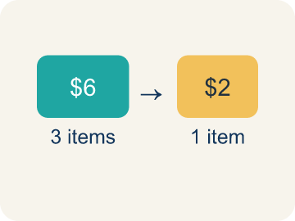 | Unit rate Tasa unitaria  A rate for just 1 of something, like cost for 1 item.  Example: $3 per 1 pound → unit rate is $3/lb
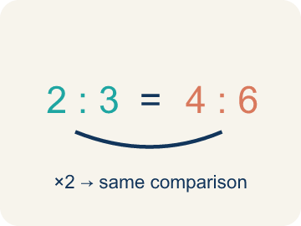 | Equivalent ratio Razón equivalente  Two ratios that mean the same thing.  Example: 4:6 and 2:3 are equivalent (both simplify to 2:3)
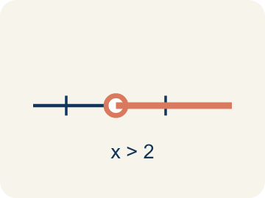 | Compare Comparar  To look at ratios and see which is bigger, smaller, or equal.  Example: 3:4 vs. 2:5 — which has more of the first ingredient per unit?
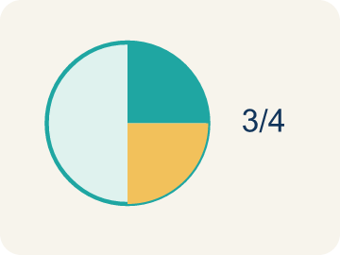 | Simplify Simplificar  To make a ratio as small as possible while keeping the same comparison.  Example: 8:12 → divide both by 4 → 2:3
 | Common denominator Denominador común  A bottom number that two fractions can share so you can compare them.  Example: To compare 3/5 and 4/7, use LCD 35: 21/35 vs 20/35

Guided Notes
Fill in each blank as we go. Use the Word Bank to help you.
WORD BANK
Unit rate • Equivalent ratio • Compare • Simplify • Common denominator

1. A rate that tells the amount for exactly one unit, like 5 miles per 1 hour, is a ___.
2. __________ — Two ratios that mean the same thing.
3. To decide which ratio is greater or if they are equal is to ___ them.
4. Writing a ratio in its smallest equal form is to ___ it.
5. A denominator shared by two fractions so they can be compared is a ___.

Worked Example

Watch & Read I Do — follow along with your teacher
Chef Academy is holding a Flavor Challenge! Chef Reyes's hot cocoa recipe uses 3 tablespoons of cocoa for every 5 ounces of milk. Chef Tran's recipe uses 4 tablespoons of cocoa for every 7 ounces of milk. The students need to figure out whose hot cocoa is more chocolatey. How can they compare the two recipes fairly?

Think about:
• What quantities are being compared in each recipe?
• Can you tell just by looking which recipe has more cocoa per ounce?
• What would make the comparison fair?
• What if both chefs used the same amount of milk — then could we compare?
• Is there a way to find how much cocoa each chef uses per ONE ounce of milk?

Solved Example I Do — watch each step
Problem: Chef A uses 2 cups of cheese for every 8 crackers. Chef B uses 3 cups of cheese for every 9 crackers. Who uses more cheese per cracker?
A) Chef B
B) Chef A
C) They use the same amount
D) Cannot determine
Step 1: Chef A: 2÷8 = 0.25 cups per cracker.
Step 2: Chef B: 3÷9 ≈ 0.33 cups per cracker.
Step 3: Chef B uses more cheese per cracker.
Answer: A. Chef B

Guided Practice

Solve Together We Do — work with your class
Problem: Which ratio is greater: 3:4 or 5:8?
A) 3:4
B) 5:8
C) They are equal
D) Cannot determine
Step 1:

Step 2:

Step 3:

Answer:

Two pizza shops are running deals. Mario's Pizza sells 2 large pizzas for $18. Sal's Pizza sells 3 large pizzas for $25. A school needs to buy pizza for a class party and wants to get the best deal per pizza.

Sentence frame: This is like our ratio comparison work because ___ and ___ are related by ___.

Turn & Talk discuss with a partner
1. [Launch] Chef Reyes uses 3 tbsp cocoa for every 5 oz of milk, and Chef Tran uses 4 tbsp for every 7 oz. Can you tell whose cocoa is more chocolatey just by looking at the numbers? Why or why not?
Start with: You ___ tell just by looking because the ___ amounts are different.
___ se puede saber solo mirando porque las cantidades de ___ son diferentes.
Word bank: ratio, compare, unit rate, equivalent ratio, fair
2. [Explore] You scaled both recipes to 35 oz of milk: Chef Reyes became 21:35 and Chef Tran became 20:35. How does scaling to a common denominator let you compare the recipes fairly?
Start with: After scaling to 35 oz, Chef Reyes has ___ tbsp and Chef Tran has ___ tbsp.
Después de escalar a 35 oz, Chef Reyes tiene ___ cucharadas y Chef Tran tiene ___ cucharadas.
Word bank: equivalent ratio, common denominator, compare, simplify, milk
3. [Connect] Two pizza shops have deals: Mario's sells 2 large pizzas for $18, and Sal's sells 3 for $25. How would you compare these to find the best price per pizza?
Start with: Mario's costs ___ per pizza because 18 divided by 2 equals ___.
Mario's cuesta ___ por pizza porque 18 entre 2 es ___.
Word bank: unit rate, compare, ratio, better deal, per
4. [Practice] During practice on Compare Ratios, what strategy did you use when a problem felt tricky?
Start with: After scaling to 35 oz, Chef Reyes has ___ tbsp and Chef Tran has ___ tbsp.
Después de escalar a 35 oz, Chef Reyes tiene ___ cucharadas y Chef Tran tiene ___ cucharadas.
Word bank: Unit rate, Equivalent ratio, Compare, Simplify

Independent Practice

On Your Own You Do — show your work
Solve each problem. Show your thinking in the work box.
1. Which lemonade recipe is more lemony? Recipe A: 2 lemons for 6 cups of water. Recipe B: 3 lemons for 7 cups of water.
A) Recipe B
B) Recipe A
C) They are the same
D) Cannot determine

2. Which is the better deal: 4 apples for $3 or 6 apples for $5?
A) 4 apples for $3
B) 6 apples for $5
C) They cost the same
D) Cannot determine

3. Store A sells 3 mangoes for $6. Store B sells 5 mangoes for $9. Which store offers a better price per mango?
A) Store B
B) Store A
C) Same price
D) Cannot determine

4. Store A sells 5 notebooks for $12. Store B sells 8 notebooks for $20. Without calculating, a student says Store B must be cheaper because you get more notebooks. Is the student's reasoning valid? Find the unit rates to prove your answer.

Exit Ticket
Answer on your own. This shows what you learned today.
★ A bakery sells 4 muffins for $10 and another bakery sells 6 muffins for $14. Which bakery has the lower price per muffin?
A) The second bakery
B) The first bakery
C) Same price
D) Cannot determine

Answer Key & Teacher Guide
Teacher reference — remove or fold back before distributing to students.

Guided Notes (Fill-in)
Notes 1: Unit rate
Notes 2: Equivalent ratio
Notes 3: Compare
Notes 4: Simplify
Notes 5: Common denominator

Worked Notes (I Do / We Do)
I Do: A. Chef B
We Do: A. 3:4

Independent Practice
1. A) Recipe B — Recipe A: 2÷6 ≈ 0.33 lemons per cup. Recipe B: 3÷7 ≈ 0.43 lemons per cup. Since 0.43 > 0.33, Recipe B is more lemony.
2. A) 4 apples for $3 — Deal 1: $3÷4 = $0.75 per apple. Deal 2: $5÷6 ≈ $0.83 per apple. $0.75 < $0.83, so 4 apples for $3 is the better deal.
3. A) Store B — Store A: $6÷3 = $2.00 per mango. Store B: $9÷5 = $1.80 per mango. Store B has the better (lower) price per mango.
4. The student's reasoning is not valid — getting more items does not mean a lower price per item. Store A: $12 ÷ 5 = $2.40 per notebook. Store B: $20 ÷ 8 = $2.50 per notebook. Store A is actually cheaper per notebook, even though Store B offers more notebooks per purchase.

Exit Ticket
A) The second bakery — First bakery: $10÷4 = $2.50 per muffin. Second bakery: $14÷6 ≈ $2.33 per muffin. The second bakery has the lower price.

