UNIT 3 · LESSON 7 STANDARD 6.RP.3

Ratio and Rate Problem Solving
Student Notes Packet
Name: ______________________ Date: ____________ Period: ________

Today's Goals
Content: I can solve real-world rate problems by finding and using unit rates.
Language: I can explain my solution using the words rate, unit rate, per, and proportion.

Key Vocabulary
Look at the picture, read the word, then read what it means.
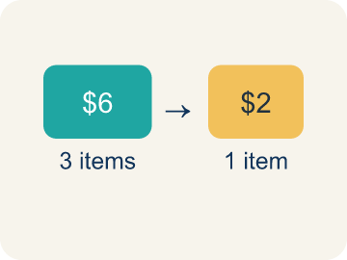 | Rate Tasa  A ratio comparing two amounts with different units, like miles per hour.  Example: $12 for 4 pounds → dollars per pound
 | Unit rate Tasa unitaria  A rate for just 1 of something, like cost for 1 item.  Example: $12 ÷ 4 = $3 per 1 pound
 | Per Por  For each one. Example: 5 dollars per book.  Example: 60 miles per hour, $5 per ticket
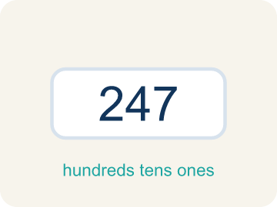 | Problem solving Resolución de problemas  Using ratios and rates to find a missing amount.  Example: Set up → Plan → Solve → Check
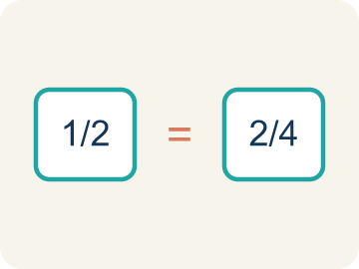 | Proportion Proporción  A math sentence saying two ratios are equal. It helps find a missing number.  Example: 3/5 = x/20 → x = 12

Guided Notes
Fill in each blank as we go. Use the Word Bank to help you.
WORD BANK
Rate • Unit rate • Per • Problem solving • Proportion

1. A ratio comparing two quantities with different units is a ___.
2. A rate for exactly one unit, like $3 per 1 pound, is a ___.
3. The word that means 'for each' in a rate, like miles ___ hour, is ___.
4. Using a plan and math steps to find an answer to a real situation is ___.
5. An equation that two ratios are equal is a ___.

Worked Example

Watch & Read I Do — follow along with your teacher
It's the final day of Chef Academy — the Culinary Competition! Teams must solve ratio and rate problems to earn ingredients for their dishes. Team 1 needs to figure out how much chicken costs if 3 pounds cost $18. Team 2 must calculate how many cupcakes they can frost if they decorate 5 cupcakes every 4 minutes. The clock is ticking!

Think about:
• What two quantities with different units are being compared?
• How could you find the cost of just 1 pound of chicken?
• How could you find the number of cupcakes frosted in 1 minute?
• Which strategy is fastest — unit rates, ratio tables, or proportions?
• What if the rate is not a whole number — can you still solve the problem?

Solved Example I Do — watch each step
Problem: A bakery makes 24 cookies in 3 batches. What is the unit rate of cookies per batch?
A) 8 cookies per batch
B) 3 cookies per batch
C) 24 cookies per batch
D) 6 cookies per batch
Step 1: Unit rate: 24 cookies ÷ 3 batches = 8 cookies per batch.
Answer: A. 8 cookies per batch

Guided Practice

Solve Together We Do — work with your class
Problem: Apples cost $5 for 4 pounds. What is the cost per pound?
A) $1.25
B) $0.80
C) $1.50
D) $4.00
Step 1:

Step 2:

Answer:

A runner trains for a 5K race. During practice, she runs 3 miles in 27 minutes. She wants to know her pace (minutes per mile) and predict how long the full 5K (3.1 miles) will take at the same rate.

Sentence frame: This is like our rate problem-solving work because ___ and ___ are related by ___.

Turn & Talk discuss with a partner
1. [Launch] Team 1 knows 3 pounds of chicken cost $18. What was your plan to find the cost of just 1 pound, and why is that unit rate useful?
Start with: My plan was to divide ___ by ___ to get the cost per ___.
Mi plan fue dividir ___ entre ___ para hallar el costo por ___.
Word bank: rate, unit rate, per, proportion, divide
2. [Explore] Team 2 frosts 5 cupcakes every 4 minutes. How did you set up a rate or proportion to find how many cupcakes they frost in a longer time?
Start with: The rate is ___ cupcakes per ___ minutes.
La tasa es ___ cupcakes por ___ minutos.
Word bank: rate, unit rate, per, proportion, scale
3. [Connect] Tell about a real situation where rates matter, like speed, pay, or price, and explain how the unit rate helps you.
Start with: Rates matter when ___, like ___ per ___.
Las tasas importan cuando ___, como ___ por ___.
Word bank: rate, unit rate, per, proportion, compare
4. [Practice] During practice on Ratio and Rate Problem Solving, what strategy did you use when a problem felt tricky?
Start with: The rate is ___ cupcakes per ___ minutes.
La tasa es ___ cupcakes por ___ minutos.
Word bank: Rate, Unit rate, Per, Problem solving

Independent Practice

On Your Own You Do — show your work
Solve each problem. Show your thinking in the work box.
1. A cyclist rides 36 miles in 3 hours. At the same rate, how far will she ride in 5 hours?
A) 60 miles
B) 48 miles
C) 72 miles
D) 45 miles

2. A printer prints 45 pages in 9 minutes. How many pages does it print per minute?
A) 5 pages per minute
B) 9 pages per minute
C) 4 pages per minute
D) 45 pages per minute

3. A car travels 150 miles in 3 hours. A bus travels 200 miles in 5 hours. Which vehicle is faster?
A) The car
B) The bus
C) Same speed
D) Cannot determine

4. A factory makes 240 widgets in 8 hours. Another factory makes 200 widgets in 5 hours. Which factory is faster? If both factories work together for 10 hours, how many total widgets would they produce?

Exit Ticket
Answer on your own. This shows what you learned today.
★ A printer prints 30 pages in 5 minutes. At this rate, how many pages will it print in 12 minutes?
A) 72
B) 60
C) 36
D) 42

Answer Key & Teacher Guide
Teacher reference — remove or fold back before distributing to students.

Guided Notes (Fill-in)
Notes 1: Rate
Notes 2: Unit rate
Notes 3: Per
Notes 4: Problem solving
Notes 5: Proportion

Worked Notes (I Do / We Do)
I Do: A. 8 cookies per batch
We Do: A. $1.25

Independent Practice
1. A) 60 miles — Unit rate: 36 ÷ 3 = 12 miles per hour. In 5 hours: 12 × 5 = 60 miles.
2. A) 5 pages per minute — Unit rate: 45 ÷ 9 = 5 pages per minute.
3. A) The car — Car: 150÷3 = 50 mph. Bus: 200÷5 = 40 mph. The car travels faster at 50 mph vs. 40 mph.
4. Factory A: 240 ÷ 8 = 30 widgets/hour. Factory B: 200 ÷ 5 = 40 widgets/hour. Factory B is faster. Together: (30 + 40) × 10 = 70 × 10 = 700 widgets in 10 hours.

Exit Ticket
A) 72 — Unit rate: 30 ÷ 5 = 6 pages per minute. In 12 minutes: 6 × 12 = 72 pages.

