UNIT 4 · LESSON 1 STANDARD 6.RP.2

Rates and Unit Rates (Flagship)
Student Notes Packet
Name: ______________________ Date: ____________ Period: ________

Today's Goals
Content: I can find a unit rate to compare prices and decide the better buy.
Language: I can explain my choice using the words rate, unit rate, per, and better buy.

Key Vocabulary
Look at the picture, read the word, then read what it means.
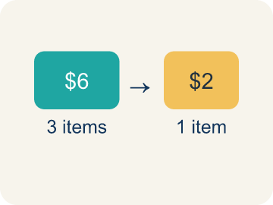 | Rate Tasa  A ratio comparing two amounts with different units, like miles per hour.  Example: $12 for 4 games is a rate
 | Unit Rate Tasa unitaria  A rate for just 1 of something, like cost for 1 item.  Example: $3 per 1 game
 | Per Por  For each one. Example: 5 dollars per book.  Example: 60 miles per hour means 60 miles for every 1 hour
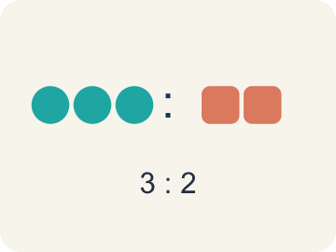 | Ratio Razón  A way to compare two amounts.  Example: 5 to 3 or 5:3
 | Better Buy Mejor compra  The choice that costs less for each item.  Example: Pack A: $0.50 per pencil vs Pack B: $0.40 per pencil — Pack B is the better buy
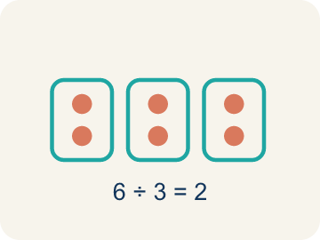 | Divide Dividir  Splitting a total into equal groups.  Example: $12 ÷ 4 games = $3 per game

Guided Notes
Fill in each blank as we go. Use the Word Bank to help you.
WORD BANK
Rate • Unit Rate • Per • Ratio • Better Buy • Divide

1. A ratio that compares two quantities with different units is a ___.
2. A rate that tells the cost or amount for one unit is a ___.
3. The word that means 'for each one' is ___.
4. A comparison of two quantities is a ___.
5. The option with the lower unit rate, costing less per item, is the ___.
6. To find a unit rate, I ___ the price by the number of units.

Worked Example

Watch & Read I Do — follow along with your teacher
Arcade Builder Challenge
You're comparing ticket prices at different game booths in the arcade. Booth A charges $3 for 5 games, and Booth B charges $5 for 8 games. Which booth gives you a better deal? To find out, you need to figure out the cost per game — that's the unit rate!

Think about:
• What two quantities are being compared at each booth?
• Which booth seems like a better deal at first glance?
• How can you compare prices when the number of games is different?
• What does it mean to find the cost for just one game?

Solved Example I Do — watch each step
Problem: A booth charges $4.50 for 9 games. What is the unit rate?
A) $0.50 per game
B) $0.45 per game
C) $2.00 per game
D) $4.50 per game
Step 1: $4.50 ÷ 9 = $0.50 per game.
Answer: A. $0.50 per game

Guided Practice

Solve Together We Do — work with your class
Problem: A car travels 180 miles using 6 gallons of gas. What is the unit rate in miles per gallon?
A) 30 miles per gallon
B) 6 miles per gallon
C) 180 miles per gallon
D) 36 miles per gallon
Step 1:

Step 2:

Answer:

The arcade snack bar sells popcorn in two sizes: a small bag with 3 cups for $2.25 and a large bag with 8 cups for $5.60. You want the most popcorn for your money.
Which size is the better deal, and how do you know?

Sentence frame: The ___ bag is the better deal because its unit rate is $___ per cup, which is ___ than $___ per cup for the other size.

Turn & Talk discuss with a partner
1. [Launch] Booth A charges $3 for 5 games and Booth B charges $5 for 8 games. Can you tell which is the better deal just by looking at the signs? Why or why not?
Start with: You ___ tell just by looking because the number of ___ is different.
___ se puede saber solo mirando porque la cantidad de ___ es diferente.
Word bank: rate, unit rate, per, better buy, compare
2. [Explore] How did you find the cost per game for each booth, and which booth wins?
Start with: Booth A costs ___ per game because 3 divided by 5 equals ___.
El puesto A cuesta ___ por juego porque 3 entre 5 es ___.
Word bank: rate, unit rate, per, better buy, divide
3. [Connect] At the snack bar, how would you use a unit rate to find the best popcorn deal among different sizes?
Start with: I would find the price per ___ for each popcorn size.
Hallaría el precio por ___ para cada tamaño de palomitas.
Word bank: rate, unit rate, per, better buy, compare
4. [Practice] During practice on Rates and Unit Rates, what strategy did you use when a problem felt tricky?
Start with: Booth A costs ___ per game because 3 divided by 5 equals ___.
El puesto A cuesta ___ por juego porque 3 entre 5 es ___.
Word bank: Rate, Unit Rate, Per, Ratio

Independent Practice

On Your Own You Do — show your work
Solve each problem. Show your thinking in the work box.
1. A pack of 8 markers costs $6.00. What is the cost per marker?
A) $0.75
B) $0.80
C) $1.33
D) $0.60

2. Which is a unit rate?
A) 12 miles per 1 hour
B) 24 miles in 2 hours
C) 36 miles for 3 gallons
D) 100 points in 5 games

3. Which token pack from the table above is the best deal?
A) Pack A
B) Pack B
C) Pack C
D) They are all the same

4. Runner A completes 4 laps in 12 minutes. Runner B completes 5 laps in 14 minutes. Who runs more laps per minute?
A) Runner B
B) Runner A
C) Same rate
D) Cannot determine

Exit Ticket
Answer on your own. This shows what you learned today.
★ A store sells 6 pencils for $1.50 and 10 pencils for $2.80. Which is the better buy?
A) 6 for $1.50 — $0.25 each
B) 10 for $2.80 — $0.28 each
C) They cost the same per pencil
D) Not enough information

Answer Key & Teacher Guide
Teacher reference — remove or fold back before distributing to students.

Guided Notes (Fill-in)
Notes 1: Rate
Notes 2: Unit Rate
Notes 3: Per
Notes 4: Ratio
Notes 5: Better Buy
Notes 6: Divide

Worked Notes (I Do / We Do)
I Do: A. $0.50 per game
We Do: A. 30 miles per gallon

Independent Practice
1. A) $0.75 — $6.00 ÷ 8 = $0.75 per marker.
2. A) 12 miles per 1 hour — A unit rate has 1 in the second quantity. '12 miles per 1 hour' is the only choice where the second quantity is 1.
3. B) Pack B — Pack B has a unit rate of $0.20 per token, which is the lowest cost per token.
4. A) Runner B — Runner A: 4÷12 ≈ 0.33 laps/min. Runner B: 5÷14 ≈ 0.36 laps/min. Runner B runs slightly more laps per minute.

Exit Ticket
A) 6 for $1.50 — $0.25 each — $1.50 ÷ 6 = $0.25 per pencil. $2.80 ÷ 10 = $0.28 per pencil. $0.25 < $0.28, so 6 for $1.50 is the better buy.

