UNIT 4 · LESSON 4 STANDARD 6.RP.3C

Find the Percent of a Number
Student Notes Packet
Name: ______________________ Date: ____________ Period: ________

Today's Goals
Content: I can find the percent of a number using an equation or a model.
Language: I can explain my steps using the words percent, base, part, and equation.

Key Vocabulary
Look at the picture, read the word, then read what it means.
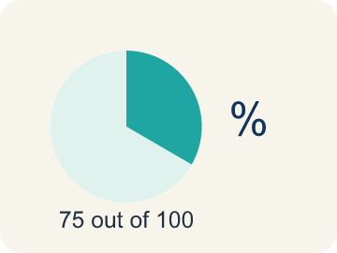 | Percent Porcentaje  A way to compare a number to 100, shown with the % sign.  Example: 30% means 30 out of 100
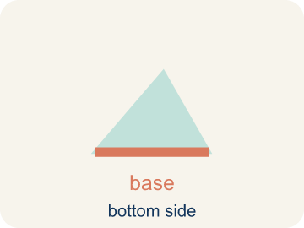 | Base Base (el todo)  The whole amount you take a percent of.  Example: In '25% of 80,' the base is 80
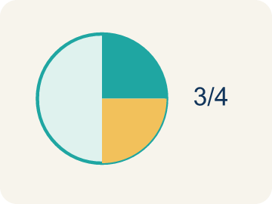 | Part Parte  The piece you get when you take a percent of a number.  Example: 25% of 80 = 20; the part is 20
 | Equation Ecuación  A math sentence with an equal sign showing both sides are the same.  Example: part = percent × base
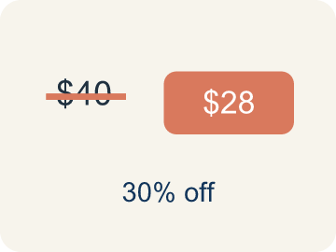 | Discount Descuento  Money taken off the first price to make it cheaper.  Example: $40 shirt at 25% off: discount = $10

Guided Notes
Fill in each blank as we go. Use the Word Bank to help you.
WORD BANK
Percent • Base • Part • Equation • Discount

1. A number out of 100 is a ___.
2. In a percent problem, the whole amount you take the percent of is the ___.
3. The piece of the whole that the percent represents is the ___.
4. A math sentence with an equal sign, like part = percent × base, is an ___.
5. An amount subtracted from a price is a ___.

Worked Example

Watch & Read I Do — follow along with your teacher
Arcade Builder Challenge
It's Discount Day at the arcade! Different games are offering percent-off deals on ticket prices. The claw machine is 25% off its usual 60-ticket price, and the racing game is 40% off 80 tickets. You need to calculate the discounts to figure out how many tickets each game actually costs!

Think about:
• What information do you need to find the discount amount?
• How is finding 25% of 60 different from finding 40% of 80?
• Is there more than one way to find a percent of a number?
• How does a bar model help you see the percent of a number?

Solved Example I Do — watch each step
Problem: What is 20% of 150?
A) 30
B) 20
C) 35
D) 75
Step 1: 20% = 0.20.
Step 2: Multiply: 0.20 × 150 = 30.
Answer: A. 30

Guided Practice

Solve Together We Do — work with your class
Problem: What is 50% of 84?
A) 42
B) 50
C) 34
D) 168
Step 1:

Step 2:

Answer:

The arcade is donating 12% of Saturday's ticket sales to charity. They sold 1,500 tickets on Saturday. The manager says they will donate 180 tickets. A student says it should be 18 tickets.
Who is correct, and how do you know?

Sentence frame: The ___ is correct because 12% of 1,500 = ___ × 1,500 = ___. The mistake was ___.

Turn & Talk discuss with a partner
1. [Launch] On Discount Day the claw machine is 25% off its 60-ticket price. In '25% of 60,' which number is the base (the whole), and what part are you trying to find?
Start with: The base is ___ and the part I want is ___.
La base es ___ y la parte que quiero es ___.
Word bank: percent, base, part, discount
2. [Explore] What steps did you follow every time to find the percent of a number in the discount table?
Start with: I changed ___% into the decimal ___.
Cambié ___% al decimal ___.
Word bank: percent, base, part, equation
3. [Connect] The arcade donates 12% of Saturday's 1,500 ticket sales. The manager says 180 tickets, a student says 18. Who is right, and how do you know?
Start with: The ___ is correct because 12% of 1,500 = ___ x 1,500 = ___.
El/La ___ tiene razón porque 12% de 1,500 = ___ x 1,500 = ___.
Word bank: percent, base, part, equation
4. [Practice] During practice on Find the Percent of a Number, what strategy did you use when a problem felt tricky?
Start with: I changed ___% into the decimal ___.
Cambié ___% al decimal ___.
Word bank: Percent, Base, Part, Equation

Independent Practice

On Your Own You Do — show your work
Solve each problem. Show your thinking in the work box.
1. What is 10% of 320?
A) 32
B) 3.2
C) 320
D) 64

2. What percent of 50 is 15?
A) 30%
B) 15%
C) 35%
D) 50%

3. An arcade prize costs 240 tickets. If you have a coupon for 15% off, how many tickets do you save?
A) 36 tickets
B) 24 tickets
C) 15 tickets
D) 204 tickets

4. A student scored 72 out of 90 on a test. What percent did they score?
A) 80%
B) 72%
C) 75%
D) 90%

Exit Ticket
Answer on your own. This shows what you learned today.
★ What is 45% of 360?
A) 162
B) 145
C) 180
D) 126

Answer Key & Teacher Guide
Teacher reference — remove or fold back before distributing to students.

Guided Notes (Fill-in)
Notes 1: Percent
Notes 2: Base
Notes 3: Part
Notes 4: Equation
Notes 5: Discount

Worked Notes (I Do / We Do)
I Do: A. 30
We Do: A. 42

Independent Practice
1. A) 32 — 10% = 0.10. Multiply: 0.10 × 320 = 32. (Or move the decimal one place left.)
2. A) 30% — 15 ÷ 50 = 0.30 = 30%.
3. A) 36 tickets — 15% of 240 = 0.15 × 240 = 36 tickets saved.
4. A) 80% — 72 ÷ 90 = 0.80 = 80%.

Exit Ticket
A) 162 — 45% = 0.45. Multiply: 0.45 × 360 = 162.

