UNIT 4 · LESSON 6 STANDARD 6.RP.3D

Convert Measurement Units
Student Notes Packet
Name: ______________________ Date: ____________ Period: ________

Today's Goals
Content: I can convert measurement units using ratios and conversion factors.
Language: I can explain my conversion using the words conversion factor, unit, equivalent, and ratio.

Key Vocabulary
Look at the picture, read the word, then read what it means.
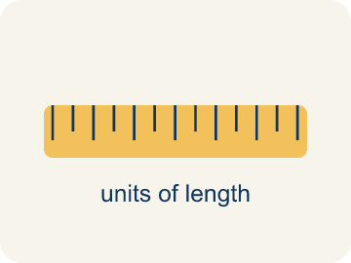 | Conversion Factor Factor de conversión  A ratio that helps you change one unit into another.  Example: 1 foot = 12 inches, so the factor is 12
 | Unit Unidad  A standard amount used to measure, like an inch or a liter.  Example: Inches, feet, pounds, ounces
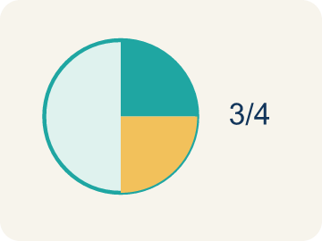 | Equivalent Equivalente  Having the same value, just in different units.  Example: 2 feet = 24 inches
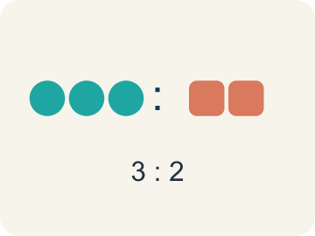 | Ratio Razón  A way to compare two amounts.  Example: 12 inches per 1 foot
 | Customary units Unidades usuales (sistema inglés)  The U.S. way of measuring, like inches, feet, and pounds.  Example: 12 inches = 1 foot, 3 feet = 1 yard, 16 ounces = 1 pound
 | Metric units Unidades métricas  A way of measuring by 10s, like meters, liters, and grams.  Example: 1 meter = 100 centimeters, 1 kilogram = 1,000 grams

Guided Notes
Fill in each blank as we go. Use the Word Bank to help you.
WORD BANK
Conversion Factor • Unit • Equivalent • Ratio • Customary units • Metric units

1. A ratio equal to 1 that relates two units, like 12 inches / 1 foot, is a ___.
2. A standard amount used to measure, like a foot or a gram, is a ___.
3. Two measurements that name the same amount, like 1 foot and 12 inches, are ___.
4. A comparison of two quantities is a ___.
5. Units like inches, feet, and pounds used mainly in the U.S. are ___.
6. Units like meters, grams, and liters based on tens are ___.

Worked Example

Watch & Read I Do — follow along with your teacher
Arcade Builder Challenge
You're building a brand-new arcade cabinet! The blueprints use feet, but the parts catalog lists measurements in inches. The wiring instructions use yards, and the weight limits are in pounds — but the shipping labels use ounces. You need to convert between units to make sure everything fits and ships correctly.

Think about:
• Why might the blueprint and the parts catalog use different units?
• How many inches are in 1 foot? How many feet in 1 yard?
• How do you decide whether to multiply or divide when converting?
• Can you use a ratio table to help convert units?

Solved Example I Do — watch each step
Problem: How many inches are in 7 feet?
A) 84 inches
B) 72 inches
C) 70 inches
D) 96 inches
Step 1: 7 × 12 = 84 inches.
Answer: A. 84 inches

Guided Practice

Solve Together We Do — work with your class
Problem: How many feet are in 3 yards?
A) 9 feet
B) 6 feet
C) 12 feet
D) 36 feet
Step 1:

Step 2:

Answer:

The arcade is ordering a new game cabinet. The doorway is 80 inches tall. The cabinet is listed as 7 feet. Your friend says it won't fit because 7 feet is 82 inches.
Will the cabinet fit through the doorway? Show your conversion to prove it.

Sentence frame: 7 feet = 7 × ___ = ___ inches. Since ___ inches is ___ than 80 inches, the cabinet ___ fit through the doorway.

Turn & Talk discuss with a partner
1. [Launch] The cabinet blueprint uses feet but the parts catalog uses inches. Why do you have to convert, and which is the bigger unit, a foot or an inch?
Start with: I have to convert because the blueprint uses ___ but the catalog uses ___.
Tengo que convertir porque el plano usa ___ pero el catálogo usa ___.
Word bank: unit, conversion factor, customary units, equivalent
2. [Explore] How did you use a conversion factor like '1 ft = 12 in' to fill in the ratio table, and how did you decide whether to multiply or divide?
Start with: To convert ___ to ___, I ___ by ___.
Para convertir ___ a ___, ___ por ___.
Word bank: conversion factor, unit, equivalent, ratio, customary units
3. [Connect] A doorway is 80 inches tall and a new cabinet is listed as 7 feet. Your friend says it won't fit because 7 feet is 82 inches. Will it fit, and where is the error?
Start with: 7 feet = 7 x ___ = ___ inches.
7 pies = 7 x ___ = ___ pulgadas.
Word bank: conversion factor, unit, equivalent, customary units
4. [Practice] During practice on Convert Measurement Units, what strategy did you use when a problem felt tricky?
Start with: To convert ___ to ___, I ___ by ___.
Para convertir ___ a ___, ___ por ___.
Word bank: Conversion Factor, Unit, Equivalent, Ratio

Independent Practice

On Your Own You Do — show your work
Solve each problem. Show your thinking in the work box.
1. How many ounces are in 4 pounds?
A) 64 ounces
B) 48 ounces
C) 32 ounces
D) 16 ounces

2. Convert 24 inches to feet.
A) 2 feet
B) 3 feet
C) 12 feet
D) 24 feet

3. A shelf is 30 inches long. How many feet and inches is that?
A) 2 feet 6 inches
B) 3 feet 0 inches
C) 2 feet 8 inches
D) 1 foot 18 inches

4. Leg 1: The joystick rod is 3 feet long, but the parts catalog lists it in inches. How many inches is that? (1 ft = 12 in)
A) 36 inches
B) 15 inches
C) 30 inches
D) 33 inches

Exit Ticket
Answer on your own. This shows what you learned today.
★ Which is the correct conversion of 5 yards to inches?
A) 180 inches
B) 60 inches
C) 15 inches
D) 540 inches

Answer Key & Teacher Guide
Teacher reference — remove or fold back before distributing to students.

Guided Notes (Fill-in)
Notes 1: Conversion Factor
Notes 2: Unit
Notes 3: Equivalent
Notes 4: Ratio
Notes 5: Customary units
Notes 6: Metric units

Worked Notes (I Do / We Do)
I Do: A. 84 inches
We Do: A. 9 feet

Independent Practice
1. A) 64 ounces — 1 pound = 16 ounces. 4 × 16 = 64 ounces.
2. A) 2 feet — 24 ÷ 12 = 2 feet.
3. A) 2 feet 6 inches — 30 ÷ 12 = 2 remainder 6. So 30 inches = 2 feet 6 inches.
4. A) 36 inches — Inches are smaller than feet, so multiply: 3 × 12 = 36 inches.

Exit Ticket
A) 180 inches — 5 yards × 3 = 15 feet. 15 feet × 12 = 180 inches. Or: 5 × 36 = 180 inches.

