UNIT 5 · LESSON 1 STANDARD 6.G.1

Area of Parallelograms
Student Notes Packet
Name: ______________________ Date: ____________ Period: ________

Today's Goals
Content: I can find the area of a parallelogram using base × height.
Language: I can explain how I found the area using the words base, height, area, and formula.

Key Vocabulary
Look at the picture, read the word, then read what it means.
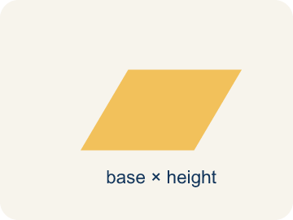 | Parallelogram Paralelogramo  A four-sided shape with two pairs of parallel sides.  Example: Think of a leaning door — the top and bottom are parallel, and the two sides are parallel, like a slanted rectangle
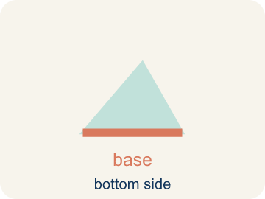 | Base Base  A side of the shape you use to find the area.  Example: If the bottom of a parallelogram is 10 cm, then b = 10 cm in the formula A = b × h
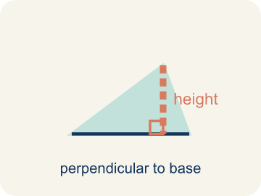 | Height Altura  The straight-up distance from the base to the top.  Example: A dashed vertical line from the top side straight down to the base, forming a 90° angle — NOT the slanted side
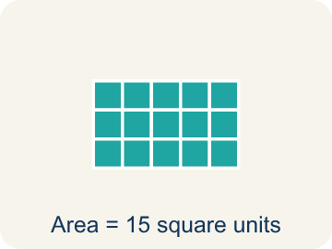 | Area Área  How much space is inside a flat shape.  Example: A 3 cm × 4 cm rectangle covers 12 square centimeters — imagine 12 tiny 1×1 squares inside it
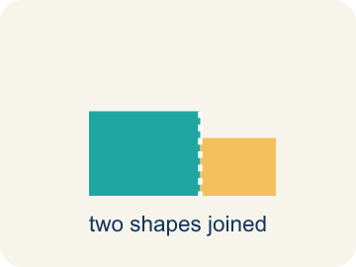 | Composite figure Figura compuesta  A shape made by putting two or more simple shapes together.  Example: An L-shaped room = a 10×8 rectangle joined to a 4×5 rectangle; total area = 80 + 20 = 100 sq ft
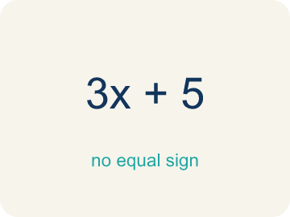 | Formula Fórmula  A math rule written with symbols.  Example: A = b × h means Area equals base times height; for a parallelogram with b = 6 and h = 4, A = 24

Guided Notes
Fill in each blank as we go. Use the Word Bank to help you.
WORD BANK
Parallelogram • Base • Height • Area • Composite figure • Formula

1. A quadrilateral with two pairs of parallel sides is a ___.
2. Any side of a parallelogram used to calculate its area is the ___.
3. The perpendicular distance between the base and the opposite side is the ___.
4. The amount of flat space inside a two-dimensional figure is its ___.
5. A shape made of two or more basic shapes combined is a ___.
6. A math rule written with symbols, like A = b × h, is a ___.

Worked Example

Watch & Read I Do — follow along with your teacher
Blueprint Review
Your architecture firm is designing a parallelogram-shaped patio for a client's backyard. The client needs to know how many square feet of pavers to order. The patio has a base of 14 feet and a height of 9 feet.

Think about:
• What shape is the patio?
• What measurements are given?
• How is a parallelogram different from a rectangle?
• Why do we use the height instead of the slanted side to find the area?
• Can you rearrange a parallelogram into a rectangle?

Solved Example I Do — watch each step
Problem: What is the area of a parallelogram with base 10 cm and height 7 cm?
A) 70 sq cm
B) 34 sq cm
C) 17 sq cm
D) 70 cm
Step 1: A = b × h = 10 × 7 = 70 square centimeters.
Answer: A. 70 sq cm

Guided Practice

Solve Together We Do — work with your class
Problem: A parallelogram has an area of 54 sq ft and a base of 9 ft. What is the height?
A) 6 ft
B) 45 ft
C) 63 ft
D) 27 ft
Step 1:

Step 2:

Answer:

A landscape architect is tiling a parallelogram-shaped courtyard. The courtyard has a base of 18 feet and a height of 10 feet. Each tile covers 2 square feet.
How many tiles does the architect need?

Sentence frame: The courtyard's area is ___ sq ft because A = ___ x ___ . She needs ___ tiles because ___ / 2 = ___.

Turn & Talk discuss with a partner
1. [Launch] Look at the patio blueprint with a base of 14 feet and a height of 9 feet. Why do we use the height (9 ft) and not the slanted side to find the area?
Start with: We use the height because it is ___ to the base.
Usamos la altura porque es ___ a la base.
Word bank: base, height, area, parallelogram, formula
2. [Explore] On the grid you cut a triangle off one end of the parallelogram and slid it to the other side. What shape did you make, and why does that prove the area is base x height?
Start with: When I move the triangle, I get a ___.
Cuando muevo el triángulo, obtengo un ___.
Word bank: rearrange, rectangle, base, height, area
3. [Connect] The landscape architect tiles an 18 ft by 10 ft parallelogram courtyard and each tile covers 2 sq ft. Talk through how you find the number of tiles.
Start with: First I find the area: 18 times 10 equals ___ square feet.
Primero hallo el área: 18 por 10 es ___ pies cuadrados.
Word bank: area, base, height, parallelogram, tiles
4. [Practice] During practice on Area of Parallelograms, what strategy did you use when a problem felt tricky?
Start with: When I move the triangle, I get a ___.
Cuando muevo el triángulo, obtengo un ___.
Word bank: Parallelogram, Base, Height, Area

Independent Practice

On Your Own You Do — show your work
Solve each problem. Show your thinking in the work box.
1. What is the area of a parallelogram with base 9 cm and height 5 cm?
A) 45 sq cm
B) 14 sq cm
C) 22.5 sq cm
D) 90 sq cm

2. Which measurement is the height of a parallelogram?
A) The perpendicular distance between the base and the opposite side
B) The length of the slanted side
C) The perimeter divided by 4
D) The longest side

3. In the design lab you cut a triangle off the slanted left end of a parallelogram blueprint and slide it to the right end. What shape do you make, and why does it prove A = base x height?
A) A rectangle with the same base and height, so its area equals base x height
B) A bigger parallelogram, so the area gets larger
C) A triangle, so the area is cut in half
D) A square, so all four sides must be equal

4. A blueprint parallelogram has a base of 8 ft, a height of 5 ft, and a slanted side of 7 ft. What is its area?
A) 40 sq ft
B) 56 sq ft
C) 35 sq ft
D) 26 sq ft

Exit Ticket
Answer on your own. This shows what you learned today.
★ A parallelogram has a base of 13 inches and a height of 5 inches. What is its area?
A) 65 sq in
B) 36 sq in
C) 18 sq in
D) 65 in

Answer Key & Teacher Guide
Teacher reference — remove or fold back before distributing to students.

Guided Notes (Fill-in)
Notes 1: Parallelogram
Notes 2: Base
Notes 3: Height
Notes 4: Area
Notes 5: Composite figure
Notes 6: Formula

Worked Notes (I Do / We Do)
I Do: A. 70 sq cm
We Do: A. 6 ft

Independent Practice
1. A) 45 sq cm — A = b × h = 9 × 5 = 45 square centimeters.
2. A) The perpendicular distance between the base and the opposite side — The height is always the perpendicular (straight up-and-down) distance between the base and the opposite side, not the slanted side.
3. A) A rectangle with the same base and height, so its area equals base x height — Sliding the cut triangle turns the parallelogram into a rectangle that keeps the same base and height. A rectangle's area is base x height, so the parallelogram's area is base x height too.
4. A) 40 sq ft — Area = base x height = 8 x 5 = 40 sq ft. The 7 ft slanted side is not used; only the perpendicular height belongs in the formula.

Exit Ticket
A) 65 sq in — A = b x h = 13 x 5 = 65 square inches.

