UNIT 6 · LESSON 1 STANDARD 6.EE.1

Powers and Exponents (Flagship)
Student Notes Packet
Name: ______________________ Date: ____________ Period: ________

Today's Goals
Content: I can write and evaluate numbers in exponent form using a base and a power.
Language: I can explain my work using the words exponent, base, power, and evaluate.

Key Vocabulary
Look at the picture, read the word, then read what it means.
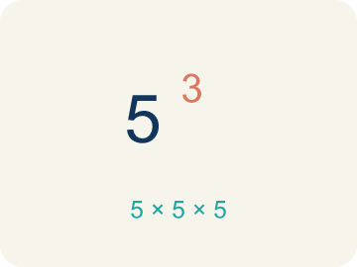 | Exponent Exponente  A small number that tells how many times to multiply the number by itself.  Example: In 2³, the small 3 means multiply 2 by itself 3 times: 2 × 2 × 2 = 8
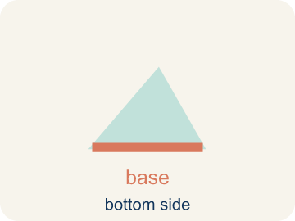 | Base Base  The number that gets multiplied by itself.  Example: In 5², the base is 5 — it is the number being multiplied: 5 × 5 = 25
 | Power Potencia  A number written with a base and an exponent, like 2³.  Example: 10³ = 10 × 10 × 10 = 1,000 — read as '10 to the third power' or '10 cubed'
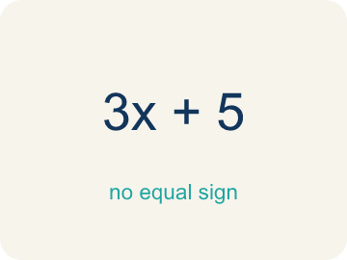 | Evaluate Evaluar  To find the value of an expression.  Example: Evaluate 3⁴: write 3 × 3 × 3 × 3, then multiply step by step: 9 × 9 = 81
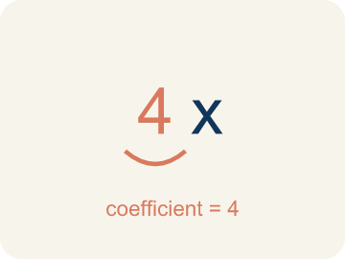 | Coefficient Coeficiente  The number in front of a letter, like the 3 in 3x.  Example: In 3x, the 3 is the coefficient — if x = 4, then 3x = 3 × 4 = 12
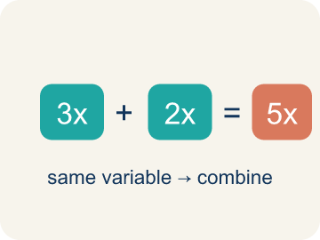 | Like terms Términos semejantes  Terms with the same letter, like 2x and 5x.  Example: 4x and 2x are like terms (both have x); 4x and 4x² are NOT like terms (different powers)

Guided Notes
Fill in each blank as we go. Use the Word Bank to help you.
WORD BANK
Exponent • Base • Power • Evaluate • Coefficient • Like terms

1. The small raised number that shows how many times the base is multiplied is the ___.
2. The number being multiplied repeatedly in a power, like the 3 in 3⁴, is the ___.
3. A number written with a base and an exponent, like 3⁴, is a ___.
4. To find the value of an expression, like 2³ = 8, is to ___ it.
5. A number multiplied by a variable, like the 5 in 5x, is a ___.
6. Terms with the same variable raised to the same power, like 3x and 7x, are ___.

Worked Example

Watch & Read I Do — follow along with your teacher
Sound Check
You're a sound engineer at a music studio. Each time you flip a switch, the volume doubles. The starting volume is 1 unit. After flipping the switch 3 times, the volume is 2³ = 2 × 2 × 2 = 8 units — that's 8 times louder! How loud does it get after more flips?

Think about:
• What happens to the volume each time you flip a switch?
• Why is 2³ equal to 8, not 6?
• How is repeated multiplication different from repeated addition?
• What if the volume tripled each time instead of doubled?
• How many flips would it take to reach over 1,000 volume units?

Solved Example I Do — watch each step
Problem: What is the value of 4³?
A) 64
B) 12
C) 43
D) 7
Step 1: 4³ = 4 × 4 × 4 = 64.
Answer: A. 64

Guided Practice

Solve Together We Do — work with your class
Problem: What is the value of 6²?
A) 36
B) 12
C) 62
D) 8
Step 1:

Step 2:

Answer:

A music studio is recording tracks. Each track layer doubles the file size. A single track is 4 MB. The file size after n layers is given by 4 × 2ⁿ.
How large is the file after 5 layers? Why does the file size grow so quickly?

Sentence frame: After 5 layers the file is ___ MB because 4 × 2⁵ = 4 × ___ = ___. The file grows quickly because each layer ___ the size.

Turn & Talk discuss with a partner
1. [Launch] Each switch flip doubles the volume: 1, then 2, then 4, then 8. How is each number related to the one before, and how could you write 2 times 2 times 2 a shorter way?
Start with: Each number is the one before it times ___, so it is repeated ___.
Cada número es el anterior por ___, así que es ___ repetida.
Word bank: base, exponent, power, evaluate, double
2. [Explore] In the power 2 cubed, which number is the base and which is the exponent? What job does each one do when you evaluate it?
Start with: The base is ___ and it is the number being ___.
La base es ___ y es el número que se está ___.
Word bank: base, exponent, power, evaluate, factor
3. [Connect] When you bounce a track, the file size grows as you double the layers. Where else do you see quantities that grow by repeated multiplication?
Start with: I see repeated multiplication when ___.
Veo multiplicación repetida cuando ___.
Word bank: base, exponent, power, evaluate, growth
4. [Practice] During practice on Powers and Exponents, what strategy did you use when a problem felt tricky?
Start with: The base is ___ and it is the number being ___.
La base es ___ y es el número que se está ___.
Word bank: Exponent, Base, Power, Evaluate

Independent Practice

On Your Own You Do — show your work
Solve each problem. Show your thinking in the work box.
1. Which expression shows 5³ as repeated multiplication?
A) 5 × 5 × 5
B) 5 × 3
C) 5 + 5 + 5
D) 3 × 3 × 3 × 3 × 3

2. Evaluate: 3 × (4 + 2)²
A) 108
B) 54
C) 36
D) 144

3. Track 1 is locked. The keypad shows 2³. What value unlocks it?
A) 8
B) 6
C) 23
D) 9

4. Track 2 needs the value of 5². Which number opens the door?
A) 25
B) 10
C) 52
D) 7

Exit Ticket
Answer on your own. This shows what you learned today.
★ What is the value of 3⁴?
A) 81
B) 12
C) 34
D) 64

Answer Key & Teacher Guide
Teacher reference — remove or fold back before distributing to students.

Guided Notes (Fill-in)
Notes 1: Exponent
Notes 2: Base
Notes 3: Power
Notes 4: Evaluate
Notes 5: Coefficient
Notes 6: Like terms

Worked Notes (I Do / We Do)
I Do: A. 64
We Do: A. 36

Independent Practice
1. A) 5 × 5 × 5 — 5³ means use 5 as a factor 3 times: 5 × 5 × 5. The exponent tells how many times to multiply, not what to multiply by.
2. A) 108 — 4 + 2 = 6. 6² = 36. 3 × 36 = 108.
3. A) 8 — 2³ means 2 × 2 × 2 = 8, so 8 unlocks Track 1.
4. A) 25 — 5² means 5 × 5 = 25, so 25 unlocks Track 2.

Exit Ticket
A) 81 — 3⁴ = 3 × 3 × 3 × 3 = 81.

