UNIT 6 · LESSON 6 STANDARD 6.EE.4

Equivalent Expressions
Student Notes Packet
Name: ______________________ Date: ____________ Period: ________

Today's Goals
Content: I can show that two expressions are equivalent by simplifying and combining like terms.
Language: I can explain my work using the words equivalent, simplify, like terms, and combine.

Key Vocabulary
Look at the picture, read the word, then read what it means.
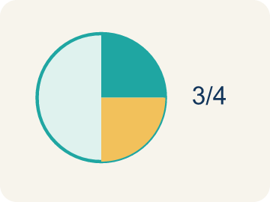 | Equivalent Equivalente  Expressions that always have the same value.  Example: 2x + 4 and 2(x + 2): when x = 3, both = 10; when x = 7, both = 18 — always the same
 | Simplify Simplificar  To write an expression in a shorter, simpler way.  Example: 3x + 2x + 5 simplifies to 5x + 5 — fewer terms, same value
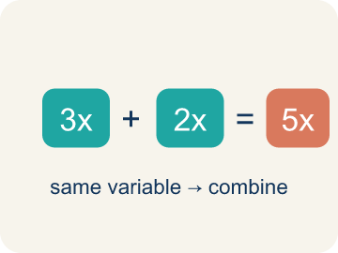 | Like Terms Términos semejantes  Terms with the same letter, like 2x and 5x.  Example: 3x and 7x are like terms (both x); 3x and 3y are NOT (x vs y); 3x and 3x² are NOT (x vs x²)
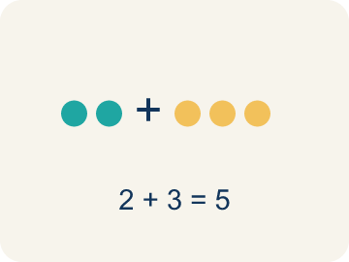 | Combine Combinar  To add or subtract terms with the same letter.  Example: 4n + 3n = 7n — add the coefficients (4 + 3 = 7) and keep the variable (n)
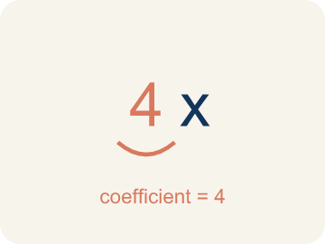 | Coefficient Coeficiente  The number in front of a letter, like the 3 in 3x.  Example: In 5x + 3, the coefficient of x is 5 — when x = 2, the 5x part equals 10

Guided Notes
Fill in each blank as we go. Use the Word Bank to help you.
WORD BANK
Equivalent • Simplify • Like Terms • Combine • Coefficient

1. __________ — Expressions that always have the same value.
2. To write an expression in its shortest equal form is to ___ it.
3. Terms with the same variable raised to the same power, like 4x and 9x, are ___.
4. To add or subtract like terms into one term is to ___ them.
5. A number multiplied by a variable is a ___.

Worked Example

Watch & Read I Do — follow along with your teacher
Remix Studio
At the music studio, two producers wrote formulas for the cost of renting equipment. Producer A wrote 3x + 2x + 10, and Producer B wrote 5x + 10. They look different, but are they really? Let's check: if x = 4, Producer A gets 3(4) + 2(4) + 10 = 30, and Producer B gets 5(4) + 10 = 30. Same result — they're equivalent expressions!

Think about:
• Why did both formulas give the same answer?
• What did Producer B do differently from Producer A?
• Would they still match if x = 10?
• Can two expressions look completely different but always give the same answer?
• Is there always a 'simplest' way to write an expression?

Solved Example I Do — watch each step
Problem: Which expression is equivalent to 4x + 3x?
A) 7x
B) 12x
C) 7x²
D) 43x
Step 1: 4x + 3x = 7x.
Step 2: Combine the coefficients: 4 + 3 = 7.
Answer: A. 7x

Guided Practice

Solve Together We Do — work with your class
Problem: Which expression is equivalent to 2(m + 5)?
A) 2m + 10
B) 2m + 5
C) m + 10
D) 7m
Step 1:

Step 2:

Answer:

A music studio charges different clients using different formulas. Client A pays 4h + 2h + 30 for h hours. Client B pays 6h + 30. A new client asks if the pricing is fair.
Are these expressions equivalent? How can you prove it?

Sentence frame: The expressions ___ equivalent because when I simplify 4h + 2h + 30, I get ___. I can prove it by substituting h = ___: both expressions equal ___.

Turn & Talk discuss with a partner
1. [Launch] Producer A wrote 3x + 2x + 10 and Producer B wrote 5x + 10. They look different but both give 30 when x = 4. Why are they equivalent?
Start with: These expressions are equivalent because 3x + 2x ___.
Estas expresiones son equivalentes porque 3x + 2x ___.
Word bank: Equivalent, Simplify, Like Terms, Combine
2. [Explore] How can you prove 2(n + 4) and 2n + 8 are equivalent? What two strategies could you use?
Start with: They are equivalent because distributing 2(n + 4) gives ___.
Son equivalentes porque distribuir 2(n + 4) da ___.
Word bank: Equivalent, Simplify, Combine, Like Terms
3. [Connect] Client A pays 4h + 2h + 30 and Client B pays 6h + 30. Is the pricing fair (equivalent)? How can you prove it?
Start with: The expressions ___ equivalent because 4h + 2h = ___.
Las expresiones ___ equivalentes porque 4h + 2h = ___.
Word bank: Equivalent, Simplify, Combine, Like Terms
4. [Practice] During practice on Equivalent Expressions, what strategy did you use when a problem felt tricky?
Start with: They are equivalent because distributing 2(n + 4) gives ___.
Son equivalentes porque distribuir 2(n + 4) da ___.
Word bank: Equivalent, Simplify, Like Terms, Combine

Independent Practice

On Your Own You Do — show your work
Solve each problem. Show your thinking in the work box.
1. Which property is shown: 3(x + 7) = 3x + 21?
A) Distributive
B) Commutative
C) Associative
D) Identity

2. Simplify: 5n + 2n
A) 7n
B) 10n
C) 7n²
D) 52n

3. Producer A wrote 2(x + 3) for a beat's cost. Which expression is equivalent?
A) 2x + 6
B) 2x + 3
C) x + 6
D) 2x + 5

4. A track stacks 3x and then one more x. Which expression is equivalent to 3x + x?
A) 4x
B) 3x²
C) 4
D) 3x

Exit Ticket
Answer on your own. This shows what you learned today.
★ Which expression is equivalent to 6n + 4 + 3n − 1?
A) 9n + 3
B) 9n + 5
C) 63n
D) 18n + 4

Answer Key & Teacher Guide
Teacher reference — remove or fold back before distributing to students.

Guided Notes (Fill-in)
Notes 1: Equivalent
Notes 2: Simplify
Notes 3: Like Terms
Notes 4: Combine
Notes 5: Coefficient

Worked Notes (I Do / We Do)
I Do: A. 7x
We Do: A. 2m + 10

Independent Practice
1. A) Distributive — Multiplying 3 by each term inside the parentheses is the distributive property.
2. A) 7n — 5n + 2n = 7n. Add the coefficients: 5 + 2 = 7. The variable stays as n.
3. A) 2x + 6 — Distribute the 2 to each term inside: 2 · x + 2 · 3 = 2x + 6. Check x = 5: 2(5 + 3) = 16 and 2(5) + 6 = 16.
4. A) 4x — 3x + x is 3 groups of x plus 1 more group of x = 4x. Add the coefficients: 3 + 1 = 4. Check x = 3: 3(3) + 3 = 12 and 4(3) = 12.

Exit Ticket
A) 9n + 3 — 6n + 3n = 9n and 4 − 1 = 3, so the simplified expression is 9n + 3.

