UNIT 8 · LESSON 1 STANDARD 6.SP.1

Statistical Questions and Data (Flagship)
Student Notes Packet
Name: ______________________ Date: ____________ Period: ________

Today's Goals
Content: I can tell the difference between a statistical question and a non-statistical question.
Language: I can explain my reasoning using the words statistical question, data, variability, and survey.

Key Vocabulary
Look at the picture, read the word, then read what it means.
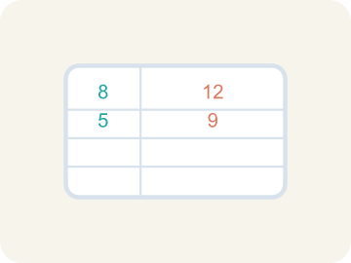 | Statistical Question Pregunta estadística  A question where the answers will be different for different people.  Example: "How tall are the players on the team?" → answers vary: 60 in, 63 in, 58 in, 65 in
 | Data Datos  Facts and numbers you collect, like answers to a survey.  Example: Player heights: 60 in, 63 in, 58 in, 65 in — four different measurements
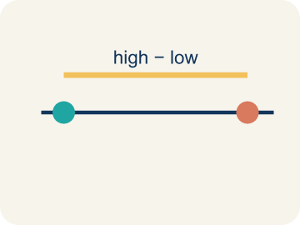 | Variability Variabilidad  How spread out the numbers are.  Example: Scores 10, 12, 11 are close together (low variability); scores 2, 15, 30 are far apart (high variability)
 | Survey Encuesta  Collecting facts by asking people questions.  Example: Asking 50 students 'What is your favorite sport?' and recording the answers
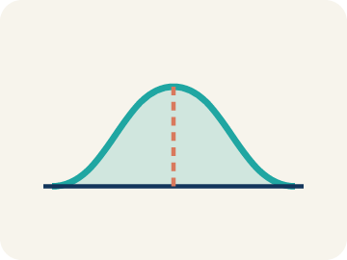 | Data distribution Distribución de datos  How the data looks: where it sits and how spread out it is.  Example: If most scores cluster in the middle with fewer at the edges, the distribution is symmetric

Guided Notes
Fill in each blank as we go. Use the Word Bank to help you.
WORD BANK
Statistical Question • Data • Variability • Survey • Data distribution

1. A question that expects a variety of answers and is answered by collecting data is a ___.
2. Facts or numbers collected to answer a question are ___.
3. How much the values in a data set differ from one another is the ___.
4. A way to collect data by asking many people the same question is a ___.
5. The way data values are spread out across a range is the ___.

Worked Example

Watch & Read I Do — follow along with your teacher
Scouting Report
You've just been hired as the data analyst for a youth basketball league. The head coach hands you a list of questions the staff wants to investigate about their players. Some questions will give you interesting data with variety, while others have just one fixed answer. Your job: figure out which questions are worth investigating with data.

Think about:
• Which questions could have many different answers?
• Which questions have only one exact answer?
• What makes a question good for collecting data?
• Why would a coach care about questions with variability?
• Could a question be reworded to become statistical?

Solved Example I Do — watch each step
Problem: Which of the following is a statistical question?
A) How many points did each player score this season?
B) How many points are scored for a free throw?
C) What sport does this team play?
D) How many halves are in a soccer game?
Step 1: "How many points did each player score?" is statistical because different players will have different scores — there is variability in the data.
Answer: A. How many points did each player score this season?

Guided Practice

Solve Together We Do — work with your class
Problem: Which question is NOT a statistical question?
A) How many innings are in a baseball game?
B) How many home runs did each player hit this year?
C) How many miles does each runner train per week?
D) How tall is each player on the basketball team?
Step 1:

Step 2:

Answer:

The school newspaper wants to write a story about the girls' soccer team. A reporter suggests asking: "How many goals has the team scored total?" The editor says they should ask: "How many goals did each player score this season?"
Which question is statistical? Why would the editor's question give the newspaper more interesting data?

Sentence frame: The reporter's question is ___ because ___. The editor's question is ___ because ___. The editor's question is better for a story because ___.

Turn & Talk discuss with a partner
1. [Launch] The coach asks, "How tall is our point guard?" and "How tall is each player on the roster?" Which one is a statistical question, and why?
Start with: The question "___" is statistical because ___.
La pregunta "___" es estadística porque ___.
Word bank: statistical question, variability, data, survey, answer
2. [Explore] While sorting the questions, what clue tells you instantly that a question will need DATA from many players to answer?
Start with: I know it needs data because it asks about ___.
Sé que necesita datos porque pregunta sobre ___.
Word bank: statistical question, variability, data, survey, vary
3. [Connect] The newspaper editor prefers "How many goals did each player score?" over "How many goals did the team score total?" Which gives more interesting data for a story?
Start with: The editor's question is better because it shows ___ among players.
La pregunta del editor es mejor porque muestra ___ entre los jugadores.
Word bank: statistical question, variability, data, survey, total
4. [Reflect] Think of one statistical question you could ask about students in this room. What variability do you expect in the answers?
Start with: My statistical question is "___".
Mi pregunta estadística es "___".
Word bank: statistical question, variability, data, survey, collect
5. [Practice] During practice on Statistical Questions and Data, what strategy did you use when a problem felt tricky?
Start with: I know it needs data because it asks about ___.
Sé que necesita datos porque pregunta sobre ___.
Word bank: Statistical Question, Data, Variability, Survey

Independent Practice

On Your Own You Do — show your work
Solve each problem. Show your thinking in the work box.
1. Why is 'How many hours of sleep did each student get last night?' a statistical question?
A) Because different students got different amounts of sleep
B) Because it asks about sleep
C) Because hours are numbers
D) Because the answer is always 8 hours

2. Match each question to its type.
3. A coach asks: "How many hours does each athlete on the track team sleep the night before a meet?" Why is this a statistical question?
A) Because the answers will vary from athlete to athlete
B) Because it is about sports
C) Because it has a numerical answer
D) Because the coach asked it

4. Match each question with what makes it statistical or not.

Exit Ticket
Answer on your own. This shows what you learned today.
★ Which question is a statistical question?
A) How many students are in the school?
B) How many hours does each student in 6th grade exercise per week?
C) What time does school start?
D) How many days are in a week?
A) B) How many hours does each student exercise per week?
B) A) How many students are in the school?
C) C) What time does school start?
D) D) How many days are in a week?

Answer Key & Teacher Guide
Teacher reference — remove or fold back before distributing to students.

Guided Notes (Fill-in)
Notes 1: Statistical Question
Notes 2: Data
Notes 3: Variability
Notes 4: Survey
Notes 5: Data distribution

Worked Notes (I Do / We Do)
I Do: A. How many points did each player score this season?
We Do: A. How many innings are in a baseball game?

Independent Practice
1. A) Because different students got different amounts of sleep — A statistical question anticipates variability — different students slept different amounts, so the data will vary.
2. Answers vary.
3. A) Because the answers will vary from athlete to athlete — A statistical question anticipates variability. Different athletes sleep different amounts, so the data collected will vary.
4. Answers vary.

Exit Ticket
A) B) How many hours does each student exercise per week? — "How many hours does each student exercise per week?" is statistical because different students exercise different amounts — the data has variability.

