UNIT 9 · LESSON 1 STANDARD 6.NS.6

Graph on the Coordinate Plane (Flagship)
Student Notes Packet
Name: ______________________ Date: ____________ Period: ________

Today's Goals
Content: I can plot and identify points on the coordinate plane using ordered pairs.
Language: I can explain my work using the words coordinate plane, ordered pair, origin, and quadrant.

Key Vocabulary
Look at the picture, read the word, then read what it means.
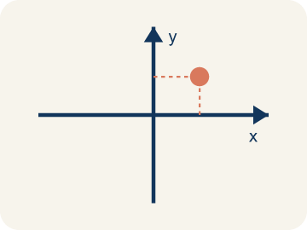 | Coordinate plane Plano cartesiano  A grid with a line going across and a line going up that cross.  Example: A grid with a horizontal line (x-axis) crossing a vertical line (y-axis), making four sections
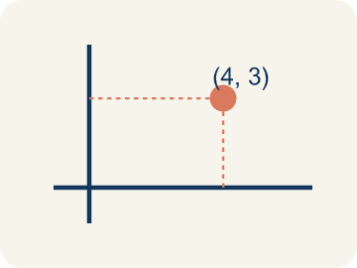 | Ordered pair Par ordenado  Two numbers (x, y) that tell where a point is on a grid.  Example: (3, 5) means move right 3 from the origin, then up 5
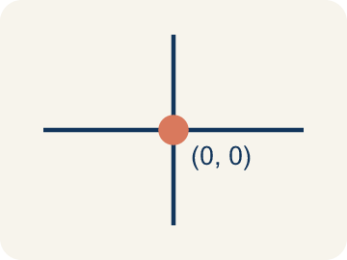 | Origin Origen  The point (0, 0) where the two grid lines cross.  Example: The starting point at the center where both axes cross — (0, 0)
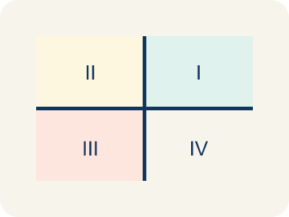 | Quadrant Cuadrante  One of the four parts of a coordinate grid.  Example: I (+,+) top-right, II (-,+) top-left, III (-,-) bottom-left, IV (+,-) bottom-right
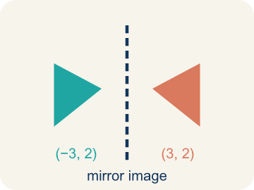 | Reflection Reflexión  A flipped, mirror image across a line.  Example: (3, 2) reflected over the x-axis becomes (3, -2) — same x, opposite y
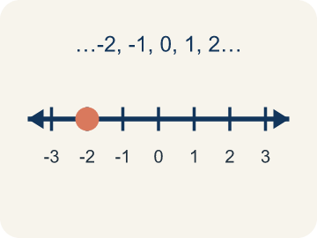 | Integer Número entero  Whole numbers and their opposites, like -2, -1, 0, 1, 2.  Example: ..., -3, -2, -1, 0, 1, 2, 3, ...

Guided Notes
Fill in each blank as we go. Use the Word Bank to help you.
WORD BANK
Coordinate plane • Ordered pair • Origin • Quadrant • Reflection • Integer

1. The grid made by a horizontal and a vertical number line is the ___.
2. Two numbers (x, y) that tell the location of a point are an ___.
3. The point (0, 0) where the x-axis and y-axis cross is the ___.
4. One of the four regions of the coordinate plane is a ___.
5. A flip of a point or shape over an axis is a ___.
6. A whole number or its opposite, with no fraction part, is an ___.

Worked Example

Watch & Read I Do — follow along with your teacher
Treasure Map Navigation
Captain Vega left a treasure map, but instead of an 'X marks the spot,' she hid the directions as ordered pairs! To find the treasure, you need to plot each point on the coordinate plane and connect them in order. The first clue says: Start at (2, 1), then go to (5, 4), then (8, 1).

Think about:
• What shape will the three points make when connected?
• Which number tells you how far right/left? Which tells you up/down?
• Why is the ORDER in an ordered pair important?
• What if one of the coordinates was negative?
• How would you describe a location without a coordinate plane?

Solved Example I Do — watch each step
Problem: Which ordered pair names a point 3 units right and 7 units up from the origin?
A) (3, 7)
B) (7, 3)
C) (3, 3)
D) (0, 7)
Step 1: The first coordinate is horizontal (right 3), the second is vertical (up 7).
Step 2: So (3, 7).
Answer: A. (3, 7)

Guided Practice

Solve Together We Do — work with your class
Problem: What are the coordinates of the origin?
A) (0, 0)
B) (1, 1)
C) (0, 1)
D) (1, 0)
Step 1:

Step 2:

Answer:

A drone delivery company programs flight paths using coordinate pairs. A drone starts at the warehouse (0, 0), flies to pickup at (3, 6), then delivers to (8, 2), then returns to base (0, 0).
How do ordered pairs help the drone navigate? What shape does the flight path make?

Sentence frame: The drone uses ordered pairs because the first number controls ___ movement and the second controls ___. The path makes a ___ shape.

Turn & Talk discuss with a partner
1. [Launch] On a treasure map laid over a coordinate plane, why do we always start at the origin (0, 0) and move sideways before moving up or down to reach the treasure?
Start with: The first number in (x, y) tells me to move ___.
El primer numero en (x, y) me dice que me mueva ___.
Word bank: coordinate plane, origin, ordered pair, x-axis, y-axis
2. [Explore] Your map says the treasure is at (4, 2). Walk your partner through every move you make from the origin, using the words x-axis and y-axis.
Start with: I move ___ units along the x-axis.
Me muevo ___ unidades por el eje x.
Word bank: origin, ordered pair, x-axis, y-axis, coordinate plane
3. [Connect] How is reading a coordinate pair on the treasure map like reading directions in a video game or on a real map?
Start with: The x-coordinate is like going ___.
La coordenada x es como ir ___.
Word bank: ordered pair, coordinate plane, x-axis, y-axis, origin
4. [Reflect] A teammate marked the treasure at (2, 6) by moving up 2 and over 6. What mistake did they make, and how would you coach them?
Start with: They mixed up the ___ and the ___.
Confundieron la ___ y la ___.
Word bank: ordered pair, x-axis, y-axis, origin, coordinate plane
5. [Practice] During practice on Graph on the Coordinate Plane, what strategy did you use when a problem felt tricky?
Start with: I move ___ units along the x-axis.
Me muevo ___ unidades por el eje x.
Word bank: Coordinate plane, Ordered pair, Origin, Quadrant

Independent Practice

On Your Own You Do — show your work
Solve each problem. Show your thinking in the work box.
1. A point is at (6, 2). What does the 6 tell you?
A) Move 6 units to the right
B) Move 6 units up
C) Move 6 units to the left
D) The point is in Quadrant 6

2. Stage 1 — Captain Vega's note says the first landmark, Palm Cove, is 6 units to the right and 4 units up from the origin. Which ordered pair names Palm Cove?
A) (6, 4)
B) (4, 6)
C) (6, 0)
D) (0, 4)

3. Stage 2 — The next clue points to Skull Rock at (-5, 3). Which quadrant is Skull Rock in?
A) Quadrant II
B) Quadrant I
C) Quadrant III
D) Quadrant IV

4. Stage 5 — Captain Vega marks the final treasure 0 units across and 8 units up from the origin. Where does this point land?
A) On the y-axis at (0, 8)
B) On the x-axis at (8, 0)
C) In Quadrant I at (8, 8)
D) At the origin (0, 0)

Exit Ticket
Answer on your own. This shows what you learned today.
★ Point P is located 6 units right and 3 units up from the origin. What ordered pair names point P?
A) (6, 3)
B) (3, 6)
C) (6, 0)
D) (0, 3)

Answer Key & Teacher Guide
Teacher reference — remove or fold back before distributing to students.

Guided Notes (Fill-in)
Notes 1: Coordinate plane
Notes 2: Ordered pair
Notes 3: Origin
Notes 4: Quadrant
Notes 5: Reflection
Notes 6: Integer

Worked Notes (I Do / We Do)
I Do: A. (3, 7)
We Do: A. (0, 0)

Independent Practice
1. A) Move 6 units to the right — The first number (x-coordinate) tells you horizontal movement. 6 means go right 6 units from the origin.
2. A) (6, 4) — The first number is horizontal (right 6) and the second is vertical (up 4), so Palm Cove is at (6, 4).
3. A) Quadrant II — The x-coordinate is negative (left) and the y-coordinate is positive (up). Negative x and positive y land in the top-left region, Quadrant II.
4. A) On the y-axis at (0, 8) — An x-coordinate of 0 means no horizontal move, so the point stays on the y-axis. Moving up 8 places it at (0, 8).

Exit Ticket
A) (6, 3) — Right 6 = x-coordinate of 6, Up 3 = y-coordinate of 3. The ordered pair is (6, 3).

