UNIT 9 · LESSON 6 STANDARD 6.NS.8

Distance on the Coordinate Plane
Student Notes Packet
Name: ______________________ Date: ____________ Period: ________

Today's Goals
Content: I can find the distance between two points on the coordinate plane using absolute value.
Language: I can explain my work using the words distance, absolute value, horizontal distance, and vertical distance.

Key Vocabulary
Look at the picture, read the word, then read what it means.
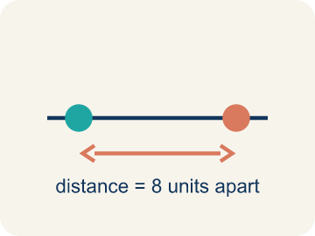 | Distance Distancia  How far apart two points are. It is never negative.  Example: The distance from -3 to 4 on a number line is |-3| + |4| = 3 + 4 = 7 units
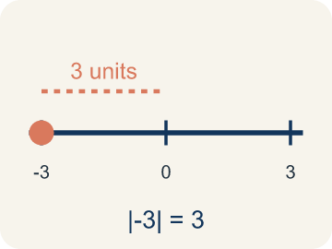 | Absolute value Valor absoluto  How far a number is from zero.  Example: |-3| = 3 and |4| = 4; to find distance: |4 - (-3)| = 7
 | Horizontal distance Distancia horizontal  How far apart two points are going left or right.  Example: From (-2, 3) to (5, 3): count from -2 to 5 = 7 units across
 | Vertical distance Distancia vertical  How far apart two points are going up or down.  Example: From (4, -1) to (4, 6): count from -1 to 6 = 7 units up
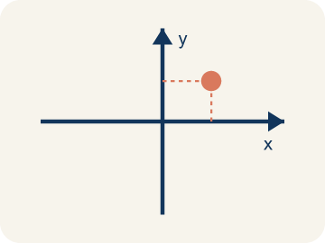 | Coordinate plane Plano cartesiano  A grid with a line going across and a line going up that cross.  Example: Two number lines crossing at (0, 0), creating four quadrants
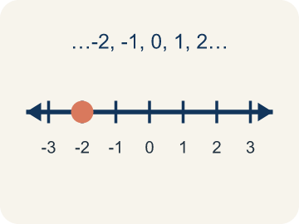 | Integer Número entero  Whole numbers and their opposites, like -2, -1, 0, 1, 2.  Example: ..., -3, -2, -1, 0, 1, 2, 3, ...

Guided Notes
Fill in each blank as we go. Use the Word Bank to help you.
WORD BANK
Distance • Absolute value • Horizontal distance • Vertical distance • Coordinate plane • Integer

1. How far apart two points are on the coordinate plane is the ___.
2. The distance of a number from zero, used to find distance between points, is its ___.
3. The distance between two points along the x-direction is the ___.
4. The distance between two points along the y-direction is the ___.
5. The grid made by the x-axis and y-axis is the ___.
6. A whole number or its opposite is an ___.

Worked Example

Watch & Read I Do — follow along with your teacher
Treasure Distances
Captain Vega has two treasure locations on her map: a buried chest at (-3, 2) and a hidden cave at (4, 2). Both are at the same height (y = 2) on the map. She needs to figure out how far apart they are so she knows how much rope to bring. Another pair of treasures is at (1, -3) and (1, 5) — same column, different rows. How far apart is each pair?

Think about:
• What do the two points (-3, 2) and (4, 2) have in common?
• How can you count the distance between points in the same row?
• How does absolute value help when one point has a negative coordinate?
• What if the two points are NOT in the same row or column?
• Is the distance between -3 and 4 the same as the distance between 4 and -3?

Solved Example I Do — watch each step
Problem: What is the distance between (-4, 3) and (2, 3)?
A) 2 units
B) 4 units
C) 6 units
D) 8 units
Step 1: Both points have y = 3, so this is a horizontal distance.
Step 2: |2 - (-4)| = |2 + 4| = 6 units.
Answer: C. 6 units

Guided Practice

Solve Together We Do — work with your class
Problem: What is the distance between (5, -2) and (5, 4)?
A) 2 units
B) 4 units
C) 6 units
D) 10 units
Step 1:

Step 2:

Answer:

A drone starts at position (-4, 0) on a grid and needs to deliver a package to (3, 0), then fly to another delivery at (3, -5). It can only fly horizontally or vertically.
How does the drone use coordinate distance to calculate the total flight path?

Sentence frame: The horizontal distance from (-4, 0) to (3, 0) is ___ units because ___. The vertical distance from (3, 0) to (3, -5) is ___ units because ___. The total flight path is ___ units.

Turn & Talk discuss with a partner
1. [Launch] Two points sit on the same horizontal line: (2, 3) and (7, 3). How can you find the distance between them without counting every square?
Start with: The y-coordinates are the same, so I only compare the ___.
Las coordenadas y son iguales, asi que solo comparo las ___.
Word bank: distance, coordinate plane, absolute value, ordered pair, x-axis
2. [Explore] One point is at (-3, 1) and another is at (4, 1). How does absolute value help you find the distance across zero?
Start with: The distance is |4| + |-3|, which equals ___.
La distancia es |4| + |-3|, que es ___.
Word bank: distance, absolute value, coordinate plane, ordered pair, negative
3. [Connect] Why does distance on the coordinate plane always come out positive, even when the coordinates are negative?
Start with: Distance measures how ___ apart two points are.
La distancia mide que tan ___ estan dos puntos.
Word bank: distance, absolute value, coordinate plane, negative, ordered pair
4. [Reflect] A classmate found the distance from (-2, 5) to (6, 5) by computing 6 - 2 = 4. What did they do wrong?
Start with: They forgot that -2 is ___, not ___.
Olvidaron que -2 es ___, no ___.
Word bank: distance, absolute value, coordinate plane, negative, ordered pair
5. [Practice] During practice on Distance on the Coordinate Plane, what strategy did you use when a problem felt tricky?
Start with: The distance is |4| + |-3|, which equals ___.
La distancia es |4| + |-3|, que es ___.
Word bank: Distance, Absolute value, Horizontal distance, Vertical distance

Independent Practice

On Your Own You Do — show your work
Solve each problem. Show your thinking in the work box.
1. A rectangle has vertices at (1, 1), (5, 1), (5, 4), (1, 4). What is its perimeter?
A) 14 units
B) 12 units
C) 20 units
D) 8 units

2. Two points are at (-3, -7) and (-3, 5). What is the distance between them?
A) 12 units
B) 2 units
C) 7 units
D) 8 units

3. The Bank is at (2, 3) and the Library is at (2, 9). How many blocks apart are they?
A) 6 blocks
B) 12 blocks
C) 3 blocks
D) 11 blocks

4. The Park is at (-4, 5) and City Hall is at (3, 5). How many blocks apart are they?
A) 1 block
B) 7 blocks
C) 12 blocks
D) 5 blocks

Exit Ticket
Answer on your own. This shows what you learned today.
★ What is the distance between the points (3, -2) and (3, 5)?
A) 3 units
B) 5 units
C) 7 units
D) 9 units

Answer Key & Teacher Guide
Teacher reference — remove or fold back before distributing to students.

Guided Notes (Fill-in)
Notes 1: Distance
Notes 2: Absolute value
Notes 3: Horizontal distance
Notes 4: Vertical distance
Notes 5: Coordinate plane
Notes 6: Integer

Worked Notes (I Do / We Do)
I Do: C. 6 units
We Do: C. 6 units

Independent Practice
1. A) 14 units — Width = 5 - 1 = 4. Height = 4 - 1 = 3. Perimeter = 2(4 + 3) = 14.
2. A) 12 units — Same x = -3. Distance = |5 - (-7)| = |5 + 7| = 12 units.
3. A) 6 blocks — Same x = 2, so the segment is vertical. Distance = |9 - 3| = 6 blocks.
4. B) 7 blocks — Same y = 5, so the segment is horizontal. The points are on opposite sides of zero, so add the absolute values: |-4| + |3| = 4 + 3 = 7 blocks.

Exit Ticket
C) 7 units — Both points share x = 3, so this is a vertical distance. |5 - (-2)| = |5 + 2| = 7 units.

