UNIT 9 · LESSON 7 STANDARD 6.NS.6B

Reflect Points Across Axes
Student Notes Packet
Name: ______________________ Date: ____________ Period: ________

Today's Goals
Content: I can reflect points across the x-axis and y-axis on the coordinate plane.
Language: I can explain my work using the words reflection, x-axis, y-axis, and symmetry.

Key Vocabulary
Look at the picture, read the word, then read what it means.
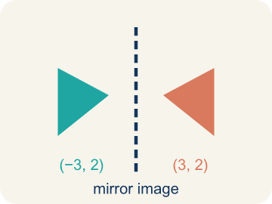 | Reflection Reflexión  A flipped image of a point on the other side of a line, the same distance away.  Example: (3, 2) reflected over the y-axis becomes (-3, 2) — x changes sign, y stays
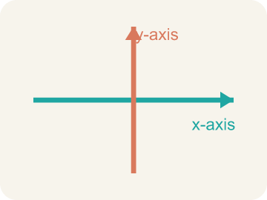 | x-axis Eje x  The line that goes across the grid. Flipping over it changes the y sign.  Example: (4, 3) → (4, -3): the y flips from +3 to -3, like folding the paper along the horizontal line
 | y-axis Eje y  The line that goes up the grid. Flipping over it changes the x sign.  Example: (4, 3) → (-4, 3): the x flips from +4 to -4, like folding the paper along the vertical line
 | Symmetry Simetría  When a shape looks the same on both sides of a line.  Example: A butterfly's wings are symmetric — fold it down the middle and both sides match
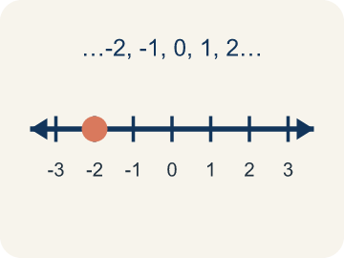 | Integer Número entero  Whole numbers and their opposites, like -2, -1, 0, 1, 2.  Example: ..., -3, -2, -1, 0, 1, 2, 3, ...

Guided Notes
Fill in each blank as we go. Use the Word Bank to help you.
WORD BANK
Reflection • x-axis • y-axis • Symmetry • Integer

1. A flip of a point or shape over an axis to make a mirror image is a ___.
2. The horizontal number line on the coordinate plane is the ___.
3. The vertical number line on the coordinate plane is the ___.
4. When two halves are mirror images of each other, the figure has ___.
5. A whole number or its opposite, with no fraction part, is an ___.

Worked Example

Watch & Read I Do — follow along with your teacher
Mirror Images on the Map
Captain Vega discovers that her treasure map has a magic mirror trick! When she folds the map along the x-axis, some clues match up perfectly with clues on the other side. For example, a marker at (2, 4) has a matching marker at (2, -4) when reflected over the x-axis. Another pair reflects over the y-axis: (5, 3) and (-5, 3). How does reflection change the coordinates?

Think about:
• When (2, 4) reflects over the x-axis to (2, -4), which coordinate changed?
• When (5, 3) reflects over the y-axis to (-5, 3), which coordinate changed?
• What stays the same in each reflection?
• What happens if you reflect a point over BOTH axes?
• Can a point be its own reflection?

Solved Example I Do — watch each step
Problem: What is the reflection of (4, -3) over the x-axis?
A) (-4, -3)
B) (4, 3)
C) (-4, 3)
D) (3, -4)
Step 1: Reflecting over the x-axis changes the sign of the y-coordinate.
Step 2: The x stays the same (4), and the y changes from -3 to 3.
Step 3: The answer is (4, 3).
Answer: B. (4, 3)

Guided Practice

Solve Together We Do — work with your class
Problem: What is the reflection of (-2, 6) over the y-axis?
A) (2, 6)
B) (-2, -6)
C) (2, -6)
D) (6, -2)
Step 1:

Step 2:

Step 3:

Answer:

A game designer creates a spaceship at (3, 2) and wants to place enemy ships as reflections to make the level symmetric. One enemy is reflected over the y-axis, and another is reflected over the x-axis.
How do reflections help the game designer create a balanced, symmetric level?

Sentence frame: The enemy reflected over the y-axis is at ___ because ___. The enemy reflected over the x-axis is at ___ because ___. Reflections help game designers because ___.

Turn & Talk discuss with a partner
1. [Launch] When you reflect the point (3, 2) over the y-axis, which coordinate changes its sign and which stays the same? Why?
Start with: The ___ coordinate changes sign.
La coordenada ___ cambia de signo.
Word bank: reflection, x-axis, y-axis, ordered pair, coordinate plane
2. [Explore] Reflect (4, -5) over the x-axis. Talk through how the coordinates change and where the new point lands.
Start with: Over the x-axis, the ___ coordinate flips sign.
Sobre el eje x, la coordenada ___ cambia de signo.
Word bank: reflection, x-axis, y-axis, ordered pair, coordinate plane
3. [Connect] How is reflecting a point over an axis like looking at it in a mirror placed on that axis?
Start with: The axis acts like the ___.
El eje actua como el ___.
Word bank: reflection, x-axis, y-axis, coordinate plane, ordered pair
4. [Reflect] A classmate reflected (2, 3) over the x-axis and got (-2, 3). What did they do wrong, and what is the correct image?
Start with: Over the x-axis, they should have changed the ___ coordinate.
Sobre el eje x, debieron cambiar la coordenada ___.
Word bank: reflection, x-axis, y-axis, ordered pair, coordinate plane
5. [Practice] During practice on Reflect Points Across Axes, what strategy did you use when a problem felt tricky?
Start with: Over the x-axis, the ___ coordinate flips sign.
Sobre el eje x, la coordenada ___ cambia de signo.
Word bank: Reflection, x-axis, y-axis, Symmetry

Independent Practice

On Your Own You Do — show your work
Solve each problem. Show your thinking in the work box.
1. Which point is on the y-axis?
A) (0, 5)
B) (5, 0)
C) (3, 3)
D) (-2, 4)

2. Point A is at (-3, 5). It is reflected over the x-axis to A', then A' is reflected over the y-axis to A''. What are the coordinates of A''?
A) (3, -5)
B) (-3, -5)
C) (3, 5)
D) (-3, 5)

3. Captain Vega folds the map along the x-axis. A marker at (7, 2) lands on its mirror image. What are the new coordinates?
A) (7, -2)
B) (-7, 2)
C) (-7, -2)
D) (2, 7)

4. A buried chest is marked at (-5, 3). Vega folds the map along the y-axis to find its mirror twin. Where is the twin?
A) (5, 3)
B) (-5, -3)
C) (5, -3)
D) (3, -5)

Exit Ticket
Answer on your own. This shows what you learned today.
★ What is the reflection of (-5, 2) over the y-axis?
A) (-5, -2)
B) (5, -2)
C) (5, 2)
D) (2, -5)

Answer Key & Teacher Guide
Teacher reference — remove or fold back before distributing to students.

Guided Notes (Fill-in)
Notes 1: Reflection
Notes 2: x-axis
Notes 3: y-axis
Notes 4: Symmetry
Notes 5: Integer

Worked Notes (I Do / We Do)
I Do: B. (4, 3)
We Do: A. (2, 6)

Independent Practice
1. A) (0, 5) — Points on the y-axis have x-coordinate = 0. (0, 5) is on the y-axis.
2. A) (3, -5) — Over x-axis: (-3, 5) → (-3, -5). Then over y-axis: (-3, -5) → (3, -5). Both coordinates changed sign.
3. A) (7, -2) — Folding along (reflecting across) the x-axis flips the sign of the y-coordinate only. (7, 2) becomes (7, -2).
4. A) (5, 3) — Reflecting across the y-axis flips the sign of the x-coordinate only. (-5, 3) becomes (5, 3).

Exit Ticket
C) (5, 2) — Reflecting over the y-axis changes the sign of the x-coordinate. x goes from -5 to 5, and y stays 2. The reflection is (5, 2).

