Name Date Period
Lesson 7-2 · Session 1 · Prerequisite Practice B · Skill 1 of 2

Write Integers for Situations
Builds on Lesson 7-1 Session 1 · 6.NS.C.5
TODAY’S LESSON | You will write numbers for spots above and below 0, like a carrot root 0.75 m down.
YOU NEED TO | Write an integer for a situation, like 40 feet below the ground = −40. You will use it in Practice Form A, problems 2 and 7.

STEPS TO FOLLOW use these same steps on every problem
1 | Find the zero point: the ground, sea level, or $0.
2 | Choose the sign: above or gain is +. Below or loss is −.
3 | Write the number with its sign.

WATCH ME the steps in action
A cave floor is 40 feet below the ground. Write an integer.
Step 1 Zero is the ground.
Step 2 Below the ground, so the sign is −.
Step 3 Write −40.
Answer −40

TRY IT WITH HELP fill in each step
1. A kite flies 30 m above the ground.
Step 1 Zero is the .
Step 2 Above the ground, so the sign is .
Step 3 The integer is .

2. A bank account owes $22.
Step 1 Zero is .
Step 2 Owing money is a loss, so the sign is .
Step 3 The integer is .

YOUR TURN use the steps on your own

3. Write an integer for each situation.
a. 25 ft above sea level | b. a debt of $18
c. 8 floors below the street | d. a gain of 12 yards
e. 15 degrees below zero | f. a drop of 6 meters

Lesson 7-2 · Session 1 · Prerequisite Practice B · Skill 2 of 2

Plot Integers on a Number Line
Builds on Lesson 7-1 Session 1 · 6.NS.C.5
TODAY’S LESSON | You will plot readings like −2.5 and 2.5 on a number line.
YOU NEED TO | Find an integer on a number line, like −3: 3 units left of 0. You will use it in Practice Form A, problems 3 and 6.

STEPS TO FOLLOW use these same steps on every problem
1 | Start at 0.
2 | Read the sign: − goes left, + goes right.
3 | Count the units. Mark the point.

WATCH ME the steps in action
Plot −4.  Step 1 Start at 0.  Step 2 The sign is −, so go left.  Step 3 Count 4 units. Mark −4.  Answer −4 is 4 units left of 0. | 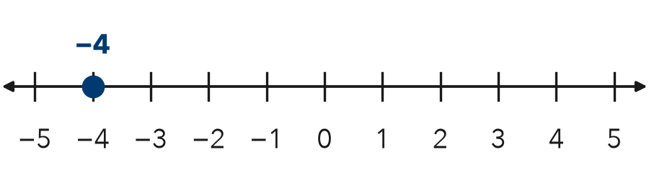

TRY IT WITH HELP fill in each step
4. Plot 3.
Step 1 Start at .
Step 2 The sign is +, so go .
Step 3 Count units. Mark the point.

5. Plot −6.
Step 1 Start at .
Step 2 The sign is −, so go .
Step 3 Count units. Mark the point.
Use this number line: 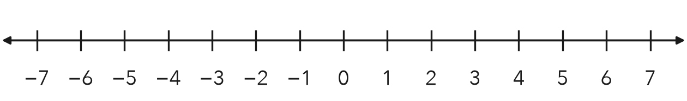

YOUR TURN use the steps on your own

6. Write how many units from 0, and left or right.
a. −7 | b. 5 | c. −2
d. 9 | e. −10 | f. 1

READY CHECK a problem like the one in today’s lesson

7. A thermometer reads −3 degrees. Where do you plot −3?
A 3 units right of 0 | B 3 units left of 0
C at 0 | D 30 units left of 0

CHECK YOURSELF | □ I can do this on my own | □ I need a little help | □ I have a question about #

