Name Date Period
Lesson 7-3 · Session 1 · Prerequisite Practice B · Skill 1 of 2

Name a Number’s Opposite
Builds on Lesson 7-1 · 6.NS.C.6a
TODAY’S LESSON | You will see that −7.5 and 7.5 have the same absolute value.
YOU NEED TO | Name the opposite of a number, like −8 and 8. You will use it in Practice Form A, problem 4.

STEPS TO FOLLOW use these same steps on every problem
1 | Find the number’s distance from 0.
2 | Switch sides of 0: left becomes right, right becomes left.
3 | Write the number on the new side. −( ) means the opposite of.

WATCH ME the steps in action
Name the opposite of −8.  Step 1 −8 is 8 units from 0.  Step 2 −8 is left of 0. Switch to the right.  Step 3 The opposite is 8.  Answer 8 | 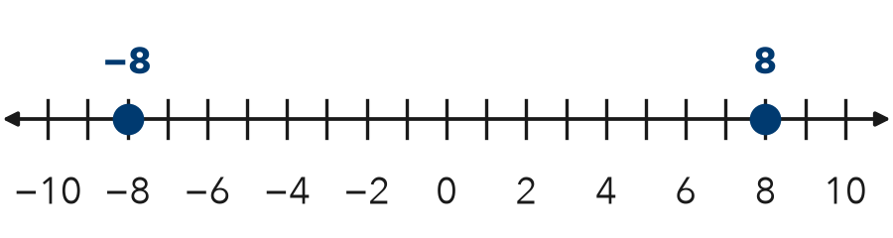

TRY IT WITH HELP fill in each step
1. Name the opposite of 3.5.
Step 1 3.5 is units from 0.
Step 2 3.5 is right of 0. Switch to the .
Step 3 The opposite is .

2. Find −(−2.5).
Step 1 −2.5 is units from 0.
Step 2 −2.5 is left of 0. Switch to the .
Step 3 −(−2.5) =

YOUR TURN use the steps on your own

3. Write the opposite of each number.
a. 12 | b. −5 | c. 0
d. −21 | e. −7.5 | f. −0.25

Lesson 7-3 · Session 1 · Prerequisite Practice B · Skill 2 of 2

Plot Rational Numbers
Builds on Lesson 7-2 · 6.NS.C.6c
TODAY’S LESSON | You will plot −6, 2.5, and −0.5, then find each distance to 0.
YOU NEED TO | Plot a negative decimal, like −0.5: halfway between −1 and 0. You will use it in Practice Form A, problem 2.

STEPS TO FOLLOW use these same steps on every problem
1 | Find the two integers the number sits between.
2 | Split that gap into equal parts.
3 | Count the parts away from 0. Mark the point.

WATCH ME the steps in action
Plot −1.5.  Step 1 −1.5 is between −1 and −2.  Step 2 Split −1 to −2 into 2 equal parts.  Step 3 Count 1 part left of −1. Mark it.  Answer −2 and −1 | 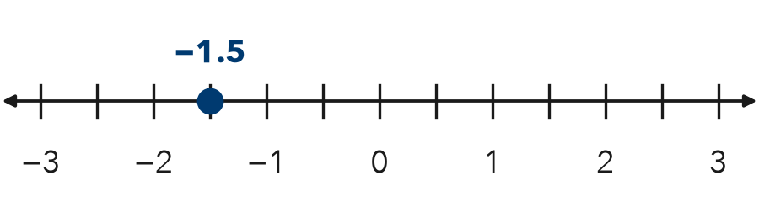

TRY IT WITH HELP fill in each step
4. Plot −3.5.
Step 1 −3.5 is between and .
Step 2 Split the gap into equal parts.
Step 3 Count part left of −3. Mark it.

5. Plot −7.5.
Step 1 −7.5 is between and .
Step 2 Split the gap into equal parts.
Step 3 Count part left of −7. Mark it.
Use this number line: 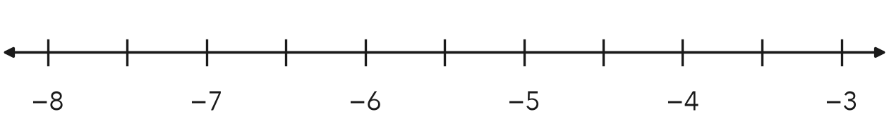

YOUR TURN use the steps on your own

6. Write the two integers each number is between.
a. −7.5 | b. 2.5 | c. −0.5
d. −5.2 | e. 4.25 | f. −14.5

READY CHECK a problem like the one in today’s lesson

7. Between which two integers is −0.5?
A 0 and 1 | B −1 and 0 | C −5 and −4 | D −2 and −1

CHECK YOURSELF | □ I can do this on my own | □ I need a little help | □ I have a question about #

