Name Date Period
Lesson 7-7 · Session 1 · Prerequisite Practice B · Skill 1 of 2

Plot and Connect Points
Builds on Lesson 7-5 Session 1 · 6.NS.C.6c
TODAY’S LESSON | You will plot garden corners like (−4, 6) and (9, −3), then connect them.
YOU NEED TO | Plot a point like (−4, 6): move left 4, then up 6. You will use it in Practice Form A, problems 2 and 4.

STEPS TO FOLLOW use these same steps on every problem
1 | Start at (0, 0). Move left or right the first number.
2 | Move up or down the second number. Draw a dot.
3 | Connect the dots in order, then back to the first.

WATCH ME the steps in action
Plot A(−3, 2), B(4, 2) and C(4, −1). Connect them.  Step 1 A: left 3. B: right 4. C: right 4.  Step 2 A: up 2. B: up 2. C: down 1. Draw dots.  Step 3 Connect A to B to C, then back to A.  Answer A triangle. | 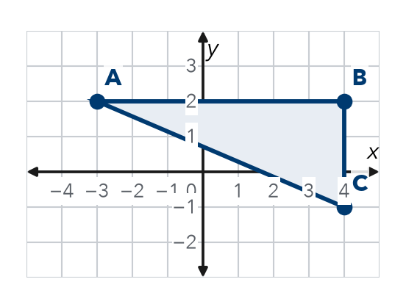

TRY IT WITH HELP fill in each step
1. Plot P(−4, 1), Q(2, 1) and R(2, −3). Connect them.  Step 1 P: 4. Q: right 2. R: right .  Step 2 P: up 1. Q: up . R: 3.  Step 3 Connect P to Q to , then back to . | 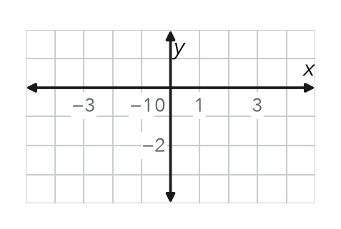

2. Plot J(−1, 4), K(3, 4), L(3, −2) and M(−1, −2). Connect them.  Step 1 J and M: 1. K and L: right .  Step 2 J and K: up . L and M: 2.  Step 3 Connect J, K, L, M, then back to . The shape is a . | 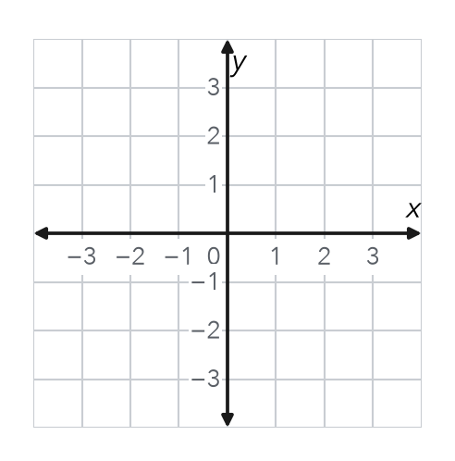  Use this grid.

YOUR TURN use the steps on your own

3. Write the two moves from (0, 0) for each point.
a. (−5, 2) | b. (3, −6)
c. (−1, −4) | d. (0, 7)

Lesson 7-7 · Session 1 · Prerequisite Practice B · Skill 2 of 2

Find Distance on a Grid
Builds on Lesson 7-6 Session 1 · 6.NS.C.8
TODAY’S LESSON | In problem 1, the side from (−3, 4) to (6, 4) is 3 + 6 = 9 units long.
YOU NEED TO | Find the distance between two points that share a coordinate. You will use it in Practice Form A, problems 1, 2 and 3.

STEPS TO FOLLOW use these same steps on every problem
1 | Find the shared coordinate. Use the other two numbers.
2 | Signs differ? Add the distances from 0. Same sign? Subtract.
3 | Write the distance in units.

WATCH ME the steps in action
Find the distance from (−4, 3) to (5, 3).
Step 1 They share y = 3. Use −4 and 5.
Step 2 Signs differ: 4 + 5 = 9.
Step 3 The distance is 9 units.
Answer 9 units

TRY IT WITH HELP fill in each step
4. Find the distance from (−6, 1) to (2, 1).
Step 1 They share = 1. Use −6 and 2.
Step 2 Signs differ: 6 + 2 = .
Step 3 The distance is units.

5. Find the distance from (−7, 2) to (−1, 2).
Step 1 They share y = 2. Use and .
Step 2 Same sign: 7 − 1 = .
Step 3 The distance is units.

YOUR TURN use the steps on your own

6. Find the distance between the points in units.
a. (−3, 4) to (6, 4) | b. (6, 4) to (6, −2)
c. (2, 8) to (2, 3) | d. (−5, −4) to (−5, 3)
e. (−9, 1) to (−2, 1) | f. (−4, −3) to (9, −3)

READY CHECK a problem like the one in today’s lesson

7. A rectangle’s top side joins (−9, 5) and (6, 5). How long is the top side?
A 3 units | B 15 units | C 10 units | D 11 units

CHECK YOURSELF | □ I can do this on my own | □ I need a little help | □ I have a question about #

