Name Date Period
Lesson 9-2 · Session 1 · Prerequisite Practice A · Skill 1 of 2

Multiply Two-Digit Numbers
Builds on Grade 4 · 4.NBT.B.5
TODAY’S LESSON | You will write the pair for 5 rows of 18 seeds: (5, 90).
YOU NEED TO | Multiply a two-digit number by a one-digit number, like 18 × 5. You will use it in Practice Form A, problems 3 and 6.

STEPS TO FOLLOW use these same steps on every problem
1 | Split the two-digit number into tens and ones.
2 | Multiply each part by the one-digit number.
3 | Add the two products.

WATCH ME the steps in action
18 × 7
Step 1 18 = 10 + 8
Step 2 10 × 7 = 70. 8 × 7 = 56.
Step 3 70 + 56 = 126
Answer 126

TRY IT WITH HELP fill in each step
1. 16 × 5
Step 1 16 = 10 +
Step 2 10 × 5 = . 6 × 5 = .
Step 3 50 + 30 =

2. 45 × 3
Step 1 45 = + 5
Step 2 40 × 3 = . 5 × 3 = .
Step 3 120 + 15 =

YOUR TURN use the steps on your own

3. Multiply. Use the same three steps.
a. 24 × 6 = | b. 35 × 4 = | c. 12 × 9 =
d. 50 × 7 = | e. 25 × 8 = | f. 16 × 5 =

Lesson 9-2 · Session 1 · Prerequisite Practice A · Skill 2 of 2

Plot Points on Scaled Axes
Builds on Grade 5 · 5.G.A.2
TODAY’S LESSON | You will plot (5, 45) on a grid where the y-axis counts by 5s.
YOU NEED TO | Find how many spaces up to go when each space counts by more than 1. You will use it in Practice Form A, problems 2 and 5.

STEPS TO FOLLOW use these same steps on every problem
1 | Find the step: how much one space up is worth.
2 | Go across to the x-value.
3 | Divide the y-value by the step. Go up that many spaces.

WATCH ME the steps in action
Plot (3, 60). The y-axis counts by 20s.  Step 1 One space up is 20.  Step 2 Go across to 3.  Step 3 60 ÷ 20 = 3. Go up 3 spaces.  Answer 3 across, 3 spaces up | 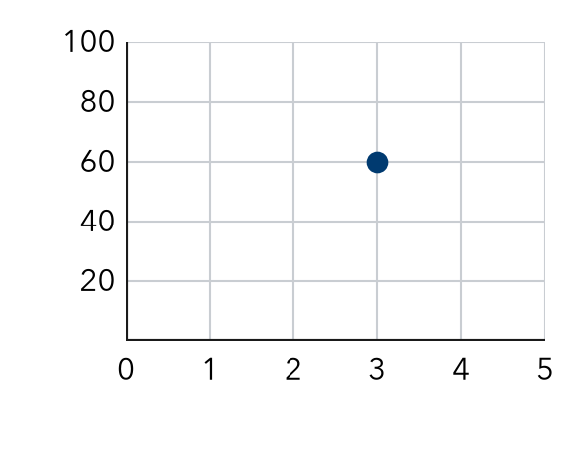

TRY IT WITH HELP fill in each step
4. Plot (2, 40). The y-axis counts by 10s.  Step 1 One space up is .  Step 2 Go across to .  Step 3 40 ÷ 10 = . Go up that many spaces.  5. Plot (4, 15). The y-axis counts by 3s.  Step 1 One space up is .  Step 2 Go across to .  Step 3 15 ÷ 3 = . Go up that many spaces. | 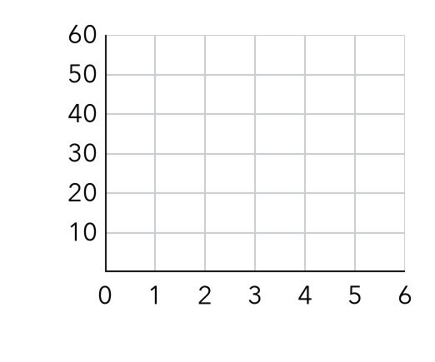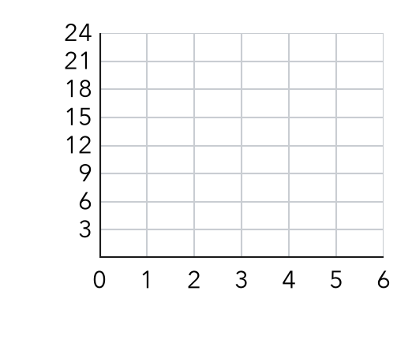  Problem 4 grid (left). Problem 5 grid (right).

YOUR TURN use the steps on your own

6. The y-axis counts by 5s. How many spaces up is each point?
a. (1, 10): | b. (3, 25): | c. (5, 35):
d. (6, 0):

READY CHECK a problem like the one in today’s lesson

7. The y-axis counts by 5s. How many spaces up is (6, 30)?
A 30 | B 5 | C 6 | D 25

CHECK YOURSELF | □ I can do this on my own | □ I need a little help | □ I have a question about #

