UNIT 2 · LESSON 5 STANDARD 6.DS.3

Describe Data by Range and Interquartile Range
Student Notes Packet
Name: ______________________ Date: ____________ Period: ________

Today's Goals
Content: I can describe the shape of a data distribution as symmetric, skewed, or having clusters and gaps.
Language: I can explain my description using the words symmetric, skewed, cluster, and gap.

Key Vocabulary
Look at the picture, read the word, then read what it means.
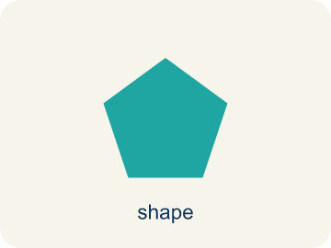 | Shape of Data Distributions Forma de las distribuciones de datos  The overall pattern of data, such as symmetric, skewed, clustered, or containing gaps.  Example: A long tail to the right means the distribution is skewed right.
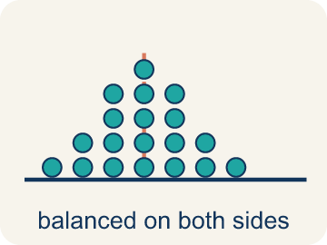 | Symmetric Simétrico  Data that looks about the same on the left and right.  Example: Heights: 60, 62, 64, 66, 68, 66, 64, 62, 60 — rises and falls evenly like a hill
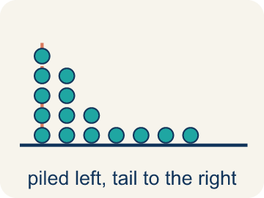 | Skewed Sesgado  When most data sits on one side with a tail on the other.  Example: Skewed right: most data low (1,2,2,3,3,3,15) — tail stretches toward the high value
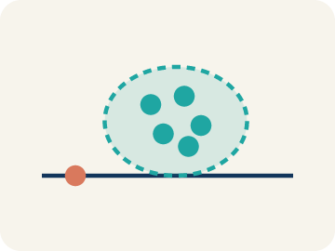 | Cluster Agrupamiento  A group of numbers that are close together.  Example: Scores 18, 19, 20, 21, 22 form a cluster around 20 — they are tightly grouped
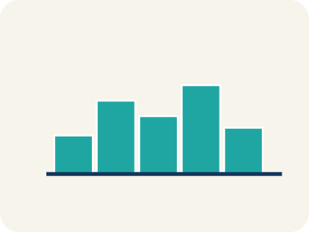 | Gap Hueco (espacio)  A big empty space where there is no data.  Example: Data: 5, 6, 7, 8, ___, ___, ___, 20 — the empty space from 9 to 19 is a gap
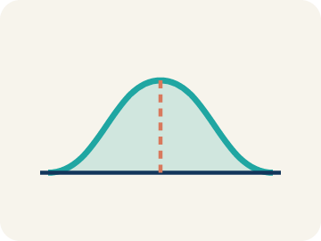 | Data distribution Distribución de datos  How the data looks: where it sits and how spread out it is.  Example: Looking at a dot plot or histogram, you can see if data is symmetric, skewed, clustered, or has gaps
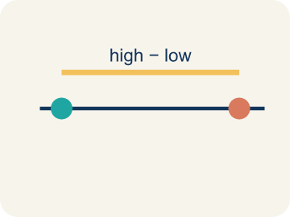 | Variability Variabilidad  How spread out the numbers are.  Example: Symmetric data with low variability: tightly packed around the center. Skewed data: spread unevenly

Guided Notes
Fill in each blank as we go. Use the Word Bank to help you.
WORD BANK
Shape of Data Distributions • Symmetric • Skewed • Cluster • Gap • Data distribution • Variability

1. __________ — The overall pattern of data, such as symmetric, skewed, clustered, or containing gaps.
2. A distribution where both sides look like mirror images is ___.
3. A distribution with a tail stretching out to one side is ___.
4. A group of data values bunched close together is a ___.
5. An interval where there are no data values is a ___.
6. The way data values are spread out across a range is the ___.
7. How much the values in a data set differ from one another is the ___.

Write About the Math
Use the support level you need. Every level answers the same math question.

1. Understand the Question describe
What is the shape of this distribution? Should the reporter use the mean or median to describe a 'typical' finish time?
Your job: Answer the question. Use math evidence. Explain how the evidence proves your answer.
Responde la pregunta. Usa evidencia matemática. Explica cómo la evidencia demuestra tu respuesta.

2. Plan Your Math Words check at least two
☐ Shape of Data Distributions — The overall pattern of data, such as symmetric, skewed, clustered, or containing gaps.
Forma de las distribuciones de datos — El patrón general de los datos, como simétrico, sesgado, agrupado o con espacios.
☐ Symmetric — Data that looks about the same on the left and right.
Simétrico — Datos que se ven casi iguales a la izquierda y a la derecha.
☐ Skewed — When most data sits on one side with a tail on the other.
Sesgado — Cuando la mayoría de los datos está de un lado con una cola del otro.
☐ Cluster — A group of numbers that are close together.
Agrupamiento — Un grupo de números que están cerca unos de otros.
☐ Gap — A big empty space where there is no data.
Hueco (espacio) — Un espacio grande y vacío donde no hay datos.
Say it first: Say your idea to a partner or quietly to yourself before you write.
The distribution is skewed ___ because the tail stretches toward the ___ finish times. There is a cluster around ___. The reporter should use the ___ because the ___ would be pulled toward the ___ by the extreme values.
Di tu respuesta primero: Mi respuesta es ___ porque ___.

3. Build Your Explanation choose your support
This model shows the parts of an explanation. It does not answer your writing question.
Claim: Different real-world data sets form different distribution shapes: symmetric, skewed, or clustered.
Evidence: Students explain different data produces different shapes and can describe symmetric (balanced) versus skewed (lopsided) distributions.
Reasoning: This evidence connects the definition of shape of data distributions to the mathematical claim.

Start Most language support
Complete the frames. Use the word bank.
Completa las oraciones. Usa el banco de palabras.
The distribution is skewed ___ because the tail stretches toward the ___ finish times. There is a cluster around ___. The reporter should use the ___ because the ___ would be pulled toward the ___ by the extreme values.
My answer is ___.
Mi respuesta es ___.

Build Some language support
Write two connected sentences. Use because, so, or but.
Escribe dos oraciones conectadas. Usa porque, entonces o pero.
My claim is ___.
Mi afirmación es ___.
I know because ___.
Lo sé porque ___.
So ___.
Entonces ___.

Explain Light language support
Write a claim, give math evidence, and explain your reasoning.
Escribe una afirmación, da evidencia matemática y explica tu razonamiento.
My claim is ___.
Mi afirmación es ___.
My math evidence is ___.
Mi evidencia matemática es ___.
This proves ___ because ___.
Esto demuestra ___ porque ___.

4. Check Your Explanation five quick checks
☐ I answered the question.
Respondí la pregunta.
☐ I used math evidence: numbers, an equation, a model, or a comparison.
Usé evidencia matemática: números, una ecuación, un modelo o una comparación.
☐ I explained how the evidence proves my answer.
Expliqué cómo la evidencia demuestra mi respuesta.
☐ I used at least two math words.
Usé por lo menos dos palabras matemáticas.
☐ I reread complete sentences and punctuation.
Volví a leer mis oraciones completas y la puntuación.

Worked Example

Watch & Read I Do — follow along with your teacher
Distribution Detective
The league analyst is studying three different data sets from the season: (1) Player heights across all teams, (2) Number of 3-pointers per game by each player, and (3) Years of experience for all coaches. Each data set has a different shape when graphed. Your job is to describe each shape and explain what it tells us about the data.

Think about:
• Do the three data sets look the same when graphed?
• Which graph has data bunched in the middle? Which has a long tail?
• Are there any gaps or clusters you can spot?
• Why would different sports data have different shapes?
• Does the shape tell you which measure of center to use?

Solved Example I Do — watch each step
Problem: A histogram of basketball players' ages shows: most players are 22–28, with a long tail of older players up to age 40. What is the shape of this distribution?
A) Skewed right
B) Symmetric
C) Skewed left
D) Uniform
Step 1: Most data is on the left (younger ages) with a tail stretching right (older ages).
Step 2: This is skewed right.
Answer: A. Skewed right

Guided Practice

Solve Together We Do — work with your class
Problem: A data set is symmetric. What is likely true about the mean and median?
A) They are approximately equal
B) The mean is much higher than the median
C) The median is much higher than the mean
D) They are always exactly the same
Step 1:

Step 2:

Answer:

A sports reporter is writing about marathon finish times. The histogram below shows the data: most runners finish between 3.5–4.5 hours, and a long tail of slower runners stretches out to 5–7 hours.
What is the shape of this distribution? Should the reporter use the mean or median to describe a 'typical' finish time?

Sentence frame: The distribution is skewed ___ because the tail stretches toward the ___ finish times. There is a cluster around ___. The reporter should use the ___ because the ___ would be pulled toward the ___ by the extreme values.

Turn & Talk discuss with a partner
1. [Launch] The analyst graphs player heights, 3-pointers per game, and coaches' years of experience. Why might each data set have a DIFFERENT shape when graphed?
Start with: The shapes are different because the data ___.
Las formas son diferentes porque los datos ___.
Word bank: symmetric, skewed, cluster, gap, distribution
2. [Explore] As you match each data description to its shape, how can you tell a symmetric distribution from a skewed one just by looking?
Start with: A symmetric distribution has data that is ___ on both sides.
Una distribución simétrica tiene datos ___ en ambos lados.
Word bank: symmetric, skewed, cluster, gap, tail
3. [Connect] Marathon times cluster at 3.5-4.5 hours, with a long tail of slower runners stretching out to 5-7 hours. What is the shape, and should the reporter use the mean or median for a 'typical' time?
Start with: This distribution is skewed to the ___ because of the long tail of ___.
Esta distribución está sesgada hacia la ___ por la cola larga de ___.
Word bank: symmetric, skewed, cluster, gap, distribution
4. [Reflect] A data set has most values clustered between 40-60 with a few at 90-100. What is the shape of the distribution, and which measure of center is best?
Start with: The shape is skewed to the ___ because of the values at ___.
La forma está sesgada hacia la ___ por los valores en ___.
Word bank: symmetric, skewed, cluster, gap, median
5. [Practice] During practice on Shape of Data Distributions, what strategy did you use when a problem felt tricky?
Start with: A symmetric distribution has data that is ___ on both sides.
Una distribución simétrica tiene datos ___ en ambos lados.
Word bank: Symmetric, Skewed, Cluster, Gap

Independent Practice

On Your Own You Do — show your work
Solve each problem. Show your thinking in the work box.

Level 1 Support extra scaffolding
1. Match each description with the correct distribution shape.
2. Which word describes the direction of the TAIL, not the peak?
A) Skew — the direction of the long tail tells you the skew direction
B) Skew — the direction of the peak tells you the skew direction
C) Skew — the direction the median points
D) Skew — the direction of the mode

On Level grade-level practice
3. A dot plot of goals scored per game shows: 0(5 dots), 1(7 dots), 2(4 dots), 3(2 dots), 4(1 dot). What is the shape?
A) Skewed right — most values at the low end with a tail to the right
B) Symmetric — equal on both sides
C) Skewed left — most values at the high end
D) Uniform — all bars the same height

4. Match the data shape with the best measure of center.

Exit Ticket
Answer on your own. This shows what you learned today.
★ A data set has most values clustered between 40–60, with a few values at 90–100. What is the shape of the distribution and which measure of center is best?
A) Skewed right; use median
B) Symmetric; use mean
C) Skewed left; use median
D) Uniform; use mean

Answer Key & Teacher Guide
Teacher reference — remove or fold back before distributing to students.

Guided Notes (Fill-in)
Notes 1: Shape of Data Distributions
Notes 2: Symmetric
Notes 3: Skewed
Notes 4: Cluster
Notes 5: Gap
Notes 6: Data distribution
Notes 7: Variability

Worked Notes (I Do / We Do)
I Do: A. Skewed right
We Do: A. They are approximately equal

Independent Practice
Watch for this mistake: A common mistake in Shape of Data Distributions is naming the skew by looking at where the TALLEST bar (the peak) sits, instead of looking at which way the TAIL stretches. For example, given bar heights 8, 5, 3, 1 (tall on the left, trailing off to the right), students often say "skewed left" because the peak is on the left — but the correct name is skewed right, because skew is always named for the direction the tail points, not the peak.

Level 1 Support
1. Answers vary. — Each description points to where the bulk of the data sits and which way the tail stretches: a tail to the right means skewed right, a tail to the left means skewed left, and balanced sides mean symmetric.
2. A) Skew — the direction of the long tail tells you the skew direction — The skew direction is named after the TAIL. If the tail stretches to the right, it is skewed right, even though the peak is on the left.

On Level
3. A) Skewed right — most values at the low end with a tail to the right — The data peaks at 0–1 goals and tails off toward 4. Most data is on the left with fewer values stretching right — this is skewed right.
4. Answers vary. — Shape decides which center is more trustworthy: in a symmetric distribution the mean and median agree, while a skewed one pulls the mean toward the tail, so the median stays closer to a typical value.

Exit Ticket
A) Skewed right; use median — The data clusters on the left (40–60) with a tail to the right (90–100). This is skewed right. The median is best because the mean would be pulled toward the high values.

Math Writing Criteria
The support level changes the amount of language scaffolding, not the mathematical expectation.
☐ I answered the question.
☐ I used math evidence: numbers, an equation, a model, or a comparison.
☐ I explained how the evidence proves my answer.
☐ I used at least two math words.
☐ I reread complete sentences and punctuation.

