UNIT 3 · LESSON 2 STANDARD 6.AT.2

Understand Rates and Unit Rates (Flagship)
Student Notes Packet
Name: ______________________ Date: ____________ Period: ________

Today's Goals
Content: I can find a unit rate to compare prices and decide the better buy.
Language: I can explain my choice using the words rate, unit rate, per, and better buy.

Key Vocabulary
Look at the picture, read the word, then read what it means.
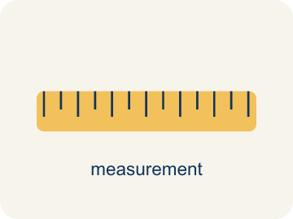 | Rates and Unit Rates Tasas y tasas unitarias  A rate compares different units; a unit rate compares a quantity to 1 unit.  Example: 180 miles in 3 hours = 60 miles per 1 hour.
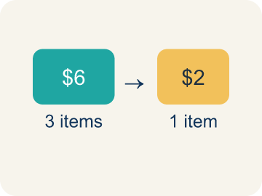 | Rate Tasa  A ratio comparing two amounts with different units, like miles per hour.  Example: $12 for 4 games is a rate
 | Unit Rate Tasa unitaria  A rate for just 1 of something, like cost for 1 item.  Example: $3 per 1 game
 | Per Por  For each one. Example: 5 dollars per book.  Example: 60 miles per hour means 60 miles for every 1 hour
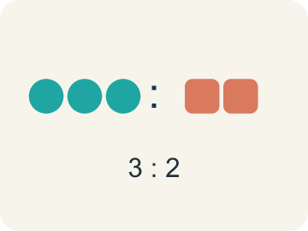 | Ratio Razón  A way to compare two amounts, like 3 to 2.  Example: 5 to 3 or 5:3
 | Better Buy Mejor compra  The choice that costs less for each item.  Example: Pack A: $0.50 per pencil vs Pack B: $0.40 per pencil — Pack B is the better buy
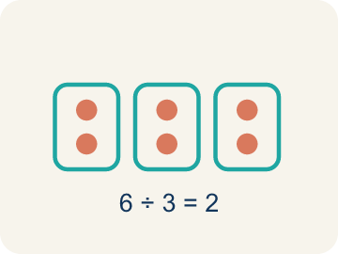 | Divide Dividir  Splitting a total into equal groups.  Example: $12 ÷ 4 games = $3 per game

Guided Notes
Fill in each blank as we go. Use the Word Bank to help you.
WORD BANK
Rates and Unit Rates • Rate • Unit Rate • Per • Ratio • Better Buy • Divide

1. __________ — A rate compares different units; a unit rate compares a quantity to 1 unit.
2. A ratio that compares two quantities with different units is a ___.
3. A rate that tells the cost or amount for one unit is a ___.
4. The word that means 'for each one' is ___.
5. A comparison of two quantities is a ___.
6. The option with the lower unit rate, costing less per item, is the ___.
7. To find a unit rate, I ___ the price by the number of units.

Write About the Math
Use the support level you need. Every level answers the same math question.

1. Understand the Question explain
Which size is the better deal, and how do you know?
Your job: Answer the question. Use math evidence. Explain how the evidence proves your answer.
Responde la pregunta. Usa evidencia matemática. Explica cómo la evidencia demuestra tu respuesta.

2. Plan Your Math Words check at least two
☐ Rates and Unit Rates — A rate compares different units; a unit rate compares a quantity to 1 unit.
Tasas y tasas unitarias — Una tasa compara unidades diferentes; una tasa unitaria compara una cantidad con 1 unidad.
☐ Rate — A ratio comparing two amounts with different units, like miles per hour.
Tasa — Una razón que compara dos cantidades con unidades distintas, como millas por hora.
☐ Unit Rate — A rate for just 1 of something, like cost for 1 item.
Tasa unitaria — Una tasa para solo 1 de algo, como el precio de 1 artículo.
☐ Per — For each one. Example: 5 dollars per book.
Por — Por cada uno. Ejemplo: 5 dólares por libro.
☐ Ratio — A way to compare two amounts, like 3 to 2.
Razón — Una manera de comparar dos cantidades, como 3 a 2.
Say it first: Say your idea to a partner or quietly to yourself before you write.
The ___ bag is the better deal because its unit rate is $___ per cup, which is ___ than $___ per cup for the other size.
Di tu respuesta primero: Mi respuesta es ___ porque ___.

3. Build Your Explanation choose your support
This model shows the parts of an explanation. It does not answer your writing question.
Claim: It is hard to compare because the booths have different numbers of games.
Evidence: Students notice the prices cannot be compared directly because the number of games differs, so they need the cost for one game (the unit rate) to compare fairly.
Reasoning: This evidence connects the definition of rates and unit rates to the mathematical claim.

Start Most language support
Complete the frames. Use the word bank.
Completa las oraciones. Usa el banco de palabras.
The ___ bag is the better deal because its unit rate is $___ per cup, which is ___ than $___ per cup for the other size.
My answer is ___.
Mi respuesta es ___.

Build Some language support
Write two connected sentences. Use because, so, or but.
Escribe dos oraciones conectadas. Usa porque, entonces o pero.
My claim is ___.
Mi afirmación es ___.
I know because ___.
Lo sé porque ___.
So ___.
Entonces ___.

Explain Light language support
Write a claim, give math evidence, and explain your reasoning.
Escribe una afirmación, da evidencia matemática y explica tu razonamiento.
My claim is ___.
Mi afirmación es ___.
My math evidence is ___.
Mi evidencia matemática es ___.
This proves ___ because ___.
Esto demuestra ___ porque ___.

4. Check Your Explanation five quick checks
☐ I answered the question.
Respondí la pregunta.
☐ I used math evidence: numbers, an equation, a model, or a comparison.
Usé evidencia matemática: números, una ecuación, un modelo o una comparación.
☐ I explained how the evidence proves my answer.
Expliqué cómo la evidencia demuestra mi respuesta.
☐ I used at least two math words.
Usé por lo menos dos palabras matemáticas.
☐ I reread complete sentences and punctuation.
Volví a leer mis oraciones completas y la puntuación.

Worked Example

Watch & Read I Do — follow along with your teacher
Arcade Builder Challenge
You're comparing ticket prices at different game booths in the arcade. Booth A charges $3 for 5 games, and Booth B charges $5 for 8 games. Which booth gives you a better deal? To find out, you need to figure out the cost per game — that's the unit rate!

Think about:
• What two quantities are being compared at each booth?
• Which booth seems like a better deal at first glance?
• How can you compare prices when the number of games is different?
• What does it mean to find the cost for just one game?

Solved Example I Do — watch each step
Problem: A booth charges $4.50 for 9 games. What is the unit rate?
A) $0.50 per game
B) $0.45 per game
C) $2.00 per game
D) $4.50 per game
Step 1: $4.50 ÷ 9 = $0.50 per game.
Answer: A. $0.50 per game

Guided Practice

Solve Together We Do — work with your class
Problem: A car travels 180 miles using 6 gallons of gas. What is the unit rate in miles per gallon?
A) 30 miles per gallon
B) 6 miles per gallon
C) 180 miles per gallon
D) 36 miles per gallon
Step 1:

Step 2:

Answer:

The arcade snack bar sells popcorn in two sizes: a small bag with 3 cups for $2.25 and a large bag with 8 cups for $5.60. You want the most popcorn for your money.
Which size is the better deal, and how do you know?

Sentence frame: The ___ bag is the better deal because its unit rate is $___ per cup, which is ___ than $___ per cup for the other size.

Turn & Talk discuss with a partner
1. [Launch] Booth A charges $3 for 5 games and Booth B charges $5 for 8 games. Just by looking, which booth seems like the better deal, and what makes it hard to be sure?
Start with: Booth ___ looks better because ___.
El puesto ___ se ve mejor porque ___.
Word bank: rate, per, ratio, compare
2. [Explore] How did you find the cost per game (the unit rate) for each booth, and what did you divide?
Start with: The unit rate is ___ per one ___.
La tasa unitaria es ___ por un ___.
Word bank: unit rate, divide, per, rate, cost
3. [Connect] The snack bar sells popcorn as 3 cups for $2.25 or 8 cups for $5.60. How do unit rates help you decide the better buy?
Start with: The ___ bag is the better buy because its unit rate is $___ per cup.
La bolsa ___ es la mejor compra porque su tasa unitaria es $___ por taza.
Word bank: unit rate, better buy, divide, per, cost
4. [Practice] During practice on Rates and Unit Rates, what strategy did you use when a problem felt tricky?
Start with: The unit rate is ___ per one ___.
La tasa unitaria es ___ por un ___.
Word bank: Rate, Unit Rate, Per, Ratio

Independent Practice

On Your Own You Do — show your work
Solve each problem. Show your thinking in the work box.

Level 1 Support extra scaffolding
1. A pack of 8 markers costs $6.00. What is the cost per marker?
A) $0.75
B) $0.80
C) $1.33
D) $0.60

2. Which is a unit rate?
A) 12 miles per 1 hour
B) 24 miles in 2 hours
C) 36 miles for 3 gallons
D) 100 points in 5 games

On Level grade-level practice
3. Which token pack from the table above is the best deal?
A) Pack A
B) Pack B
C) Pack C
D) They are all the same

4. Runner A completes 4 laps in 12 minutes. Runner B completes 5 laps in 14 minutes. Who runs more laps per minute?
A) Runner B
B) Runner A
C) Same rate
D) Cannot determine

Exit Ticket
Answer on your own. This shows what you learned today.
★ A store sells 6 pencils for $1.50 and 10 pencils for $2.80. Which is the better buy?
A) 6 for $1.50 — $0.25 each
B) 10 for $2.80 — $0.28 each
C) They cost the same per pencil
D) Not enough information

Answer Key & Teacher Guide
Teacher reference — remove or fold back before distributing to students.

Guided Notes (Fill-in)
Notes 1: Rates and Unit Rates
Notes 2: Rate
Notes 3: Unit Rate
Notes 4: Per
Notes 5: Ratio
Notes 6: Better Buy
Notes 7: Divide

Worked Notes (I Do / We Do)
I Do: A. $0.50 per game
We Do: A. 30 miles per gallon

Independent Practice
Watch for this mistake: A common mistake in Rates and Unit Rates is comparing total costs instead of unit rates: a student sees Pack X at $4.00 for 10 tokens and Pack Y at $6.00 for 16 tokens and picks Pack X just because $4.00 is the smaller number, without dividing to find the cost per token ($0.40 for Pack X vs. $0.375 for Pack Y — Pack Y is actually the better buy). A second common mistake is dividing backwards — finding tokens ÷ cost instead of cost ÷ tokens — which turns 'dollars per token' into 'tokens per dollar' and gives an answer that looks reasonable but answers the wrong question. Always divide the total cost by the number of items, and check that your unit rate answers 'the cost for ONE item,' not the reverse.

Level 1 Support
1. A) $0.75 — $6.00 ÷ 8 = $0.75 per marker.
2. A) 12 miles per 1 hour — A unit rate has 1 in the second quantity. '12 miles per 1 hour' is the only choice where the second quantity is 1.

On Level
3. B) Pack B — Pack B has a unit rate of $0.20 per token, which is the lowest cost per token.
4. A) Runner B — Runner A: 4÷12 ≈ 0.33 laps/min. Runner B: 5÷14 ≈ 0.36 laps/min. Runner B runs slightly more laps per minute.

Exit Ticket
A) 6 for $1.50 — $0.25 each — $1.50 ÷ 6 = $0.25 per pencil. $2.80 ÷ 10 = $0.28 per pencil. $0.25 < $0.28, so 6 for $1.50 is the better buy.

Math Writing Criteria
The support level changes the amount of language scaffolding, not the mathematical expectation.
☐ I answered the question.
☐ I used math evidence: numbers, an equation, a model, or a comparison.
☐ I explained how the evidence proves my answer.
☐ I used at least two math words.
☐ I reread complete sentences and punctuation.

