UNIT 6 · LESSON 4 STANDARD 6.AT.6C

Write and Evaluate Numerical Expressions with Exponents
Student Notes Packet
Name: ______________________ Date: ____________ Period: ________

Today's Goals
Content: I can evaluate algebraic expressions by substituting values for the variables.
Language: I can explain my steps using the words variable, expression, evaluate, and substitute.

Key Vocabulary
Look at the picture, read the word, then read what it means.
 | Evaluate Expressions Evaluar expresiones  Find the value of an expression by substituting numbers and following the order of operations.  Example: If x = 4, then 3x + 2 = 3(4) + 2 = 14.
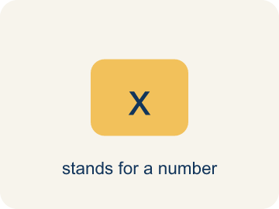 | Variable Variable  A letter that stands for a number that is unknown or can change.  Example: In 3x + 5, x can be any number — if x = 2, the expression equals 11; if x = 10, it equals 35
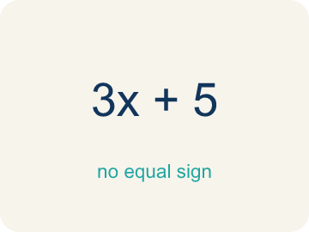 | Expression Expresión  A math phrase with numbers and letters, but no equal sign.  Example: 2n + 7 is an expression: the 2n means '2 times some number' and the + 7 means 'then add 7'
 | Evaluate Evaluar  To find the value by putting numbers in for the letters.  Example: Evaluate 2n + 7 when n = 4: replace n with 4 → 2(4) + 7 = 8 + 7 = 15
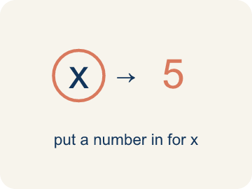 | Substitute Sustituir  To put a number in place of a letter.  Example: Substitute 3 for x in 5x: replace x with 3 → 5(3) = 15
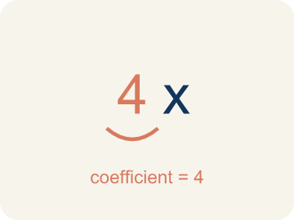 | Coefficient Coeficiente  The number in front of a letter, like the 3 in 3x.  Example: In 7m, the coefficient 7 tells you to multiply m by 7 — if m = 3, then 7m = 21
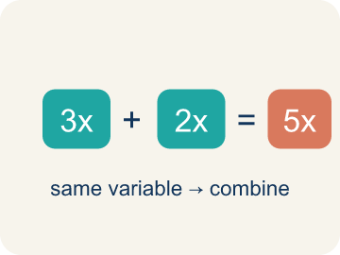 | Like terms Términos semejantes  Terms with the same letter raised to the same power, like 2x and 5x.  Example: 4x and 2x are like terms (both x¹); 4x and 4y are NOT (different variables)

Guided Notes
Fill in each blank as we go. Use the Word Bank to help you.
WORD BANK
Evaluate Expressions • Variable • Expression • Evaluate • Substitute • Coefficient • Like terms

1. __________ — Find the value of an expression by substituting numbers and following the order of operations.
2. A letter that stands for an unknown number, like x, is a ___.
3. A group of numbers, variables, and operations with no equal sign is an ___.
4. To find the value of an expression for given values is to ___ it.
5. To replace a variable with a number is to ___.
6. A number multiplied by a variable, like the 4 in 4y, is a ___.
7. Terms with the same variable part, like 2x and 6x, are ___.

Write About the Math
Use the support level you need. Every level answers the same math question.

1. Understand the Question explain
How much will the ride cost? How does the expression model this situation?
Your job: Answer the question. Use math evidence. Explain how the evidence proves your answer.
Responde la pregunta. Usa evidencia matemática. Explica cómo la evidencia demuestra tu respuesta.

2. Plan Your Math Words check at least two
☐ Evaluate Expressions — Find the value of an expression by substituting numbers and following the order of operations.
Evaluar expresiones — Hallar el valor de una expresión sustituyendo números y siguiendo el orden de las operaciones.
☐ Variable — A letter that stands for a number that is unknown or can change.
Variable — Una letra que representa un número desconocido o que puede cambiar.
☐ Expression — A math phrase with numbers and letters, but no equal sign.
Expresión — Una frase matemática con números y letras, pero sin signo igual.
☐ Evaluate — To find the value by putting numbers in for the letters.
Evaluar — Encontrar el valor poniendo números en lugar de las letras.
☐ Substitute — To put a number in place of a letter.
Sustituir — Poner un número en lugar de una letra.
Say it first: Say your idea to a partner or quietly to yourself before you write.
The ride costs $___ because 2.50 + 1.75(___) = ___. The 2.50 is the ___ and 1.75 is the ___.
Di tu respuesta primero: Mi respuesta es ___ porque ___.

3. Build Your Explanation choose your support
This model shows the parts of an explanation. It does not answer your writing question.
Claim: Substitute the number of speakers for s, then evaluate.
Evidence: Students substitute s = 5 (150 + 12 × 5 = 210), explain 150 is the fixed venue fee and 12 is the cost per speaker, and note s can be any number.
Reasoning: This evidence connects the definition of expression to the mathematical claim.

Start Most language support
Complete the frames. Use the word bank.
Completa las oraciones. Usa el banco de palabras.
The ride costs $___ because 2.50 + 1.75(___) = ___. The 2.50 is the ___ and 1.75 is the ___.
My answer is ___.
Mi respuesta es ___.

Build Some language support
Write two connected sentences. Use because, so, or but.
Escribe dos oraciones conectadas. Usa porque, entonces o pero.
My claim is ___.
Mi afirmación es ___.
I know because ___.
Lo sé porque ___.
So ___.
Entonces ___.

Explain Light language support
Write a claim, give math evidence, and explain your reasoning.
Escribe una afirmación, da evidencia matemática y explica tu razonamiento.
My claim is ___.
Mi afirmación es ___.
My math evidence is ___.
Mi evidencia matemática es ___.
This proves ___ because ___.
Esto demuestra ___ porque ___.

4. Check Your Explanation five quick checks
☐ I answered the question.
Respondí la pregunta.
☐ I used math evidence: numbers, an equation, a model, or a comparison.
Usé evidencia matemática: números, una ecuación, un modelo o una comparación.
☐ I explained how the evidence proves my answer.
Expliqué cómo la evidencia demuestra mi respuesta.
☐ I used at least two math words.
Usé por lo menos dos palabras matemáticas.
☐ I reread complete sentences and punctuation.
Volví a leer mis oraciones completas y la puntuación.

Worked Example

Watch & Read I Do — follow along with your teacher
Mix the Track
You're a music producer setting up a concert. The total cost of the event is given by the expression 150 + 12s, where s is the number of speakers rented. The venue charges $150 as a base fee, plus $12 for each speaker. How much will it cost for different numbers of speakers?

Think about:
• What does the 150 represent in the expression?
• What does the 12s represent?
• What happens to the total cost as s gets bigger?
• What if speakers cost $15 each instead?
• How many speakers can we afford with a $300 budget?

Solved Example I Do — watch each step
Problem: Evaluate 3x + 7 when x = 4.
A) 19
B) 34
C) 12
D) 14
Step 1: 3(4) + 7 = 12 + 7 = 19.
Answer: A. 19

Guided Practice

Solve Together We Do — work with your class
Problem: Evaluate 20 − 2n when n = 6.
A) 8
B) 14
C) 32
D) 12
Step 1:

Step 2:

Answer:

A rideshare app charges $2.50 plus $1.75 per mile. The expression for the fare is 2.50 + 1.75m, where m is miles traveled. Your friend lives 8 miles away.
How much will the ride cost? How does the expression model this situation?

Sentence frame: The ride costs $___ because 2.50 + 1.75(___) = ___. The 2.50 is the ___ and 1.75 is the ___.

Turn & Talk discuss with a partner
1. [Launch] The concert cost is 150 + 12s, where s is the number of speakers. How do you find the cost for 5 speakers, and why does this one expression work for any number of speakers?
Start with: I substitute s = 5 into 150 + 12s to get ___.
Sustituyo s = 5 en 150 + 12s para obtener ___.
Word bank: Variable, Expression, Evaluate, Substitute
2. [Explore] When you evaluate an expression like 4x² + 3, what order do you follow, and why must you square before you multiply?
Start with: First I substitute, then I do ___ because of the order of operations.
Primero sustituyo, luego hago ___ por el orden de las operaciones.
Word bank: Evaluate, Substitute, Expression, Variable
3. [Connect] The rideshare fare is 2.50 + 1.75m for m miles. How much is an 8-mile ride, and what does each part of the expression represent?
Start with: I substitute m = 8: 2.50 + 1.75 × ___ = ___.
Sustituyo m = 8: 2.50 + 1.75 × ___ = ___.
Word bank: Substitute, Variable, Evaluate, Expression
4. [Practice] During practice on Evaluate Expressions, what strategy did you use when a problem felt tricky?
Start with: First I substitute, then I do ___ because of the order of operations.
Primero sustituyo, luego hago ___ por el orden de las operaciones.
Word bank: Variable, Expression, Evaluate, Substitute

Independent Practice

On Your Own You Do — show your work
Solve each problem. Show your thinking in the work box.

Level 1 Support extra scaffolding
1. Which expression means '5 less than twice a number n'?
A) 2n − 5
B) 5 − 2n
C) 2(n − 5)
D) 2 − 5n

2. Evaluate 4m + 1 when m = 5.
A) 21
B) 20
C) 9
D) 25

Exit Ticket
Answer on your own. This shows what you learned today.
★ Evaluate 5(n − 3) + 2 when n = 7.
A) 22
B) 34
C) 20
D) 18

Answer Key & Teacher Guide
Teacher reference — remove or fold back before distributing to students.

Guided Notes (Fill-in)
Notes 1: Evaluate Expressions
Notes 2: Variable
Notes 3: Expression
Notes 4: Evaluate
Notes 5: Substitute
Notes 6: Coefficient
Notes 7: Like terms

Worked Notes (I Do / We Do)
I Do: A. 19
We Do: A. 8

Independent Practice
Watch for this mistake: A common mistake in Evaluate Expressions is treating a coefficient like an addend instead of a factor — for example, evaluating 3x + 7 when x = 4 as 3 + 4 + 7 = 14 instead of the correct 3(4) + 7 = 12 + 7 = 19. A number written right next to a variable always means multiply, never add. Before you submit, ask: "Did I multiply the coefficient by the value I substituted, or did I accidentally add it?"

Level 1 Support
1. A) 2n − 5 — Twice n is 2n. Five less than that is 2n − 5.
2. A) 21 — 4(5) + 1 = 20 + 1 = 21.

Exit Ticket
A) 22 — Do the parentheses first: 7 − 3 = 4. Then multiply: 5 × 4 = 20. Then add: 20 + 2 = 22. (If you got 34, you multiplied 5 × 7 first and ignored the parentheses instead of subtracting 3 before multiplying. If you got 20, you found 5(7 − 3) correctly but forgot to add the 2 at the end. If you got 18, you subtracted 2 instead of adding it.)

Math Writing Criteria
The support level changes the amount of language scaffolding, not the mathematical expectation.
☐ I answered the question.
☐ I used math evidence: numbers, an equation, a model, or a comparison.
☐ I explained how the evidence proves my answer.
☐ I used at least two math words.
☐ I reread complete sentences and punctuation.

