UNIT 6 · LESSON 7 STANDARD 6.NOS.4

Find Factors and Multiples
Student Notes Packet
Name: ______________________ Date: ____________ Period: ________

Today's Goals
Content: I can find the greatest common factor (GCF) of two numbers by listing or comparing their factors.
Language: I can explain how I found the GCF using the words factor, common factor, divisible, and greatest common factor.

Key Vocabulary
Look at the picture, read the word, then read what it means.
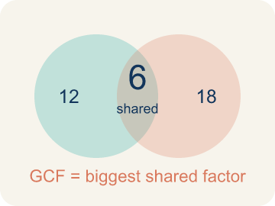 | Greatest Common Factor Máximo común divisor  The greatest whole number that divides two or more numbers with no remainder.  Example: Factors shared by 12 and 18 are 1, 2, 3, and 6, so GCF = 6.
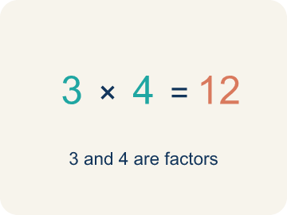 | Factor Factor  A factor of a whole number divides it evenly, with no remainder. For example, 3 is a factor of 12 because 12 ÷ 3 = 4.  Example: Factors of 12: 1, 2, 3, 4, 6, 12 — each divides 12 with no remainder
 | Common factor Factor común  A number that divides two or more numbers evenly.  Example: 8 and 12 both divide evenly by 1, 2, and 4 — those are their common factors
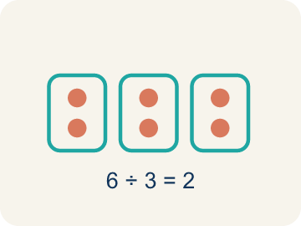 | Divisible Divisible  A number you can divide evenly, with nothing left over.  Example: 15 ÷ 3 = 5 with no remainder, so 15 is divisible by 3
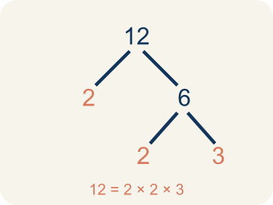 | Prime factorization Factorización prima  Writing a number as prime numbers multiplied together. It helps you find the GCF.  Example: 12 = 2 × 2 × 3 and 18 = 2 × 3 × 3. Shared primes: 2 × 3 = 6 = GCF

Guided Notes
Fill in each blank as we go. Use the Word Bank to help you.
WORD BANK
Greatest Common Factor • Factor • Common factor • Divisible • Prime factorization

1. __________ — The greatest whole number that divides two or more numbers with no remainder.
2. A number that divides evenly into another number with no remainder is a ___.
3. A factor that two or more numbers share is a ___ factor.
4. A number that can be divided by another with no remainder is ___ by that number.
5. __________ — Writing a number as prime numbers multiplied together. It helps you find the GCF.

Write About the Math
Use the support level you need. Every level answers the same math question.

1. Understand the Question explain
How does the GCF help the baker? How many boxes can she make?
Your job: Answer the question. Use math evidence. Explain how the evidence proves your answer.
Responde la pregunta. Usa evidencia matemática. Explica cómo la evidencia demuestra tu respuesta.

2. Plan Your Math Words check at least two
☐ Greatest Common Factor — The greatest whole number that divides two or more numbers with no remainder.
Máximo común divisor — El mayor número entero que divide dos o más números sin dejar residuo.
☐ Factor — A factor of a whole number divides it evenly, with no remainder. For example, 3 is a factor of 12 because 12 ÷ 3 = 4.
Factor — Un factor de un número entero lo divide exactamente, sin dejar residuo. Por ejemplo, 3 es un factor de 12 porque 12 ÷ 3 = 4.
☐ Common factor — A number that divides two or more numbers evenly.
Factor común — Un número que divide a dos o más números sin que sobre nada.
☐ Divisible — A number you can divide evenly, with nothing left over.
Divisible — Un número que se puede dividir sin que sobre nada.
☐ Prime factorization — Writing a number as prime numbers multiplied together. It helps you find the GCF.
Factorización prima — Escribir un número como números primos multiplicados. Ayuda a encontrar el MCD.
Say it first: Say your idea to a partner or quietly to yourself before you write.
The baker can make ___ boxes because the GCF of 48 and 32 is ___.
Di tu respuesta primero: Mi respuesta es ___ porque ___.

3. Build Your Explanation choose your support
This model shows the parts of an explanation. It does not answer your writing question.
Claim: The number of pods must divide BOTH 24 and 36 evenly.
Evidence: Students see the number of pods has to be a common factor of 24 and 36, so it must divide both with nothing left over, ruling out numbers that only divide one of them.
Reasoning: This evidence connects the definition of factor to the mathematical claim.

Start Most language support
Complete the frames. Use the word bank.
Completa las oraciones. Usa el banco de palabras.
The baker can make ___ boxes because the GCF of 48 and 32 is ___.
My answer is ___.
Mi respuesta es ___.

Build Some language support
Write two connected sentences. Use because, so, or but.
Escribe dos oraciones conectadas. Usa porque, entonces o pero.
My claim is ___.
Mi afirmación es ___.
I know because ___.
Lo sé porque ___.
So ___.
Entonces ___.

Explain Light language support
Write a claim, give math evidence, and explain your reasoning.
Escribe una afirmación, da evidencia matemática y explica tu razonamiento.
My claim is ___.
Mi afirmación es ___.
My math evidence is ___.
Mi evidencia matemática es ___.
This proves ___ because ___.
Esto demuestra ___ porque ___.

4. Check Your Explanation five quick checks
☐ I answered the question.
Respondí la pregunta.
☐ I used math evidence: numbers, an equation, a model, or a comparison.
Usé evidencia matemática: números, una ecuación, un modelo o una comparación.
☐ I explained how the evidence proves my answer.
Expliqué cómo la evidencia demuestra mi respuesta.
☐ I used at least two math words.
Usé por lo menos dos palabras matemáticas.
☐ I reread complete sentences and punctuation.
Volví a leer mis oraciones completas y la puntuación.

Worked Example

Watch & Read I Do — follow along with your teacher
Space Station Supply Sort
Mission Control needs to organize 24 food packs and 36 water containers into equal groups for the crew pods. Each pod must get the same number of food packs AND the same number of water containers. What is the largest number of pods they can fill equally?

Think about:
• What two quantities need to be divided equally?
• What numbers could divide into both 24 and 36?
• What's the biggest number of equal groups we can make?
• What if we had 24 food packs and 40 water containers instead?

Solved Example I Do — watch each step
Problem: What is the GCF of 8 and 12?
A) 4
B) 2
C) 8
D) 24
Step 1: Factors of 8: 1, 2, 4, 8.
Step 2: Factors of 12: 1, 2, 3, 4, 6, 12.
Step 3: The largest common factor is 4.
Answer: A. 4

Guided Practice

Solve Together We Do — work with your class
Problem: Which pair of numbers has a GCF of 5?
A) 15 and 25
B) 10 and 12
C) 6 and 15
D) 8 and 20
Step 1:

Step 2:

Step 3:

Answer:

A baker is making gift boxes with cookies and brownies. She has 48 cookies and 32 brownies. She wants every box to have the same number of cookies and the same number of brownies, with none left over.
How does the GCF help the baker? How many boxes can she make?

Sentence frame: The baker can make ___ boxes because the GCF of 48 and 32 is ___.

Turn & Talk discuss with a partner
1. [Launch] Mission Control must split 24 food packs and 36 water containers into equal crew pods, with each pod getting the same of each. Why won't the answer just be 24 or 36?
Start with: The number of pods must be a factor of both ___ and ___.
El número de cápsulas debe ser un factor de ___ y de ___.
Word bank: factor, common factor, divisible, greatest common factor, equal groups
2. [Explore] How did you find the factors that 24 and 36 share, and how did you decide which one is the GCF?
Start with: The common factors are ___.
Los factores comunes son ___.
Word bank: factor, common factor, greatest common factor, divisible, prime factorization
3. [Connect] A florist has 18 roses and 24 tulips and wants identical bouquets with no flowers left over. How does the GCF tell her the most bouquets she can make?
Start with: The florist can make ___ bouquets because the GCF of 18 and 24 is ___.
La florista puede hacer ___ ramos porque el MCD de 18 y 24 es ___.
Word bank: greatest common factor, factor, divide, equal, remainder
4. [Reflect] How is the greatest common factor different from the least common multiple, and how can you tell which one a problem needs?
Start with: The GCF is the largest number that ___, but the LCM is the smallest number that ___.
El MCD es el número más grande que ___, pero el mcm es el número más pequeño que ___.
Word bank: greatest common factor, common factor, divisible, factor, equal groups
5. [Practice] During practice on Greatest Common Factor, what strategy did you use when a problem felt tricky?
Start with: The common factors are ___.
Los factores comunes son ___.
Word bank: Factor, Greatest Common Factor, Common factor, Divisible

Independent Practice

On Your Own You Do — show your work
Solve each problem. Show your thinking in the work box.

Level 1 Support extra scaffolding
1. What is the GCF of 14 and 21?
A) 7
B) 14
C) 3
D) 1

2. What is the GCF of 9 and 15?
A) 3
B) 1
C) 9
D) 45

On Level grade-level practice
3. A teacher has 36 pencils and 48 erasers. She wants to make identical supply bags with no items left over. What is the greatest number of bags she can make?
A) 12 bags
B) 6 bags
C) 4 bags
D) 36 bags

Exit Ticket
Answer on your own. This shows what you learned today.
★ What is the GCF of 18 and 27?
A) 9
B) 3
C) 6
D) 18

