UNIT 7 · LESSON 7 STANDARD 6.NOS.9

Represent Polygons on the Coordinate Plane
Student Notes Packet
Name: ______________________ Date: ____________ Period: ________

Today's Goals
Content: I can draw polygons from their vertex coordinates on the coordinate plane, and use coordinates to find side lengths and solve perimeter and area problems.
Language: I can explain how I found a distance using the words vertices, coordinates, and absolute value.

Key Vocabulary
Look at the picture, read the word, then read what it means.
 | vertex vértice  A corner point of a polygon, named by an ordered pair on the coordinate plane.
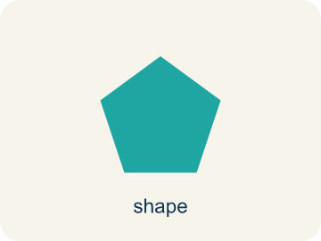 | polygon polígono  A closed figure made of line segments; on the plane you draw it by plotting the vertices and connecting them in order.
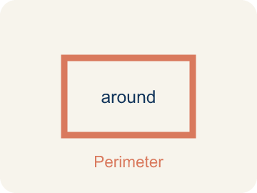 | perimeter perímetro  The total distance around a polygon — the sum of all its side lengths.
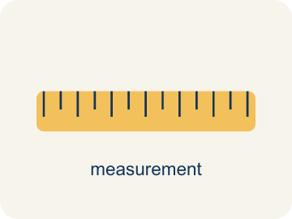 | distance between vertices distancia entre vértices  When two vertices share an x- or y-coordinate, the distance between them is the absolute difference of the other coordinates.
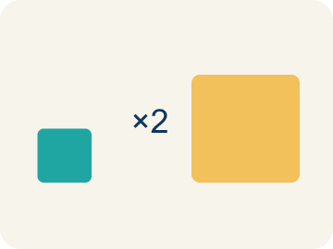 | scale escala  What one grid unit stands for in the real situation.

Guided Notes
Fill in each blank as we go. Use the Word Bank to help you.
WORD BANK
vertex • polygon • perimeter • distance between vertices • scale

1. __________ — A corner point of a polygon, named by an ordered pair on the coordinate plane.
2. __________ — A closed figure made of line segments; on the plane you draw it by plotting the vertices and connecting them in order.
3. __________ — The total distance around a polygon — the sum of all its side lengths.
4. __________ — When two vertices share an x- or y-coordinate, the distance between them is the absolute difference of the other coordinates.
5. __________ — What one grid unit stands for in the real situation.

Write About the Math
Use the support level you need. Every level answers the same math question.

1. Understand the Question explain
Where do the other two vertices go — and how do the known coordinates, the scale, and the area work together to tell you?
Your job: Answer the question. Use math evidence. Explain how the evidence proves your answer.
Responde la pregunta. Usa evidencia matemática. Explica cómo la evidencia demuestra tu respuesta.

2. Plan Your Math Words check at least two
☐ vertex — A corner point of a polygon, named by an ordered pair on the coordinate plane.
vértice — Un punto de esquina de un polígono, nombrado por un par ordenado en el plano de coordenadas.
☐ polygon — A closed figure made of line segments; on the plane you draw it by plotting the vertices and connecting them in order.
polígono — Una figura cerrada hecha de segmentos; en el plano se dibuja marcando los vértices y conectándolos en orden.
☐ perimeter — The total distance around a polygon — the sum of all its side lengths.
perímetro — La distancia total alrededor de un polígono: la suma de todos sus lados.
☐ distance between vertices — When two vertices share an x- or y-coordinate, the distance between them is the absolute difference of the other coordinates.
distancia entre vértices — Cuando dos vértices comparten una coordenada x o y, la distancia es la diferencia absoluta de las otras coordenadas.
☐ scale — What one grid unit stands for in the real situation.
escala — Lo que representa una unidad de la cuadrícula en la situación real.
Say it first: Say your idea to a partner or quietly to yourself before you write.
The park's width is ___ feet. Using the area formula, its length is ___ feet, which is ___ units on the map — so the new vertices sit that many units below the known ones.
Di tu respuesta primero: Mi respuesta es ___ porque ___.

3. Build Your Explanation choose your support
This model shows the parts of an explanation. It does not answer your writing question.
Claim: When two vertices share the same y-coordinate, the segment between them is horizontal, so its length comes from the DIFFERENCE in the coordinate that changes — the x-coordinates.
Evidence: A strong answer explains that the SHARED coordinate tells you the direction of the side, and the DIFFERING coordinate is what you subtract. A weak answer just says 'subtract the numbers' without identifying which pair.
Reasoning: This evidence connects the definition of polygon to the mathematical claim.

Start Most language support
Complete the frames. Use the word bank.
Completa las oraciones. Usa el banco de palabras.
The park's width is ___ feet. Using the area formula, its length is ___ feet, which is ___ units on the map — so the new vertices sit that many units below the known ones.
My answer is ___.
Mi respuesta es ___.

Build Some language support
Write two connected sentences. Use because, so, or but.
Escribe dos oraciones conectadas. Usa porque, entonces o pero.
My claim is ___.
Mi afirmación es ___.
I know because ___.
Lo sé porque ___.
So ___.
Entonces ___.

Explain Light language support
Write a claim, give math evidence, and explain your reasoning.
Escribe una afirmación, da evidencia matemática y explica tu razonamiento.
My claim is ___.
Mi afirmación es ___.
My math evidence is ___.
Mi evidencia matemática es ___.
This proves ___ because ___.
Esto demuestra ___ porque ___.

4. Check Your Explanation five quick checks
☐ I answered the question.
Respondí la pregunta.
☐ I used math evidence: numbers, an equation, a model, or a comparison.
Usé evidencia matemática: números, una ecuación, un modelo o una comparación.
☐ I explained how the evidence proves my answer.
Expliqué cómo la evidencia demuestra mi respuesta.
☐ I used at least two math words.
Usé por lo menos dos palabras matemáticas.
☐ I reread complete sentences and punctuation.
Volví a leer mis oraciones completas y la puntuación.

Worked Example

Watch & Read I Do — follow along with your teacher
Unit 7 · Lesson 7
A polygon's vertices are given as coordinates: (-4.5, 3), (5, 3), (5, -3.75), and (-4.5, -3.75). What is its perimeter?

Solved Example I Do — watch each step
Problem: Vertices (-4.5, 3) and (5, 3) share y = 3. What is the distance between them?
A) 9.5 units
B) 0.5 units
C) 8 units
D) 1.5 units
Step 1: They differ only in x: |5 − (−4.5)| = 5 + 4.5 = 9.5 units.
Answer: A. 9.5 units

Guided Practice

Solve Together We Do — work with your class
Problem: Vertices (5, 3) and (5, -3.75) share x = 5. What is the distance between them?
A) 6.75 units
B) 0.75 units
C) 5 units
D) 8.75 units
Step 1:

Step 2:

Answer:

Designing the Town Square: a rectangular park will have an area of 240,000 square feet. Two vertices are already marked on the planning grid, 3 units apart, and each grid unit represents 100 feet.
Where do the other two vertices go — and how do the known coordinates, the scale, and the area work together to tell you?

Sentence frame: The park's width is ___ feet. Using the area formula, its length is ___ feet, which is ___ units on the map — so the new vertices sit that many units below the known ones.

Turn & Talk discuss with a partner
1. [Launch] The vertices (-4.5, 3) and (5, 3) share y = 3, so the side between them is horizontal, with length |5 − (−4.5)| = 9.5. Why is that side's length found by comparing the x-coordinates instead of the y-coordinates?
Start with: The side is horizontal because both vertices share the same ___-coordinate.
El lado es horizontal porque ambos vértices comparten la misma coordenada ___.
Word bank: vertex, coordinates, distance between vertices
2. [Explore] You sorted pairs of vertices into 'subtract coordinates' versus 'slanted.' How did you decide that (0, 0) and (4, 3) belonged in the slanted group?
Start with: (0, 0) and (4, 3) are slanted because they don't share the same ___ or the same ___.
(0, 0) y (4, 3) están inclinados porque no comparten la misma ___ ni la misma ___.
Word bank: vertex, coordinates, distance between vertices
3. [Connect] The Town Square park's two known vertices are 3 units apart, and each unit represents 100 feet, so the width is 300 feet. The park's area must be 240,000 square feet. How do you use that to find how many units below the known vertices the missing vertices go?
Start with: The length is 240,000 ÷ ___ = ___ feet.
La longitud es 240,000 ÷ ___ = ___ pies.
Word bank: scale, area, vertex
4. [Practice] Look back at a problem where you found the perimeter of a rectangle from its vertices. What were your steps from the coordinates to the final perimeter?
Start with: First I found the width using vertices ___ and ___, which gave ___ units.
Primero encontré el ancho usando los vértices ___ y ___, lo cual dio ___ unidades.
Word bank: perimeter, distance between vertices, vertex

Independent Practice

On Your Own You Do — show your work
Solve each problem. Show your thinking in the work box.

Level 1 Support extra scaffolding
1. What is the perimeter of the rectangle with side lengths 9.5 and 6.75 units?
A) 32.5 units
B) 16.25 units
C) 64.125 units
D) 26 units

2. Why are two of the terms multiplied by 2 in the perimeter calculation?
A) A rectangle's opposite sides are equal, so each length appears on two sides
B) Because perimeter always doubles the area
C) Because there are two coordinates in each ordered pair
D) It is a rounding rule

3. To draw a polygon from a list of vertices, you:
A) Plot each ordered pair, then connect them in order with segments
B) Plot only the first vertex
C) Connect the points in any random order
D) Add all the coordinates together

4. A square has vertices (1, 2), (6, 2), (6, -3), (1, -3). Find one side length and the perimeter.

On Level grade-level practice
5. The park's marked vertices are 3 units apart and each unit is 100 feet. What is the park's width?
A) 300 feet
B) 3 feet
C) 103 feet
D) 30 feet

6. The park's area must be 240,000 sq ft and its width is 300 ft. What is its length?
A) 800 feet
B) 80,000 feet
C) 720 feet
D) 240,300 feet

Exit Ticket
Answer on your own. This shows what you learned today.
★ A rectangle has vertices (-1, 4), (5, 4), (5, 1), (-1, 1). What is its perimeter?
A) 18 units
B) 9 units
C) 6 units
D) 18 square units

Answer Key & Teacher Guide
Teacher reference — remove or fold back before distributing to students.

Guided Notes (Fill-in)
Notes 1: vertex
Notes 2: polygon
Notes 3: perimeter
Notes 4: distance between vertices
Notes 5: scale

Worked Notes (I Do / We Do)
I Do: A. 9.5 units
We Do: A. 6.75 units

Independent Practice
Watch for this mistake: Subtracting coordinates without the absolute value — from y = 3 down to y = −3.75 the distance is 3 + 3.75 = 6.75 units, not 3.75 − 3 = 0.75. Distances that cross zero are the whole reason the absolute value is there.

Level 1 Support
1. A) 32.5 units — Perimeter = 2(9.5) + 2(6.75) = 19 + 13.5 = 32.5 units.
2. A) A rectangle's opposite sides are equal, so each length appears on two sides — The two 9.5 sides and the two 6.75 sides each come in pairs — that is what the 2 counts.
3. A) Plot each ordered pair, then connect them in order with segments — Graph the points on the plane and connect them in order — the closed figure that appears is the polygon.
4. Answers vary.

On Level
5. A) 300 feet — 3 units × 100 feet per unit = 300 feet.
6. A) 800 feet — Length = area ÷ width = 240,000 ÷ 300 = 800 feet.

Exit Ticket
A) 18 units — Width |5 − (−1)| = 6, height |4 − 1| = 3. Perimeter = 2(6) + 2(3) = 18 units.

Math Writing Criteria
The support level changes the amount of language scaffolding, not the mathematical expectation.
☐ I answered the question.
☐ I used math evidence: numbers, an equation, a model, or a comparison.
☐ I explained how the evidence proves my answer.
☐ I used at least two math words.
☐ I reread complete sentences and punctuation.

