UNIT 8 · LESSON 6 STANDARD 6.AT.8

Solve and Graph Inequalities
Student Notes Packet
Name: ______________________ Date: ____________ Period: ________

Today's Goals
Content: I can solve an inequality and graph its solution set on a number line.
Language: I can explain my work using the words solve, graph, solution, and substitute.

Key Vocabulary
Look at the picture, read the word, then read what it means.
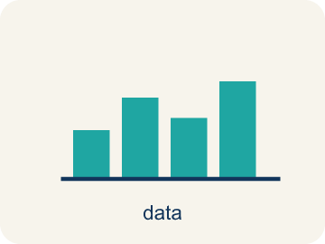 | Solve and Graph Inequalities Resolver y representar desigualdades  Isolate the variable, then show the complete solution set on a number line.  Example: x + 2 ≤ 7 → x ≤ 5; closed circle at 5, arrow left.
 | Solve Resolver  To find the number that makes it true.  Example: x + 3 > 10 → subtract 3 → x > 7 — any number greater than 7 works
 | Graph Graficar  To show answers on a number line with circles and shading.  Example: x > 7: open circle at 7, shade right — shows all solutions at a glance
 | Solution Solución  A number that makes the equation or inequality true.  Example: x = 8 is a solution to x > 7 because 8 > 7 is true; x = 5 is not because 5 > 7 is false
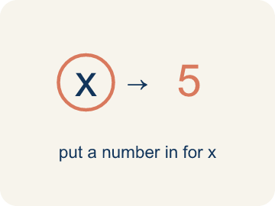 | Substitute Sustituir  To put a number in place of a letter.  Example: Substitute x = 5 into x + 3 > 10: 5 + 3 = 8, and 8 > 10 is false, so x = 5 is not a solution
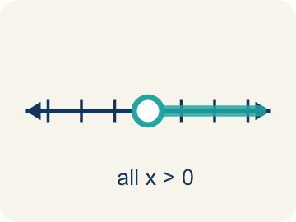 | Solution set Conjunto solución  All the numbers that make the inequality true.  Example: For x > 4, the solution set is every number greater than 4, such as 5, 6, 7, ...
 | Inverse operation Operación inversa  Two math actions that undo each other, like × and ÷.  Example: To solve x + 3 > 7, use the inverse of adding 3: subtract 3 to get x > 4.

Guided Notes
Fill in each blank as we go. Use the Word Bank to help you.
WORD BANK
Solve and Graph Inequalities • Solve • Graph • Solution • Substitute • Solution set • Inverse operation

1. __________ — Isolate the variable, then show the complete solution set on a number line.
2. To find all the values that make an inequality true is to ___ it.
3. To show the solutions on a number line is to ___ them.
4. A value that makes an inequality true is a ___.
5. To check a solution, I ___ the value back into the inequality.
6. All the values that make an inequality true form the ___.
7. An operation that undoes another to isolate the variable is an ___.

Write About the Math
Use the support level you need. Every level answers the same math question.

1. Understand the Question explain
How much more does the detective need? How did you solve and graph this inequality?
Your job: Answer the question. Use math evidence. Explain how the evidence proves your answer.
Responde la pregunta. Usa evidencia matemática. Explica cómo la evidencia demuestra tu respuesta.

2. Plan Your Math Words check at least two
☐ Solve and Graph Inequalities — Isolate the variable, then show the complete solution set on a number line.
Resolver y representar desigualdades — Aislar la variable y luego mostrar el conjunto completo de soluciones en una recta numérica.
☐ Solve — To find the number that makes it true.
Resolver — Encontrar el número que la hace verdadera.
☐ Graph — To show answers on a number line with circles and shading.
Graficar — Mostrar respuestas en una recta numérica con círculos y sombreado.
☐ Solution — A number that makes the equation or inequality true.
Solución — Un número que hace verdadera la ecuación o desigualdad.
☐ Substitute — To put a number in place of a letter.
Sustituir — Poner un número en lugar de una letra.
Say it first: Say your idea to a partner or quietly to yourself before you write.
The detective needs at least $__ more because 48 + s ≥ 75 means s ≥ 75 − ___ = ___.
Di tu respuesta primero: Mi respuesta es ___ porque ___.

3. Build Your Explanation choose your support
This model shows the parts of an explanation. It does not answer your writing question.
Claim: Solving an inequality gives a range of solutions, not one number.
Evidence: Students note both use inverse operations to isolate the variable, but an inequality's solution is many values (a range) while an equation's is a single value.
Reasoning: This evidence connects the definition of solve and graph inequalities to the mathematical claim.

Start Most language support
Complete the frames. Use the word bank.
Completa las oraciones. Usa el banco de palabras.
The detective needs at least $__ more because 48 + s ≥ 75 means s ≥ 75 − ___ = ___.
My answer is ___.
Mi respuesta es ___.

Build Some language support
Write two connected sentences. Use because, so, or but.
Escribe dos oraciones conectadas. Usa porque, entonces o pero.
My claim is ___.
Mi afirmación es ___.
I know because ___.
Lo sé porque ___.
So ___.
Entonces ___.

Explain Light language support
Write a claim, give math evidence, and explain your reasoning.
Escribe una afirmación, da evidencia matemática y explica tu razonamiento.
My claim is ___.
Mi afirmación es ___.
My math evidence is ___.
Mi evidencia matemática es ___.
This proves ___ because ___.
Esto demuestra ___ porque ___.

4. Check Your Explanation five quick checks
☐ I answered the question.
Respondí la pregunta.
☐ I used math evidence: numbers, an equation, a model, or a comparison.
Usé evidencia matemática: números, una ecuación, un modelo o una comparación.
☐ I explained how the evidence proves my answer.
Expliqué cómo la evidencia demuestra mi respuesta.
☐ I used at least two math words.
Usé por lo menos dos palabras matemáticas.
☐ I reread complete sentences and punctuation.
Volví a leer mis oraciones completas y la puntuación.

Worked Example

Watch & Read I Do — follow along with your teacher
Case File: Solve and Map It
Detective Kim knows that the suspect withdrew more than $50 from an ATM. The amount plus a $3 fee totaled more than $53. She writes x + 3 > 53 and needs to solve for x, then graph the solution set to share with the bank. How can she find and display all possible withdrawal amounts?

Think about:
• What is the unknown in this situation?
• What operation do you need to undo?
• Will the answer be one number or many numbers?
• What if the total was at most $53 instead of more than $53?
• How would the graph change if the symbol were ≥ instead of >?

Solved Example I Do — watch each step
Problem: Solve: x + 6 > 14
A) x > 8
B) x > 20
C) x < 8
D) x = 8
Step 1: Subtract 6 from both sides: x > 14 − 6 = 8.
Step 2: Graph: open circle at 8, shade right.
Answer: A. x > 8

Guided Practice

Solve Together We Do — work with your class
Problem: Solve: x − 9 ≤ 3
A) x ≤ 12
B) x ≤ 6
C) x ≥ 12
D) x = 12
Step 1:

Step 2:

Answer:

A detective needs at least $75 for a surveillance camera. She has already saved $48. The inequality 48 + s ≥ 75 represents how much more money s she needs.
How much more does the detective need? How did you solve and graph this inequality?

Sentence frame: The detective needs at least $__ more because 48 + s ≥ 75 means s ≥ 75 − ___ = ___.

Turn & Talk discuss with a partner
1. [Launch] Solving an inequality and solving an equation both isolate the variable. What is the same about your steps, and what is different about the answer you get?
Start with: The steps are the same because I ___ to ___ the variable.
Los pasos son iguales porque ___ para ___ la variable.
Word bank: solve, graph, solution, substitute
2. [Explore] What steps did you follow to solve and then graph the inequality, and how did you check a value to make sure your solution set is right?
Start with: First I solved by ___, then I graphed ___.
Primero resolví al ___, luego grafiqué ___.
Word bank: solve, graph, solution, substitute
3. [Connect] When would solving an inequality help you stay within a real-life limit?
Start with: Solving an inequality would help me stay within ___ when ___.
Resolver una desigualdad me ayudaría a quedarme dentro de ___ cuando ___.
Word bank: solve, graph, solution, substitute
4. [Practice] During practice on Solve and Graph Inequalities, what strategy did you use when a problem felt tricky?
Start with: First I solved by ___, then I graphed ___.
Primero resolví al ___, luego grafiqué ___.
Word bank: Solve, Graph, Solution, Substitute

Independent Practice

On Your Own You Do — show your work
Solve each problem. Show your thinking in the work box.

Level 1 Support extra scaffolding
1. Solve: x + 10 ≥ 25
A) x ≥ 15
B) x ≥ 35
C) x ≤ 15
D) x = 15

2. Solve: x − 4 < 11
A) x < 15
B) x < 7
C) x > 15
D) x = 15

On Level grade-level practice
3. Is x = 5 a solution to x + 4 > 12?
A) No, because 5 + 4 = 9, and 9 is not greater than 12
B) Yes, because 5 + 4 = 9
C) Yes, because 5 > 4
D) No, because 5 < 12

Exit Ticket
Answer on your own. This shows what you learned today.
★ Solve and describe the graph: x + 5 < 11
A) x < 6; open circle at 6, shade left
B) x < 16; open circle at 16, shade left
C) x ≤ 6; closed circle at 6, shade left
D) x > 6; open circle at 6, shade right

