UNIT 1 · LESSON 3 STANDARD 5.NBT.B.7

Math is In My World
Student Notes Packet
Name: ______________________ Date: ____________ Period: ________
Level 3 · Enrichment

Today's Goals
Content: I can represent a real-world situation with a tape diagram or table and use decimal operations to solve it.
Language: I can describe my tool using the words tape diagram, table, and this represents ___ .

Key Vocabulary
Look at the picture, read the word, then read what it means.
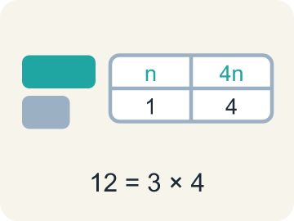 | representation representación  A picture, diagram, table, or equation that shows the mathematics in a situation.  Example: The same 12 shown three ways: a tape diagram, a table, and 3 × 4.
 | tape diagram diagrama de cintas  A rectangle cut into equal parts that helps you visualize how a total breaks apart.  Example: One bar of 4,000 passengers cut into equal groups of 80.
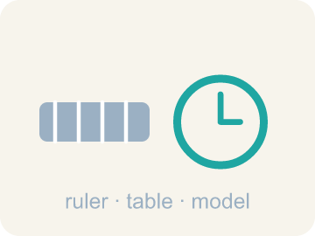 | tool herramienta  Anything you choose to help you see relationships and solve a problem — a table, a diagram, a graph.  Example: A table, a number line, or a tape diagram — whichever shows the relationship.
 | ordered pair par ordenado  Two numbers that go together, like a time and a number of trips, that you can plot as a point.  Example: (4, 60): 4 hours costs $60 — the hours always come first.
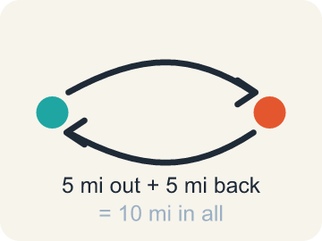 | round trip viaje de ida y vuelta  A complete journey from the start, to the destination, and back to the start.  Example: 5 miles out plus 5 miles back = 10 miles in all.

Guided Notes
Fill in each blank as we go. Use the Word Bank to help you.
WORD BANK
representation • tape diagram • tool • ordered pair • round trip

1. A drawing, table, or equation that shows the math in a situation is a ________________.
2. A rectangle cut into equal parts that shows how a total breaks apart is a ________________ ________________.
3. Anything you choose to help you see relationships and solve is a ________________.
4. Two numbers that go together and can be plotted as a point are an ________________ ________________.
5. A journey out to a place and all the way back is a ________________ ________________.

Write About the Math
What tool can you use to represent the relationship between time and round trips, and how does it answer the question?
¿Qué herramienta puedes usar para representar la relación entre el tiempo y los viajes redondos, y cómo responde la pregunta?
Say your answer to a partner first. Then write it, using at least two of these words:
☐ representation · representación
☐ tape diagram · diagrama de cintas
☐ tool · herramienta
☐ ordered pair · par ordenado
☐ round trip · viaje de ida y vuelta
Model: Moving 4,000 passengers in rides of 80 each requires dividing 4,000 by 80. — A strong answer identifies division because you're splitting a total into equal-sized groups (rides of 80). A weak answer just says 'divide' without connecting it to splitting the total passengers into groups.

Start Most language support
Complete the frames. Use the word bank.
Completa las oraciones. Usa el banco de palabras.
Name the tool you would use to show the relationship — a ___ of values — then name the two quantities in the problem: ___ and ___ .
My answer is ___ because ___.
Mi respuesta es ___ porque ___.

Build Some language support
Write two connected sentences. Use because, so, or but.
Escribe dos oraciones conectadas. Usa porque, entonces o pero.
My claim is ___.
Mi afirmación es ___.
My evidence is ___, so ___.
Mi evidencia es ___, entonces ___.

Explain Light language support
Write a claim, give math evidence, and explain your reasoning.
Escribe una afirmación, da evidencia matemática y explica tu razonamiento.

Check Your Explanation three quick checks
☐ I answered the question.
☐ I used math evidence: numbers, an equation, or a model.
☐ I used at least two math words.

Worked Example

Watch & Read I Do — follow along with your teacher
Unit 1 · Lesson 3
Math lives in your world — in coins on a table and tram cars over a valley. Today you visualize real situations, pick tools like tape diagrams and tables, and let decimal arithmetic do the heavy lifting.

Solved Example I Do — watch each step
Problem: One tram ride takes 12.5 minutes. How many minutes do 10 rides take?
A) 1.25 minutes
B) 22.5 minutes
C) 125 minutes
D) 1,250 minutes
Step 1: 12.5 × 10 = 125.
Step 2: Multiplying by 10 shifts every digit one place to the left.
Answer: C. 125 minutes

Independent Practice

On Your Own You Do — show your work
Solve each problem. Show your thinking in the work box.

Level 2 Enrichment stretch your thinking
1. Apply — What Time Is It? The new year starts at midnight on January 1st. What time will it be 2,022 minutes after midnight?
A) 8:22 p.m. on January 1
B) 9:42 a.m. on January 2
C) 9:42 a.m. on January 1
D) 9:42 p.m. on January 2

2. How many rides would the tram need for 10,000 passengers, at 80 passengers per ride?
A) 12.5 rides
B) 125 rides
C) 250 rides
D) 1,250 rides

3. The lesson says we make strategic decisions about which tool to use. For the 10-hour round-trip question, would you choose a table of values, a coordinate plane, or an equation? Defend your choice.
4. Math is in YOUR world. Describe a real situation from your life that works like the tram problem — a total split into equal groups, or a time built from equal chunks — and show the math.

Exit Ticket
Answer on your own. This shows what you learned today.
★ Which statement best shows what this lesson means by "math is in my world"?
A) We visualize real problems, use tools to show relationships among quantities, and choose our tools strategically
B) Real-world problems can only be solved with a calculator
C) Tables and diagrams are decorations we add after solving
D) Every problem must be solved with the same one tool

Answer Key & Teacher Guide
Teacher reference — remove or fold back before distributing to students.

Guided Notes (Fill-in)
Notes 1: representation
Notes 2: tape diagram
Notes 3: tool
Notes 4: ordered pair
Notes 5: round trip

Worked Notes (I Do / We Do)
I Do: C. 125 minutes
We Do: B. 10 + 2.5

Independent Practice
Watch for this mistake: Converting minutes to hours by moving the decimal point — 625 minutes is NOT 6.25 hours. An hour is 60 minutes, so divide by 60: 625 ÷ 60 ≈ 10.42 hours.

Level 1 Support
1. Answers vary.
2. C) 625 minutes — 12.5 × 50 = 625, just as the table shows: 1 ride → 12.5, 10 rides → 125, 50 rides → 625.
3. A) 50 rides — 4,000 ÷ 80 = 50. A tape diagram of 4,000 cut into equal groups of 80 shows why this is division.
4. Answers vary.

On Level
5. B) About 10.42 hours — 625 ÷ 60 ≈ 10.42, so it would take about 10.42 hours to transport 4,000 passengers.
6. C) 312.5 minutes — 2,000 ÷ 80 = 25 rides, and 25 × 12.5 = 312.5 minutes — half the passengers, half the 625 minutes.

Exit Ticket
A) We visualize real problems, use tools to show relationships among quantities, and choose our tools strategically — The summary makes three claims: we visualize and represent problems, we use tools to show relationships among quantities, and we make strategic decisions about which tool to use.

Math Writing Criteria
The support level changes the amount of language scaffolding, not the mathematical expectation.
☐ The answer to the math question is correct.
☐ The evidence is real lesson mathematics (numbers, equation, or model), not restated claim.
☐ The support level changed the language scaffolding, never the mathematical expectation.

