Name Date Period
Lesson 4-2 · Session 1 · Explain Your Thinking

Fractions, Decimals, Percents
Study the model. Then solve your own problem the same way. Use only the help you need.
WORDS percent (por ciento) · equivalent (equivalente) · hundredths (centésimas)

1 · SEE A MODEL read it with a partner
SEE A MODEL a problem like yours, solved
A pie is cut into 5 equal slices. Leo eats 2 slices. Write the part he ate as a fraction, a decimal, and a percent.
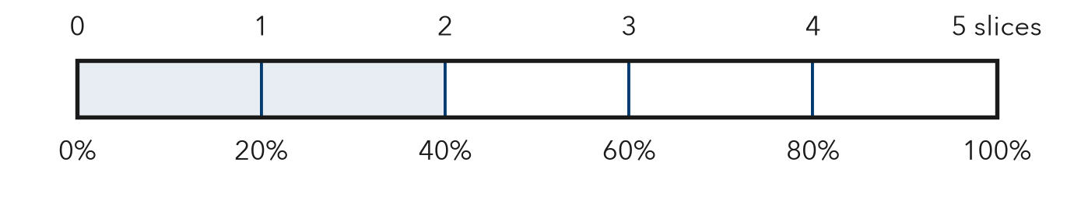
HOW I SOLVED IT  1 Name the whole. 5 slices = 100%.  2 Find one slice. 100% ÷ 5 = 20%. 2 slices = 2 × 20% = 40%.  3 Write all three. Fraction 2/5. Decimal 2 ÷ 5 = 0.4 = 0.40. Percent 40%. | I SAY  “2/5 of the pie is 40% because each slice is 20% and he ate 2 slices.”  I WRITE  I know 2/5 = 40% because each slice is 20%. 0.40 is 40 hundredths, so 2/5 = 0.4 = 40%.

2 · DRAW IT your turn: label the whole, the part and the percent
A pizza is cut into 8 equal slices. Mia eats 3 slices. Fill in the percent row on the bar. Then write the part she ate as a fraction, a decimal, and a percent.
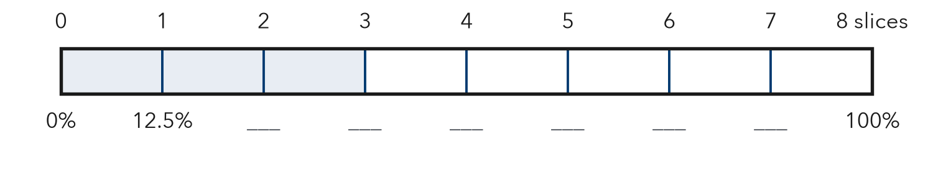
TRY THESE STEPS fill in the blanks as you work
1 Find one slice: 100% ÷ 8 = %.
2 Fill in the percent row by adding % each time.
3 Divide 3 ÷ 8 = for the decimal.

3 · SAY IT tell a partner
Partner A: “3/8 of the pizza is % because .” Partner B: “Show me on the bar where you see that.”

4 · WRITE IT pick a starter · name the whole · use units
WORD BANK fraction · decimal · percent · equal parts · hundredths · each slice
Because I know 3/8 = % because each slice is %.
But Some students think 3/8 = 38%, but .
So Each slice is 12.5%, so 3 slices are %.
Name Date Period
Lesson 4-2 · Session 2 · Explain Your Thinking

Compare and Order
Study the model. Then solve your own problem the same way. Use only the help you need.
WORDS common form (forma común) · benchmark (punto de referencia) · order (orden)

1 · SEE A MODEL read it with a partner
SEE A MODEL a problem like yours, solved
Team A won 0.62 of its games. Team B won 3/5. Team C won 65%. Order the teams from least to greatest.
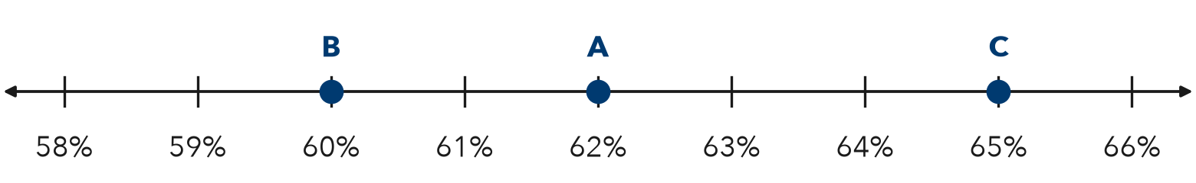
HOW I SOLVED IT  1 Make them all percents. 0.62 = 62%. 3/5 = 60/100 = 60%. 65% stays 65%.  2 Mark each point. B at 60%, A at 62%, C at 65%.  3 Read left to right. 60% < 62% < 65%: Team B, Team A, Team C. | I SAY  “I wrote every value as a percent: 62%, 60%, 65%. So the order is B, A, C.”  I WRITE  In percents the values are 60% < 62% < 65%, so the order is Team B, Team A, Team C.

2 · DRAW IT your turn: label the whole, the part and the percent
Class A recycled 0.45 of its bottles. Class B recycled 2/5. Class C recycled 48%. Mark each value on the number line. Then order the classes from least to greatest.
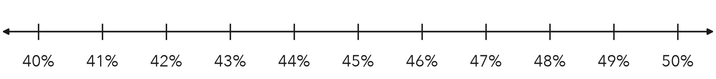
TRY THESE STEPS fill in the blanks as you work
1 Change 0.45 to a percent: %.
2 Change 2/5 to hundredths: 2/5 = /100 = %.
3 Mark all three on the line, then read left to right.

3 · SAY IT tell a partner
Partner A: “I wrote every value as a percent: , , . So the order is .” Partner B: “Which value is closest to 50%? How do you know?”

4 · WRITE IT pick a starter · name the whole · use units
WORD BANK least · greatest · less than (<) · greater than (>) · as a percent · closest to
Because I know is greater than because % > %.
But Some students think 2/5 is greater because 5 > 4, but .
So In percents the values are < < , so the order is .

