Name Date Period
Lesson 4-3 · Session 1 · Explain Your Thinking

Estimate with Benchmarks
Study the model. Then solve your own problem the same way. Use only the help you need.
WORDS estimate (estimar) · benchmark percent (porcentaje de referencia) · the whole (el entero)

1 · SEE A MODEL read it with a partner
SEE A MODEL a problem like yours, solved
A parking lot has 80 spaces. 61 spaces are full. About what percent of the lot is full?
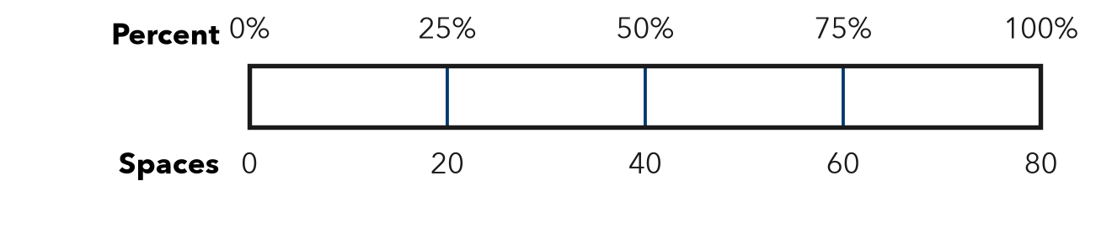
HOW I SOLVED IT  1 Name the whole. 80 spaces = 100%.  2 Find benchmarks. 25% = 20, 50% = 40, 75% = 60.  3 Compare. 61 is very close to 60, so the lot is about 75% full. | I SAY  “The whole is 80. The part is close to 60, which is 75% of the whole.”  I WRITE  I know 61 out of 80 is about 75% because 75% of 80 is 60, and 61 is close to 60.

2 · DRAW IT your turn: label the whole, the part and the percent
A water tank holds 120 gallons. It has 82 gallons in it. About what percent of the tank is full? Use the bar to find benchmark amounts.
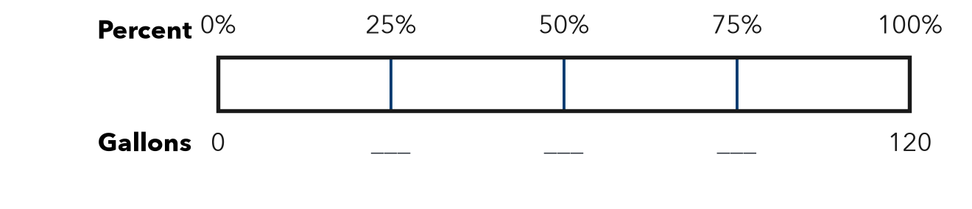
TRY THESE STEPS fill in the blanks as you work
1 Name the whole: gallons = 100%.
2 Fill in the benchmarks: 25% = , 50% = , 75% = .
3 Which benchmark is 82 closest to?

3 · SAY IT tell a partner
Partner A: “The whole is . The part is close to , which is % of the whole.” Partner B: “How do you know it is closer to % than to %?”

4 · WRITE IT pick a starter · name the whole · use units
WORD BANK about · benchmark · close to · between · the whole · estimate
Because I know out of is about % because % of is .
But Some students think 82 out of 120 is 82%, but the whole is , so .
So is between and , so the percent is between % and %.
Name Date Period
Lesson 4-3 · Session 2 · Explain Your Thinking

Estimate a Percent of a Number
Study the model. Then solve your own problem the same way. Use only the help you need.
WORDS estimate (estimación) · compatible (friendly) numbers (números compatibles) · ten percent (diez por ciento)

1 · SEE A MODEL read it with a partner
SEE A MODEL a problem like yours, solved
A school has 396 students. About 24% walk to school. Estimate the number of students who walk, two ways.
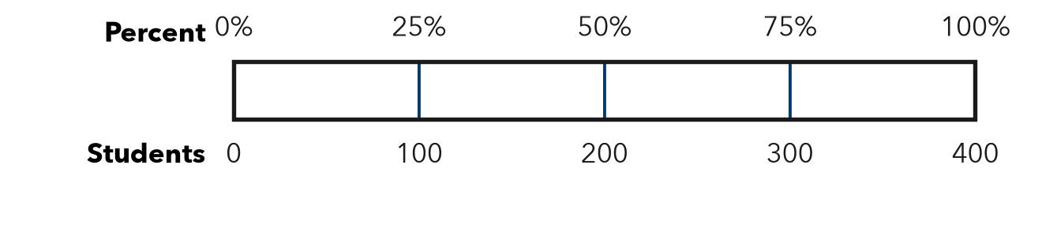
HOW I SOLVED IT  1 Way 1. 396 ≈ 400 and 24% ≈ 25%. 25% is 1/4, so 400 ÷ 4 = about 100.  2 Way 2. 396 ≈ 400 and 24% ≈ 20%. 10% of 400 = 40, so 20% = about 80.  3 Compare. 24% is much closer to 25% than to 20%, so 100 is the better estimate. | I SAY  “I used 25% of 400 because 400 is easy to divide by 4.” “I used 20% of 400. Our estimates are different because we rounded the percent differently.”  I WRITE  I rounded 396 to 400 because 400 is easy to divide by 4. 24% is close to 25%, so about 100 students walk.

2 · DRAW IT your turn: label the whole, the part and the percent
A theater sold 588 tickets. About 26% were for kids. Estimate the number of kids’ tickets two ways, using different compatible (friendly) numbers.
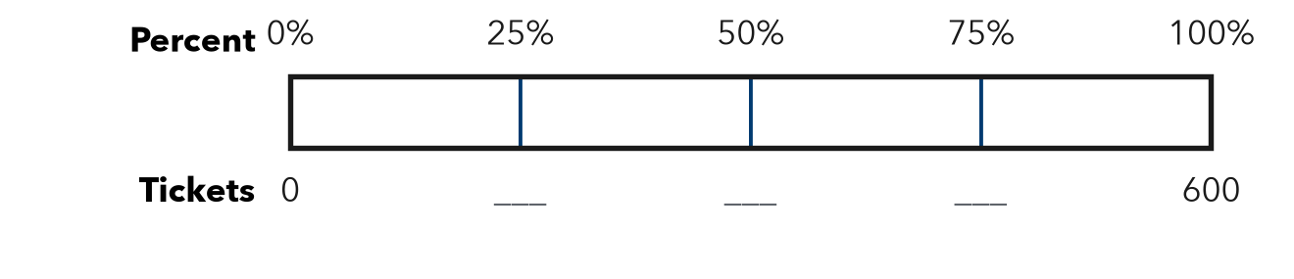
TRY THESE STEPS fill in the blanks as you work
1 Way 1: round 588 to and 26% to %.
2 Way 2: round 588 to a different friendly number: .
3 Which estimate is closer? Why?

3 · SAY IT tell a partner
Partner A: “I used % of because .” Partner B: “I used % of . Our estimates are different because .”

4 · WRITE IT pick a starter · name the whole · use units
WORD BANK round · compatible (friendly) number · about · estimate · closer · divide by 4
Because I rounded to because is easy to divide by .
But Some students think only one estimate is right, but and are both close because .
So I rounded up, so my estimate is a little .

