Name Date Period
Lesson 4-5 · Session 1 · Explain Your Thinking

Find the Whole
Study the model. Then solve your own problem the same way. Use only the help you need.
WORDS part (parte) · whole (entero) · double number line (doble recta numérica)

1 · SEE A MODEL read it with a partner
SEE A MODEL a problem like yours, solved
Jada has read 40 pages. That is 20% of her book. How many pages are in the whole book?
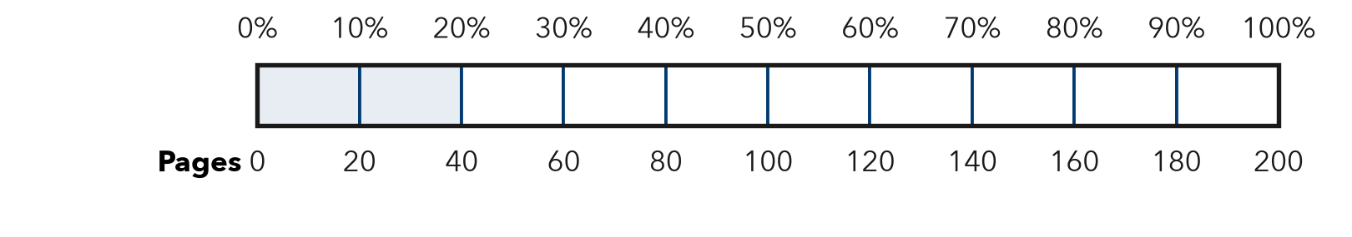
HOW I SOLVED IT  1 Match the part. 40 pages = 20% = 2 parts of 10%.  2 Find one part. 10% = 40 ÷ 2 = 20 pages.  3 Build the whole. 100% = 10 parts = 10 × 20 = 200 pages. Check: 0.20 × 200 = 40. | I SAY  “The part is 40 pages. It is 20% of the whole.” “So 10% is 20, and 100% is 200.”  I WRITE  One part of the bar is 20 pages, so all 10 parts are 200 pages. The whole is greater than 40 because 20% is less than 100%.

2 · DRAW IT your turn: label the whole, the part and the percent
A bike club has saved $27 for a trip. That is 30% of the money it needs. How much money does the club need in all?
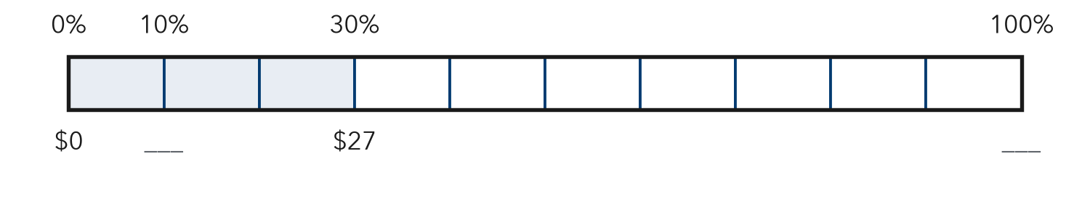
TRY THESE STEPS fill in the blanks as you work
1 $27 is 30%, which is parts of 10%.
2 Find one part: $27 ÷ 3 = $ .
3 Build the whole: 10 × $ = $ .

3 · SAY IT tell a partner
Partner A: “The part is . It is % of the whole.” Partner B: “So 10% is , and 100% is .” Then switch.

4 · WRITE IT pick a starter · name the whole · use units
WORD BANK the part · the whole · one part · 10% · greater than · in all
Because I know 10% is because ÷ = .
But Some students think the whole is , but the whole must be greater than the part because .
So One part of the bar is , so all 10 parts are .
Name Date Period
Lesson 4-5 · Session 2 · Explain Your Thinking

Solve for the Whole
Study the model. Then solve your own problem the same way. Use only the help you need.
WORDS variable (variable) · equation (ecuación) · inverse operation (operación inversa)

1 · SEE A MODEL read it with a partner
SEE A MODEL a problem like yours, solved
A tank has 12 liters of water. That is 60% of the whole tank. Write an equation with w for the whole tank. Solve it.
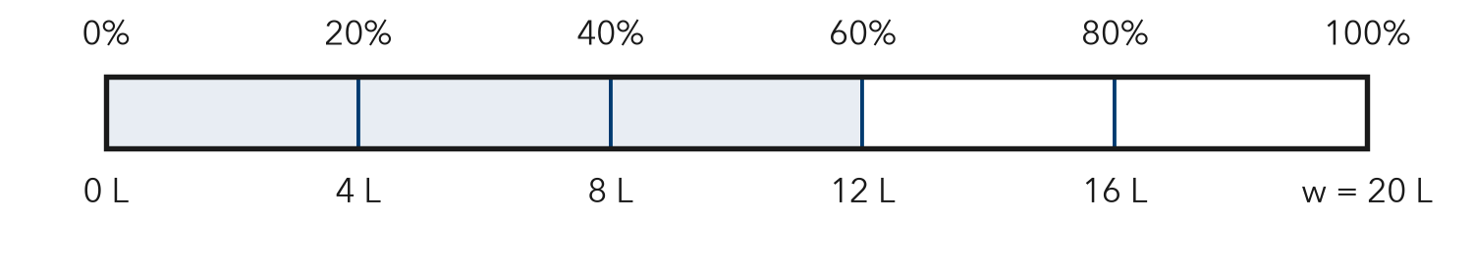
HOW I SOLVED IT  1 Write the equation. percent × whole = part: 0.60 × w = 12.  2 Divide. w = 12 ÷ 0.60 = 120 ÷ 6 = 20 liters.  3 Check. 0.60 × 20 = 12. The whole (20 L) is greater than the part (12 L). | I SAY  “The part is 12 liters and the percent is 60%.” “0.60 × w = 12, so w = 20.” “Check: 0.60 × 20 = 12.”  I WRITE  0.60 × w = 12, so w = 12 ÷ 0.60 = 20 liters. I divide because I know the part and the percent, and I need the whole.

2 · DRAW IT your turn: label the whole, the part and the percent
A runner has run 9 km. That is 45% of the whole race. Write an equation with w for the whole race. Solve it.
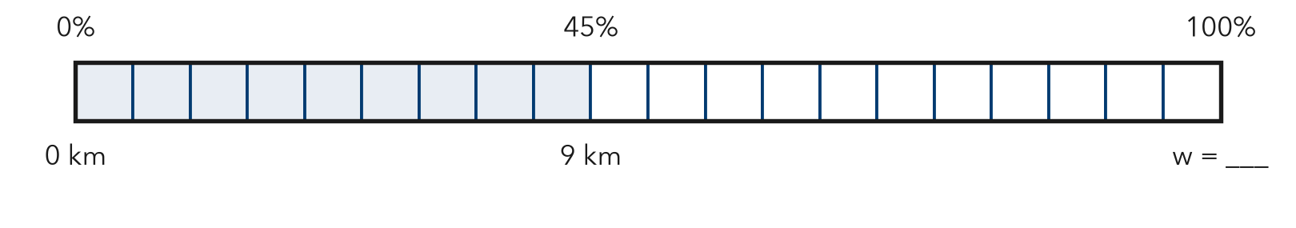
TRY THESE STEPS fill in the blanks as you work
1 Write the percent as a decimal: 45% = .
2 Equation: × w = 9.
3 Divide: w = 9 ÷ = km. Check by multiplying.

3 · SAY IT tell a partner
Partner A: “The part is and the percent is .” Partner B writes × w = and solves. Both check: × = .

4 · WRITE IT pick a starter · name the whole · use units
WORD BANK equation · variable (w) · divide · multiply to check · part · whole
Because I divide by because .
But Some students multiply by , but the whole must be greater than .
So × w = , so w = ÷ = .

