1.1 Small Group · Group 1 — Homework
Lesson 1-1-group1 • Standard MPP.3
Name: ______________________ Period: ______ Date: ____________

Today's Goals
Content: With my small group, I can describe the ways we are all doers of math, and compare my math story with a classmate's — one step at a time, with support.
Language: I can talk through each step out loud using a sentence frame and the lesson's key words.

Key Words
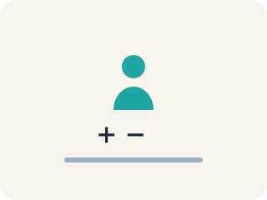
doer of math (persona que hace matemáticas) — Anyone who uses mathematical thinking — which is everyone, every day.

math story (historia matemática) — Your own history with mathematics — what you have done, felt, and learned so far.

strength (fortaleza) — Something you already do well and can share with others.
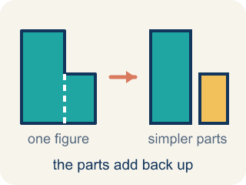
decompose (descomponer) — To break a number into parts that add, subtract, multiply, or divide back to it.
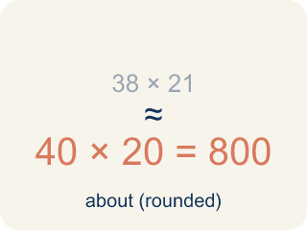
estimate (estimar) — A reasoned answer that is close enough to be useful, without counting every one.

Practice
Show your work. Use the blank space under each problem.
1. About how many people can ride the Ferris wheel at one time if it has 20 cars that each hold about 4 people?
A. About 80
B. About 24
C. About 5
D. About 400
______________________________________________________________________
2. Which of these is a correct way to decompose 78.5?
A. 70 + 8.5
B. 70 + 8.05
C. 78 + 5
D. 7 + 8.5
______________________________________________________________________
3. Which decomposition of 78.5 uses multiplication correctly?
A. 39.25 × 2
B. 39.25 × 3
C. 78.5 × 2
D. 39 × 2
______________________________________________________________________
4. A Ferris wheel holds about 78 riders per turn and makes 6 turns an hour. About how many riders per hour?
A. About 468
B. About 84
C. About 13
D. About 780
______________________________________________________________________
5.
______________________________________________________________________
______________________________________________________________________
______________________________________________________________________
______________________________________________________________________
6. Which statement matches this lesson's big idea?
A. Everyone is a doer of math, and we do it in different ways
B. Only people who are fast at math are doers of math
C. Math only counts when it happens in a classroom
D. There is one right way to think about a math problem
______________________________________________________________________
7.
______________________________________________________________________
______________________________________________________________________
______________________________________________________________________
______________________________________________________________________
8. You estimate 80 riders and the true count is 78. Was your estimate useful?
A. Yes — it was close enough to plan with
B. No — an estimate is only useful if it is exact
C. No — you should never estimate
D. Yes — because any answer is fine
______________________________________________________________________

Answer Key (Teacher)
1. A. About 80
20 cars with about 4 riders each is 20 × 4, which is about 80 people.
Watch for: Believing that 'doing math' only counts when it happens on paper in a classroom.
2. A. 70 + 8.5
70 + 8.5 = 78.5. Decomposing means the parts must add back to the original number.
Watch for: Believing that 'doing math' only counts when it happens on paper in a classroom.
3. A. 39.25 × 2
39.25 × 2 = 78.5, so halving and doubling is another way to break the number apart.
Watch for: Believing that 'doing math' only counts when it happens on paper in a classroom.
4. A. About 468
78 riders on each of 6 turns is 78 × 6 = 468 riders in an hour.
Watch for: Believing that 'doing math' only counts when it happens on paper in a classroom.
5. Open response — answers will vary.
6. A. Everyone is a doer of math, and we do it in different ways
The lesson's whole point is that everyone already does math, differently, and sharing those differences helps everyone.
Watch for: Believing that 'doing math' only counts when it happens on paper in a classroom.
7. Open response — answers will vary.
8. A. Yes — it was close enough to plan with
80 and 78 are close enough for planning, which is exactly what an estimate is for.
Watch for: Believing that 'doing math' only counts when it happens on paper in a classroom.

