1.5 Small Group · Group 1 — Homework
Lesson 1-5-group1 • Standard 5.OA.B.3
Name: ______________________ Period: ______ Date: ____________

Today's Goals
Content: With my small group, I can find patterns and pattern rules, use them to make generalizations, and check my solutions with a table of values — one step at a time, with support.
Language: I can talk through each step out loud using a sentence frame and the lesson's key words.

Key Words
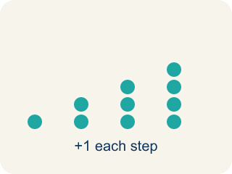
pattern (patrón) — Something that repeats or changes in a predictable way.

pattern rule (regla del patrón) — The instruction that tells how to get from one number in a pattern to the next.

generalization (generalización) — A statement that is true for a whole pattern, made by noticing repeated calculations.
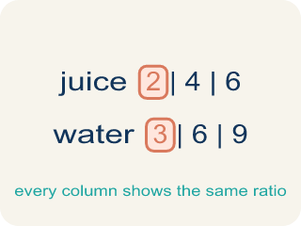
table of values (tabla de valores) — A table that lists each step of a pattern so you can check that a solution is reasonable.
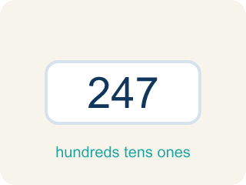
reasonableness (sensatez del resultado) — Whether an answer makes sense — checked as you work, with adjustments made when needed.

Practice
Show your work. Use the blank space under each problem.
1. Each penny has a value of $0.01. What is the value of 100 pennies?
A. $1.00
B. $0.10
C. $10.00
D. $100.00
______________________________________________________________________
2. Each quarter has a value of $0.25. Following the pattern, what is the value of 100 quarters?
A. $25.00
B. $2.50
C. $250.00
D. $100.25
______________________________________________________________________
3. Player A had 18 points before making 10 two-pointers in a row. How many points does Player A have after the streak?
A. 38
B. 28
C. 20
D. 48
______________________________________________________________________
4. Akela's jar totals $53.50. Why can the number of pennies only be a multiple of 5?
A. Because the total's cents end in 0, and only pennies make amounts that aren't multiples of 5 cents
B. Because pennies always come in rolls of 5
C. Because there are exactly 5 kinds of coins in the jar
D. Because $53.50 is divisible by 5
______________________________________________________________________
5. Which combination of coins totals exactly $53.50?
A. 200 quarters, 25 dimes, 15 nickels, 25 pennies
B. 200 quarters, 25 dimes, 15 nickels, 20 pennies
C. 200 quarters, 30 dimes, 15 nickels, 25 pennies
D. 100 quarters, 25 dimes, 15 nickels, 25 pennies
______________________________________________________________________
6. How does a table of values check that Player A really scored 38 points?
A. It lists the score after every shot, so you can see the pattern land exactly on 38
B. It rounds the answer to the nearest ten
C. It replaces the pattern rule so you don't need one
D. It proves the answer without doing any calculations
______________________________________________________________________
7.
______________________________________________________________________
______________________________________________________________________
______________________________________________________________________
______________________________________________________________________
8.
______________________________________________________________________
______________________________________________________________________
______________________________________________________________________
______________________________________________________________________

Answer Key (Teacher)
1. A. $1.00
100 × $0.01 = $1.00 — one hundred hundredths make one whole dollar.
Watch for: Reporting only the points from the streak (20 or 30) and forgetting to add the points each player had before the streak began.
2. A. $25.00
100 × $0.25 = $25.00 — the same pattern as 100 pennies making $1.00 and 100 nickels making $5.00.
Watch for: Reporting only the points from the streak (20 or 30) and forgetting to add the points each player had before the streak began.
3. A. 38
Ten two-pointers add 10 × 2 = 20 points, and 18 + 20 = 38 points.
Watch for: Reporting only the points from the streak (20 or 30) and forgetting to add the points each player had before the streak began.
4. A. Because the total's cents end in 0, and only pennies make amounts that aren't multiples of 5 cents
Nickels, dimes, and quarters are each worth a multiple of 5 cents. For the total to land on a 0, the pennies must also add up to a multiple of 5 cents — so their count is a multiple of 5.
Watch for: Reporting only the points from the streak (20 or 30) and forgetting to add the points each player had before the streak began.
5. A. 200 quarters, 25 dimes, 15 nickels, 25 pennies
$50.00 + $2.50 + $0.75 + $0.25 = $53.50 exactly.
Watch for: Reporting only the points from the streak (20 or 30) and forgetting to add the points each player had before the streak began.
6. A. It lists the score after every shot, so you can see the pattern land exactly on 38
The book's table lists each step — 20, 22, 24, … — and verifies that the calculations were correct: Player A scored 38.
Watch for: Reporting only the points from the streak (20 or 30) and forgetting to add the points each player had before the streak began.
7. Open response — answers will vary.
8. Open response — answers will vary.

