1.6 Small Group · Group 1 — Homework
Lesson 1-6-group1 • Standard MPP.3
Name: ______________________ Period: ______ Date: ____________

Today's Goals
Content: With my small group, I can describe my problem-solving process, name strategies for getting unstuck, and identify the behaviors that make our class a community of math thinkers — one step at a time, with support.
Language: I can talk through each step out loud using a sentence frame and the lesson's key words.

Key Words

make sense of a problem (comprender un problema) — To figure out what a problem is asking — what you know, and what you don't know yet.
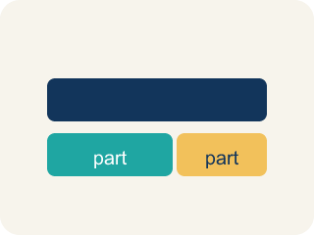
representation (representación) — A way of showing a problem — a drawing, table, equation, or model — that helps you see it.

strategy (estrategia) — A plan of attack for a problem — and something you can switch when you get stuck.
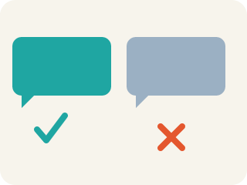
critique (criticar constructivamente) — To examine an idea and say what is convincing or not — about the idea, never about the person.

community agreement (acuerdo comunitario) — A rule the whole class agrees to so that everyone can learn together.

Practice
Show your work. Use the blank space under each problem.
1. A bicycle rack holds 8 bikes, and each bike has 2 wheels. How many wheels are on the rack?
A. 16
B. 10
C. 4
D. 82
______________________________________________________________________
2. Another bicycle rack has 6 times as many wheels as the rack with 16 wheels. About how many wheels does it have?
A. About 96
B. About 22
C. About 66
D. About 616
______________________________________________________________________
3. You are solving a problem and realize your strategy is not making progress. What does the problem-solving process say to do?
A. Notice your progress has stalled and shift to a different strategy
B. Keep using the same strategy no matter what
C. Erase everything and decide the problem is impossible
D. Copy a classmate's paper
______________________________________________________________________
4. The first rack has 16 wheels and the other rack has 6 times as many. How many BIKES does the bigger rack hold, if every bike has 2 wheels?
A. 48
B. 96
C. 24
D. 192
______________________________________________________________________
5.
______________________________________________________________________
______________________________________________________________________
______________________________________________________________________
______________________________________________________________________
6.
______________________________________________________________________
______________________________________________________________________
______________________________________________________________________
______________________________________________________________________
7. You are working on your own and get stuck. Which move follows BOTH parts of our working-alone agreements?
A. Try a get-unstuck strategy first, then quietly ask for help without interrupting classmates unnecessarily
B. Immediately call across the room to a friend
C. Sit silently for the rest of class without seeking help
D. Take a classmate's paper to see their work
______________________________________________________________________
8.
______________________________________________________________________
______________________________________________________________________
______________________________________________________________________
______________________________________________________________________

Answer Key (Teacher)
1. A. 16
8 bikes with 2 wheels each is 8 × 2 = 16 wheels.
Watch for: Treating 'stuck' as a stop sign instead of a signal — waiting silently instead of trying a strategy: asking a question, drawing the problem, or recalling a similar problem.
2. A. About 96
6 times as many as 16 is 16 × 6 = 96 wheels.
Watch for: Treating 'stuck' as a stop sign instead of a signal — waiting silently instead of trying a strategy: asking a question, drawing the problem, or recalling a similar problem.
3. A. Notice your progress has stalled and shift to a different strategy
We are aware of our progress in solving the problem and shift strategies when needed.
Watch for: Treating 'stuck' as a stop sign instead of a signal — waiting silently instead of trying a strategy: asking a question, drawing the problem, or recalling a similar problem.
4. A. 48
The bigger rack has 16 × 6 = 96 wheels, and 96 ÷ 2 = 48 bikes.
Watch for: Treating 'stuck' as a stop sign instead of a signal — waiting silently instead of trying a strategy: asking a question, drawing the problem, or recalling a similar problem.
5. Open response — answers will vary.
6. Open response — answers will vary.
7. A. Try a get-unstuck strategy first, then quietly ask for help without interrupting classmates unnecessarily
When we work on our own, we seek help when we are stuck AND we avoid interrupting our classmates unnecessarily — the best move honors both.
Watch for: Treating 'stuck' as a stop sign instead of a signal — waiting silently instead of trying a strategy: asking a question, drawing the problem, or recalling a similar problem.
8. Open response — answers will vary.

