1.6 Small Group · Group 2 — Homework
Lesson 1-6-group2 • Standard MPP.3
Name: ______________________ Period: ______ Date: ____________

Today's Goals
Content: I can describe my problem-solving process, name strategies for getting unstuck, and identify the behaviors that make our class a community of math thinkers, explain how I can tell, and judge a case I have not seen before.
Language: I can justify my answer to a skeptic and connect it to a second strategy or representation.

Key Words

make sense of a problem (comprender un problema) — To figure out what a problem is asking — what you know, and what you don't know yet.
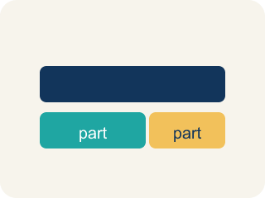
representation (representación) — A way of showing a problem — a drawing, table, equation, or model — that helps you see it.

strategy (estrategia) — A plan of attack for a problem — and something you can switch when you get stuck.

critique (criticar constructivamente) — To examine an idea and say what is convincing or not — about the idea, never about the person.

community agreement (acuerdo comunitario) — A rule the whole class agrees to so that everyone can learn together.

Practice
Show your work. Use the blank space under each problem.
1. You are solving a problem and realize your strategy is not making progress. What does the problem-solving process say to do?
A. Notice your progress has stalled and shift to a different strategy
B. Keep using the same strategy no matter what
C. Erase everything and decide the problem is impossible
D. Copy a classmate's paper
______________________________________________________________________
2. The first rack has 16 wheels and the other rack has 6 times as many. How many BIKES does the bigger rack hold, if every bike has 2 wheels?
A. 48
B. 96
C. 24
D. 192
______________________________________________________________________
3.
______________________________________________________________________
______________________________________________________________________
______________________________________________________________________
______________________________________________________________________
4.
______________________________________________________________________
______________________________________________________________________
______________________________________________________________________
______________________________________________________________________

Answer Key (Teacher)
1. A. Notice your progress has stalled and shift to a different strategy
We are aware of our progress in solving the problem and shift strategies when needed.
Watch for: Treating 'stuck' as a stop sign instead of a signal — waiting silently instead of trying a strategy: asking a question, drawing the problem, or recalling a similar problem.
2. A. 48
The bigger rack has 16 × 6 = 96 wheels, and 96 ÷ 2 = 48 bikes.
Watch for: Treating 'stuck' as a stop sign instead of a signal — waiting silently instead of trying a strategy: asking a question, drawing the problem, or recalling a similar problem.
3. Open response — answers will vary.
4. Open response — answers will vary.

