10.1 Small Group · Group 2 — Homework
Lesson 10-1-group2 • Standard MPP.3
Name: ______________________ Period: ______ Date: ____________

Today's Goals
Content: I can find applications of math outside of school — in professions like being a chef, in hobbies like gardening, and around my own house, explain why the method works, and use it on a problem I have not seen before.
Language: I can justify my answer to a skeptic and connect it to a second strategy or representation.

Key Words

profession (profesión) — A job someone is trained to do, like chef, nurse, or carpenter.

inventory (inventario) — The supply of items a business keeps on hand, tracked by counting.
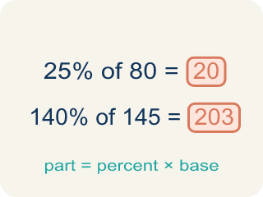
portion (porción) — The measured amount of food served to one person.
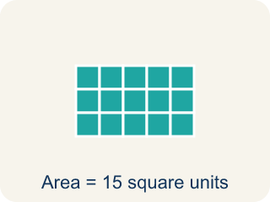
area (área) — The amount of flat space a surface covers, measured in square units.

volume (volumen) — The amount of space something fills, measured in cubic units.

Practice
Show your work. Use the blank space under each problem.
1. One person saves 8 gallons of water a day by turning the water on only to rinse. How much water does that person save in a year (365 days)?
A. 2,920 gallons
B. 373 gallons
C. 1,460 gallons
D. 365 gallons
______________________________________________________________________
2. If each person in a house saves 2,920 gallons a year, how much does a household of 3 people save in a year?
A. 8,760 gallons
B. 2,923 gallons
C. 973 gallons
D. 5,840 gallons
______________________________________________________________________
3. A household of 5 saves 2,920 gallons per person per year. A household of 4 does the same. How much MORE does the household of 5 save than the household of 4?
A. 2,920 gallons
B. 14,600 gallons
C. 11,680 gallons
D. 1 gallon
______________________________________________________________________
4.
______________________________________________________________________
______________________________________________________________________
______________________________________________________________________
______________________________________________________________________

Answer Key (Teacher)
1. A. 2,920 gallons
8 gallons a day × 365 days = 2,920 gallons in a year.
Watch for: Believing math only 'counts' when it happens in a classroom — and walking past the calculating, measuring, and projecting inside jobs, hobbies, and chores every day.
2. A. 8,760 gallons
2,920 gallons per person × 3 people = 8,760 gallons a year.
Watch for: Believing math only 'counts' when it happens in a classroom — and walking past the calculating, measuring, and projecting inside jobs, hobbies, and chores every day.
3. A. 2,920 gallons
5 people save 5 × 2,920 = 14,600 gallons and 4 people save 4 × 2,920 = 11,680 gallons. The difference is 14,600 − 11,680 = 2,920 gallons — exactly one more person's savings.
Watch for: Believing math only 'counts' when it happens in a classroom — and walking past the calculating, measuring, and projecting inside jobs, hobbies, and chores every day.
4. Open response — answers will vary.

