10.2 Small Group · Group 1 — Homework
Lesson 10-2-group1 • Standard MPP.7
Name: ______________________ Period: ______ Date: ____________

Today's Goals
Content: With my small group, I can use bilateral symmetry to describe structure in nature and in human creations — one step at a time, with support.
Language: I can talk through each step out loud using a sentence frame and the lesson's key words.

Key Words
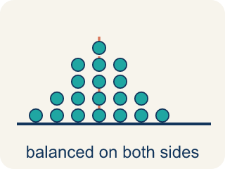
symmetric (simétrico) — Having two halves that match — one side is a mirror image of the other.
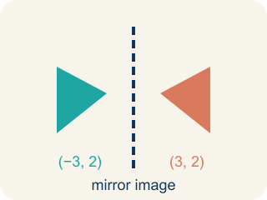
mirror image (imagen reflejada) — A copy of a shape flipped across a line, like a reflection in a mirror.

bilateral symmetry (simetría bilateral) — Reflective symmetry in plants and animals — the two sides of the body mirror each other.

line of symmetry (eje de simetría) — The line you can draw through a figure so each side is a reflection of the other.
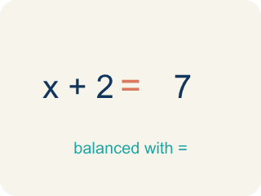
balance (equilibrio) — An even, steady arrangement — neither side feels heavier than the other.

Practice
Show your work. Use the blank space under each problem.
1. What does it mean that a butterfly is symmetric?
A. The two sides of the butterfly look like mirror images
B. The butterfly has exactly two wings
C. The butterfly's wings are very colorful
D. The butterfly is larger than most insects
______________________________________________________________________
2. In plants and animals, reflective symmetry is called:
A. bilateral symmetry
B. rotational symmetry
C. a mirror image
D. balance
______________________________________________________________________
3. Why do people find symmetry pleasing?
A. Our brains are wired to favor balance, and bilateral symmetry provides balance
B. Symmetric things are always brightly colored
C. Symmetry only appears in rare and expensive objects
D. Symmetric shapes are always larger than non-symmetric ones
______________________________________________________________________
4. There are over 17,000 species of butterflies, and ALL butterflies have reflective symmetry. About how many of those species have reflective symmetry?
A. All 17,000+ of them
B. About half of them
C. Only the most colorful ones
D. None — symmetry is only in plants
______________________________________________________________________
5.
______________________________________________________________________
______________________________________________________________________
______________________________________________________________________
______________________________________________________________________
6. A plant grows 2 leaves at a time, one layer per week. How many leaves has it grown after 6 weeks?
A. 12 leaves
B. 8 leaves
C. 6 leaves
D. 36 leaves
______________________________________________________________________
7.
______________________________________________________________________
______________________________________________________________________
______________________________________________________________________
______________________________________________________________________
8. Which is the best test for whether a figure has bilateral symmetry?
A. Find a line where one side is the mirror image of the other
B. Check whether the figure has an even number of parts
C. Check whether the figure is found in nature
D. Check whether the figure looks beautiful to you
______________________________________________________________________

Answer Key (Teacher)
1. A. The two sides of the butterfly look like mirror images
Symmetric means one side is a mirror image of the other — that is exactly what we see across the butterfly's body.
Watch for: Thinking a figure lacks bilateral symmetry just because its line of symmetry is not vertical — the mirror line can run in any direction, and the test is whether the two sides match across it.
2. A. bilateral symmetry
The lesson says it directly: all butterflies have reflective symmetry, and in plants and animals this is called bilateral symmetry.
Watch for: Thinking a figure lacks bilateral symmetry just because its line of symmetry is not vertical — the mirror line can run in any direction, and the test is whether the two sides match across it.
3. A. Our brains are wired to favor balance, and bilateral symmetry provides balance
The lesson says it directly: our brains are wired to favor balance, and bilateral symmetry provides balance.
Watch for: Thinking a figure lacks bilateral symmetry just because its line of symmetry is not vertical — the mirror line can run in any direction, and the test is whether the two sides match across it.
4. A. All 17,000+ of them
'All butterflies have reflective symmetry' means every one of the 17,000+ species — no exceptions.
Watch for: Thinking a figure lacks bilateral symmetry just because its line of symmetry is not vertical — the mirror line can run in any direction, and the test is whether the two sides match across it.
5. Open response — answers will vary.
6. A. 12 leaves
One layer per week for 6 weeks is 6 layers, and 6 layers × 2 leaves = 12 leaves.
Watch for: Thinking a figure lacks bilateral symmetry just because its line of symmetry is not vertical — the mirror line can run in any direction, and the test is whether the two sides match across it.
7. Open response — answers will vary.
8. A. Find a line where one side is the mirror image of the other
Bilateral symmetry means exactly this: there is a line across which the two sides are mirror images.
Watch for: Thinking a figure lacks bilateral symmetry just because its line of symmetry is not vertical — the mirror line can run in any direction, and the test is whether the two sides match across it.

