10.2 Small Group · Group 2 — Homework
Lesson 10-2-group2 • Standard MPP.7
Name: ______________________ Period: ______ Date: ____________

Today's Goals
Content: I can use bilateral symmetry to describe structure in nature and in human creations, explain how I can tell, and judge a case I have not seen before.
Language: I can justify my answer to a skeptic and connect it to a second strategy or representation.

Key Words
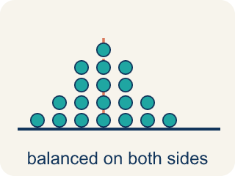
symmetric (simétrico) — Having two halves that match — one side is a mirror image of the other.
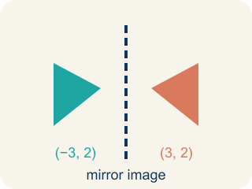
mirror image (imagen reflejada) — A copy of a shape flipped across a line, like a reflection in a mirror.

bilateral symmetry (simetría bilateral) — Reflective symmetry in plants and animals — the two sides of the body mirror each other.

line of symmetry (eje de simetría) — The line you can draw through a figure so each side is a reflection of the other.
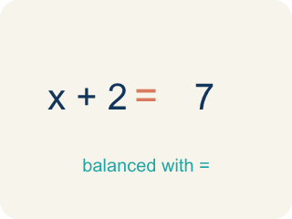
balance (equilibrio) — An even, steady arrangement — neither side feels heavier than the other.

Practice
Show your work. Use the blank space under each problem.
1. Why do people find symmetry pleasing?
A. Our brains are wired to favor balance, and bilateral symmetry provides balance
B. Symmetric things are always brightly colored
C. Symmetry only appears in rare and expensive objects
D. Symmetric shapes are always larger than non-symmetric ones
______________________________________________________________________
2. There are over 17,000 species of butterflies, and ALL butterflies have reflective symmetry. About how many of those species have reflective symmetry?
A. All 17,000+ of them
B. About half of them
C. Only the most colorful ones
D. None — symmetry is only in plants
______________________________________________________________________
3.
______________________________________________________________________
______________________________________________________________________
______________________________________________________________________
______________________________________________________________________
4. A plant grows 2 leaves at a time, one layer per week. How many leaves has it grown after 6 weeks?
A. 12 leaves
B. 8 leaves
C. 6 leaves
D. 36 leaves
______________________________________________________________________

Answer Key (Teacher)
1. A. Our brains are wired to favor balance, and bilateral symmetry provides balance
The lesson says it directly: our brains are wired to favor balance, and bilateral symmetry provides balance.
Watch for: Thinking a figure lacks bilateral symmetry just because its line of symmetry is not vertical — the mirror line can run in any direction, and the test is whether the two sides match across it.
2. A. All 17,000+ of them
'All butterflies have reflective symmetry' means every one of the 17,000+ species — no exceptions.
Watch for: Thinking a figure lacks bilateral symmetry just because its line of symmetry is not vertical — the mirror line can run in any direction, and the test is whether the two sides match across it.
3. Open response — answers will vary.
4. A. 12 leaves
One layer per week for 6 weeks is 6 layers, and 6 layers × 2 leaves = 12 leaves.
Watch for: Thinking a figure lacks bilateral symmetry just because its line of symmetry is not vertical — the mirror line can run in any direction, and the test is whether the two sides match across it.

