10.4 Small Group · Group 1 — Homework
Lesson 10-4-group1 • Standard MPP.4
Name: ______________________ Period: ______ Date: ____________

Today's Goals
Content: With my small group, I can use ratios and models to explain how the Penny Farthing and gear-driven bicycles were ingenious solutions to a real problem — one step at a time, with support.
Language: I can talk through each step out loud using a sentence frame and the lesson's key words.

Key Words

ingenuity (ingenio) — Coming up with different, and sometimes unique, solutions to problems.
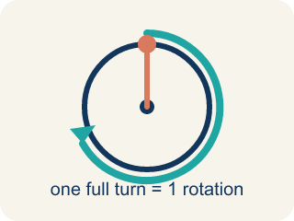
rotation (rotación) — One full turn of a wheel, gear, or pedal all the way around.
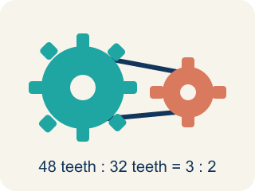
gear (engranaje) — A toothed wheel that transfers motion through a chain or another gear.
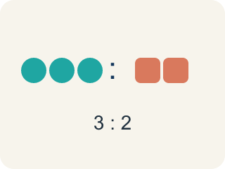
ratio (razón) — A comparison of two quantities, like pedal rotations to wheel rotations.
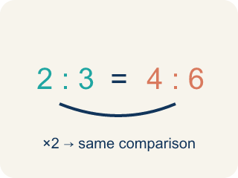
equivalent ratios (razones equivalentes) — Ratios that make the same comparison using different numbers.

Practice
Show your work. Use the blank space under each problem.
1. On the Penny Farthing, what is the ratio of pedal rotations to front-wheel rotations?
A. 1 to 1
B. 1 to 2
C. 2 to 1
D. 1 to 4
______________________________________________________________________
2. How far does the Penny Farthing travel with each pedal rotation?
A. The length of the perimeter of the front wheel
B. The height of the rider
C. The length of the pedal
D. It does not move a fixed distance
______________________________________________________________________
3. The pedal gear turns 48 teeth per rotation. The largest rear gear needs 32 teeth for one full rotation. How many rotations does the rear wheel make for each pedal rotation?
A. 1.5 rotations
B. 16 rotations
C. 0.5 rotations
D. 2 rotations
______________________________________________________________________
4. The smallest rear gear has 12 teeth. How many rotations will the rear wheel make for each rotation of the 48-tooth pedal gear?
A. 4 rotations
B. 36 rotations
C. 3 rotations
D. 0.25 rotations
______________________________________________________________________
5. You are about to ride up a steep hill. Which rear gear should the chain be on, and why?
A. The 32-tooth gear, because 1.5 rotations per pedal makes pedaling easier at slow speeds
B. The 12-tooth gear, because 4 rotations per pedal is always better
C. The 32-tooth gear, because it makes the bike go faster
D. It does not matter which gear you use on a hill
______________________________________________________________________
6.
______________________________________________________________________
______________________________________________________________________
______________________________________________________________________
______________________________________________________________________
7. With the chain on the 12-tooth gear, the rider makes 10 pedal rotations. How many rotations does the rear wheel make?
A. 40 rotations
B. 14 rotations
C. 22 rotations
D. 120 rotations
______________________________________________________________________
8.
______________________________________________________________________
______________________________________________________________________
______________________________________________________________________
______________________________________________________________________

Answer Key (Teacher)
1. A. 1 to 1
The pedals are attached directly to the front wheel, so each pedal rotation rotates the wheel one time — a 1 to 1 ratio.
Watch for: Thinking a rear gear with MORE teeth makes the wheel spin more — it is the opposite: the 32-tooth gear gives only 1.5 rotations per pedal rotation, while the 12-tooth gear gives 4.
2. A. The length of the perimeter of the front wheel
One wheel rotation rolls the bike forward exactly the perimeter of the wheel, and one pedal rotation makes one wheel rotation.
Watch for: Thinking a rear gear with MORE teeth makes the wheel spin more — it is the opposite: the 32-tooth gear gives only 1.5 rotations per pedal rotation, while the 12-tooth gear gives 4.
3. A. 1.5 rotations
48 ÷ 32 = 1.5, so the rear wheel makes 1.5 rotations for each pedal rotation.
Watch for: Thinking a rear gear with MORE teeth makes the wheel spin more — it is the opposite: the 32-tooth gear gives only 1.5 rotations per pedal rotation, while the 12-tooth gear gives 4.
4. A. 4 rotations
48 ÷ 12 = 4, so the rear wheel makes 4 rotations for each pedal rotation.
Watch for: Thinking a rear gear with MORE teeth makes the wheel spin more — it is the opposite: the 32-tooth gear gives only 1.5 rotations per pedal rotation, while the 12-tooth gear gives 4.
5. A. The 32-tooth gear, because 1.5 rotations per pedal makes pedaling easier at slow speeds
The larger gear turns the wheel fewer times per pedal rotation, which makes it easier to pedal at slower speeds or go uphill.
Watch for: Thinking a rear gear with MORE teeth makes the wheel spin more — it is the opposite: the 32-tooth gear gives only 1.5 rotations per pedal rotation, while the 12-tooth gear gives 4.
6. Open response — answers will vary.
7. A. 40 rotations
The rear wheel makes 4 rotations per pedal rotation, so 10 pedal rotations give 10 × 4 = 40 wheel rotations.
Watch for: Thinking a rear gear with MORE teeth makes the wheel spin more — it is the opposite: the 32-tooth gear gives only 1.5 rotations per pedal rotation, while the 12-tooth gear gives 4.
8. Open response — answers will vary.

