10.4 Small Group · Group 2 — Homework
Lesson 10-4-group2 • Standard MPP.4
Name: ______________________ Period: ______ Date: ____________

Today's Goals
Content: I can use ratios and models to explain how the Penny Farthing and gear-driven bicycles were ingenious solutions to a real problem, explain why the method works, and use it on a problem I have not seen before.
Language: I can justify my answer to a skeptic and connect it to a second strategy or representation.

Key Words

ingenuity (ingenio) — Coming up with different, and sometimes unique, solutions to problems.
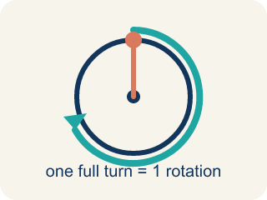
rotation (rotación) — One full turn of a wheel, gear, or pedal all the way around.
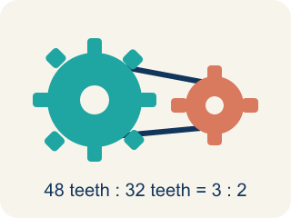
gear (engranaje) — A toothed wheel that transfers motion through a chain or another gear.
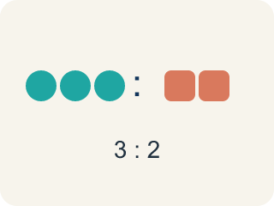
ratio (razón) — A comparison of two quantities, like pedal rotations to wheel rotations.
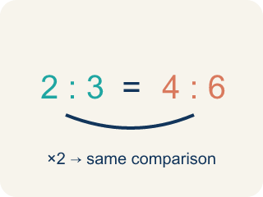
equivalent ratios (razones equivalentes) — Ratios that make the same comparison using different numbers.

Practice
Show your work. Use the blank space under each problem.
1. The pedal gear turns 48 teeth per rotation. The largest rear gear needs 32 teeth for one full rotation. How many rotations does the rear wheel make for each pedal rotation?
A. 1.5 rotations
B. 16 rotations
C. 0.5 rotations
D. 2 rotations
______________________________________________________________________
2. The smallest rear gear has 12 teeth. How many rotations will the rear wheel make for each rotation of the 48-tooth pedal gear?
A. 4 rotations
B. 36 rotations
C. 3 rotations
D. 0.25 rotations
______________________________________________________________________
3. You are about to ride up a steep hill. Which rear gear should the chain be on, and why?
A. The 32-tooth gear, because 1.5 rotations per pedal makes pedaling easier at slow speeds
B. The 12-tooth gear, because 4 rotations per pedal is always better
C. The 32-tooth gear, because it makes the bike go faster
D. It does not matter which gear you use on a hill
______________________________________________________________________
4.
______________________________________________________________________
______________________________________________________________________
______________________________________________________________________
______________________________________________________________________

Answer Key (Teacher)
1. A. 1.5 rotations
48 ÷ 32 = 1.5, so the rear wheel makes 1.5 rotations for each pedal rotation.
Watch for: Thinking a rear gear with MORE teeth makes the wheel spin more — it is the opposite: the 32-tooth gear gives only 1.5 rotations per pedal rotation, while the 12-tooth gear gives 4.
2. A. 4 rotations
48 ÷ 12 = 4, so the rear wheel makes 4 rotations for each pedal rotation.
Watch for: Thinking a rear gear with MORE teeth makes the wheel spin more — it is the opposite: the 32-tooth gear gives only 1.5 rotations per pedal rotation, while the 12-tooth gear gives 4.
3. A. The 32-tooth gear, because 1.5 rotations per pedal makes pedaling easier at slow speeds
The larger gear turns the wheel fewer times per pedal rotation, which makes it easier to pedal at slower speeds or go uphill.
Watch for: Thinking a rear gear with MORE teeth makes the wheel spin more — it is the opposite: the 32-tooth gear gives only 1.5 rotations per pedal rotation, while the 12-tooth gear gives 4.
4. Open response — answers will vary.

