10.6 Small Group · Group 2 — Homework
Lesson 10-6-group2 • Standard MPP.3
Name: ______________________ Period: ______ Date: ____________

Today's Goals
Content: I can look back at my answers from Lesson 1-1, describe how my math biography has changed this year, and recognize ways we are all doers of math, explain how I can tell, and judge a case I have not seen before.
Language: I can justify my answer to a skeptic and connect it to a second strategy or representation.

Key Words

math biography (biografía matemática) — The story of your relationship with math — and how it has changed over time.
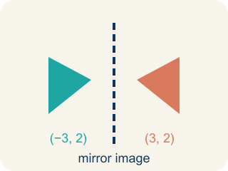
reflect (reflexionar) — To look back at what you did, felt, and learned, and think about what it means.
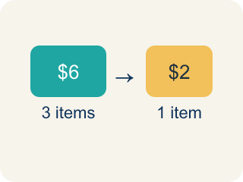
growth (crecimiento) — The change between what you could do before and what you can do now.

confidence (confianza) — Trusting yourself to try a problem, even when the first attempt might fail.

community (comunidad) — The people and places around you — where math shows up outside the classroom.

Practice
Show your work. Use the blank space under each problem.
1. Now stretch the September estimate with this year's math: about 80 riders per turn, 6 turns each hour. About how many riders per hour?
A. About 480
B. About 86
C. About 13
D. About 800
______________________________________________________________________
2. Percents were new this year. What is 50% of 157?
A. 78.5
B. 77.5
C. 31.4
D. 107
______________________________________________________________________
3.
______________________________________________________________________
______________________________________________________________________
______________________________________________________________________
______________________________________________________________________
4. Which of these is the strongest evidence that YOUR math reasoning grew this year?
A. You can explain why a method works, not just follow its steps
B. You finish worksheets faster than in September
C. You memorized more answers than before
D. You stopped making any mistakes
______________________________________________________________________

Answer Key (Teacher)
1. A. About 480
80 riders on each of 6 turns is 80 × 6 = 480 riders per hour — a rate, one of this year's tools.
Watch for: Treating your math story as finished — writing the same answers you wrote in Lesson 1-1 instead of looking for what actually changed. The story grows and evolves; a retrospective that copies September has missed the point.
2. A. 78.5
50% means half, and 157 ÷ 2 = 78.5 — the very number you decomposed back in Lesson 1-1.
Watch for: Treating your math story as finished — writing the same answers you wrote in Lesson 1-1 instead of looking for what actually changed. The story grows and evolves; a retrospective that copies September has missed the point.
3. Open response — answers will vary.
4. A. You can explain why a method works, not just follow its steps
Constructing and explaining reasoning is the growth this lesson asks you to look for — it is what makes the math yours.
Watch for: Treating your math story as finished — writing the same answers you wrote in Lesson 1-1 instead of looking for what actually changed. The story grows and evolves; a retrospective that copies September has missed the point.

