UNIT 10 · LESSON 6 STANDARD MPP.3

Math is Mine
Student Notes Packet
Name: ______________________ Date: ____________ Period: ________

Today's Goals
Content: I can look back at my answers from Lesson 1-1, describe how my math biography has changed this year, and recognize ways we are all doers of math.
Language: I can compare my beginning-of-year and end-of-year math stories using the words then, now, changed, and grown.

Key Vocabulary
Look at the picture, read the word, then read what it means.
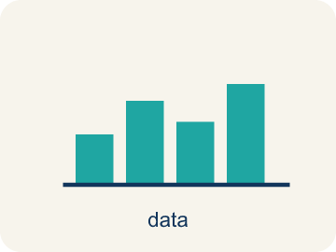 | math biography biografía matemática  The story of your relationship with math — and how it has changed over time.
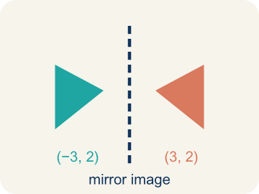 | reflect reflexionar  To look back at what you did, felt, and learned, and think about what it means.
 | growth crecimiento  The change between what you could do before and what you can do now.
 | confidence confianza  Trusting yourself to try a problem, even when the first attempt might fail.
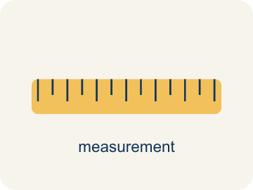 | community comunidad  The people and places around you — where math shows up outside the classroom.

Guided Notes
Fill in each blank as we go. Use the Word Bank to help you.
WORD BANK
math biography • reflect • growth • confidence • community

1. __________ — The story of your relationship with math — and how it has changed over time.
2. __________ — To look back at what you did, felt, and learned, and think about what it means.
3. __________ — The change between what you could do before and what you can do now.
4. __________ — Trusting yourself to try a problem, even when the first attempt might fail.
5. __________ — The people and places around you — where math shows up outside the classroom.

Write About the Math
Use the support level you need. Every level answers the same math question.

1. Understand the Question compare
How does your classmate's end-of-school-year math story compare to your story?
Your job: Answer the question. Use math evidence. Explain how the evidence proves your answer.
Responde la pregunta. Usa evidencia matemática. Explica cómo la evidencia demuestra tu respuesta.

2. Plan Your Math Words check at least two
☐ math biography — The story of your relationship with math — and how it has changed over time.
biografía matemática — La historia de tu relación con las matemáticas y cómo ha cambiado con el tiempo.
☐ reflect — To look back at what you did, felt, and learned, and think about what it means.
reflexionar — Mirar atrás a lo que hiciste, sentiste y aprendiste, y pensar en lo que significa.
☐ growth — The change between what you could do before and what you can do now.
crecimiento — El cambio entre lo que podías hacer antes y lo que puedes hacer ahora.
☐ confidence — Trusting yourself to try a problem, even when the first attempt might fail.
confianza — Confiar en ti mismo para intentar un problema, aunque el primer intento pueda fallar.
☐ community — The people and places around you — where math shows up outside the classroom.
comunidad — Las personas y los lugares que te rodean, donde las matemáticas aparecen fuera del aula.
Say it first: Say your idea to a partner or quietly to yourself before you write.
Describe how your math story has ___ this year, ask a ___ about their story, and then ___ the two to see how they are alike and different.
Di tu respuesta primero: Mi respuesta es ___ porque ___.

3. Build Your Explanation choose your support
This model shows the parts of an explanation. It does not answer your writing question.
Claim: 80 riders per turn × 6 turns an hour = 480 riders an hour, using a rate — a tool this year's math added.
Evidence: A strong answer multiplies 80 × 6 = 480 correctly and names 'rate' as the new tool. A weak answer gives 480 with no explanation of what changed since September.
Reasoning: This evidence connects the definition of math biography to the mathematical claim.

Start Most language support
Complete the frames. Use the word bank.
Completa las oraciones. Usa el banco de palabras.
Describe how your math story has ___ this year, ask a ___ about their story, and then ___ the two to see how they are alike and different.
My answer is ___.
Mi respuesta es ___.

Build Some language support
Write two connected sentences. Use because, so, or but.
Escribe dos oraciones conectadas. Usa porque, entonces o pero.
My claim is ___.
Mi afirmación es ___.
I know because ___.
Lo sé porque ___.
So ___.
Entonces ___.

Explain Light language support
Write a claim, give math evidence, and explain your reasoning.
Escribe una afirmación, da evidencia matemática y explica tu razonamiento.
My claim is ___.
Mi afirmación es ___.
My math evidence is ___.
Mi evidencia matemática es ___.
This proves ___ because ___.
Esto demuestra ___ porque ___.

4. Check Your Explanation five quick checks
☐ I answered the question.
Respondí la pregunta.
☐ I used math evidence: numbers, an equation, a model, or a comparison.
Usé evidencia matemática: números, una ecuación, un modelo o una comparación.
☐ I explained how the evidence proves my answer.
Expliqué cómo la evidencia demuestra mi respuesta.
☐ I used at least two math words.
Usé por lo menos dos palabras matemáticas.
☐ I reread complete sentences and punctuation.
Volví a leer mis oraciones completas y la puntuación.

Worked Example

Watch & Read I Do — follow along with your teacher
Unit 10 · Lesson 6
Throughout this school year, you have seen math used in many different activities and used it to solve different kinds of problems. Today you look back at the answers you wrote to the questions in Lesson 1-1 — and see how far your math story has come.

Solved Example I Do — watch each step
Problem: In Lesson 1-1 you estimated the Ferris wheel: 20 cars each holding about 4 people. About how many riders was that?
A) About 80
B) About 24
C) About 5
D) About 400
Step 1: 20 × 4 = 80 — the same estimate you made in September, and it still holds up.
Answer: A. About 80

Guided Practice

Solve Together We Do — work with your class
Problem: How has your attitude about math changed over the year?
Step 1:

Step 2:

Answer:

You and your classmates each wrote about your math stories at the beginning of the school year. Everyone has their own math story, and as you encounter new challenges and experiences, your story might change.
How does your classmate's end-of-school-year math story compare to your story?

Sentence frame: Describe how your math story has ___ this year, ask a ___ about their story, and then ___ the two to see how they are alike and different.

Turn & Talk discuss with a partner
1. [Launch] In September you estimated 20 cars × 4 riders = about 80 Ferris wheel riders per turn. Now, at 6 turns an hour, how many riders per hour — and what tool did you use that you didn't have in September?
Start with: The Ferris wheel carries about ___ riders an hour because ___.
La rueda de la fortuna lleva alrededor de ___ pasajeros por hora porque ___.
Word bank: rate, growth, changed
2. [Explore] When you sorted skills into 'I could already do this in September' and 'I learned or grew into this during Grade 6,' what made 'dividing a fraction by a fraction' belong in the growth column?
Start with: Dividing fractions belongs in the growth column because ___.
Dividir fracciones pertenece a la columna de crecimiento porque ___.
Word bank: growth, math biography, confidence
3. [Connect] In September you decomposed 78.5 as 70 + 8.5. This year you learned 78.5 = 157 ÷ 2 and 50% of 157 = 78.5. How does comparing these show your math story changing?
Start with: My math story changed because I can now write 78.5 using ___, not just ___.
Mi historia matemática cambió porque ahora puedo escribir 78.5 usando ___, no solo ___.
Word bank: math biography, growth, changed
4. [Practice] During practice, when you compared your September answers to your answers now, what strategy helped you notice real growth instead of just repeating your old answer?
Start with: I noticed growth by comparing ___ to ___.
Noté crecimiento al comparar ___ con ___.
Word bank: growth, reflect, confidence

Independent Practice

On Your Own You Do — show your work
Solve each problem. Show your thinking in the work box.

Level 1 Support extra scaffolding
1. In September you decomposed 78.5 as 70 + 8.5. Which of these ALSO equals 78.5, using division?
A) 157 ÷ 2
B) 156 ÷ 2
C) 78.5 ÷ 2
D) 157 ÷ 4

2. How have you used math at home or with your family in new or different ways this year?
3. Which statement matches this lesson's big idea about math stories?
A) Our math stories continue to grow and evolve as we grow
B) Your math story was finished when you wrote it in September
C) Only students with high grades have a math story
D) A math story never changes once it is written

4. As a result of what we learned together this year, where do you see math used in your community?

On Level grade-level practice
5. Now stretch the September estimate with this year's math: about 80 riders per turn, 6 turns each hour. About how many riders per hour?
A) About 480
B) About 86
C) About 13
D) About 800

6. Percents were new this year. What is 50% of 157?
A) 78.5
B) 77.5
C) 31.4
D) 107

Exit Ticket
Answer on your own. This shows what you learned today.
★ Which statement best captures this lesson's end-of-year summary of 'Math is Mine'?
A) We are all doers of math in daily life, and our math stories continue to grow and evolve as we grow
B) Math belongs only to the students who mastered every unit this year
C) A math story is written once in September and never changes
D) Math stops mattering once the school year ends

