2.1 Small Group · Group 1 — Homework
Lesson 2-1-group1 • Standard 6.DS.1
Name: ______________________ Period: ______ Date: ____________

Today's Goals
Content: With my small group, I can tell the difference between a statistical question and a non-statistical question — one step at a time, with support.
Language: I can talk through each step out loud using a sentence frame and the lesson's key words.

Key Words
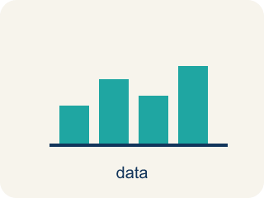
Statistical Questions and Data (Preguntas estadísticas y datos) — A statistical question expects varied answers that can be collected as data.
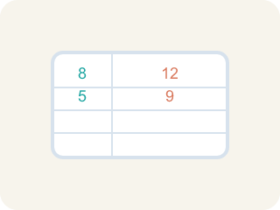
Statistical Question (Pregunta estadística) — A question where the answers will be different for different people.

Non-statistical Question (Pregunta no estadística) — A question that has just one fixed answer that is the same no matter who you ask, so there is no data to collect.

Data (Datos) — Facts and numbers you collect, like answers to a survey.
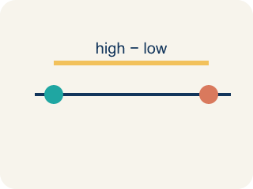
Variability (Variabilidad) — How spread out the numbers are.

Survey (Encuesta) — Collecting facts by asking people questions.
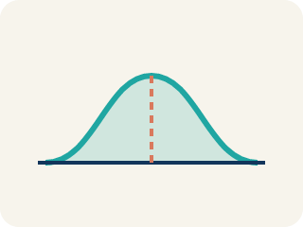
Data distribution (Distribución de datos) — How the data looks: where it sits and how spread out it is.

Practice
Show your work. Use the blank space under each problem.
1. Which of the following is a statistical question?
A. How many points did each player score this season?
B. How many points are scored for a free throw?
C. What sport does this team play?
D. How many halves are in a soccer game?
______________________________________________________________________
2. Which question is NOT a statistical question?
A. How many innings are in a baseball game?
B. How many home runs did each player hit this year?
C. How many miles does each runner train per week?
D. How tall is each player on the basketball team?
______________________________________________________________________
3. Which of these would collect data that VARIES (making it a statistical question)?
A. How many days are in one week?
B. How many siblings does each student in the class have?
C. How many minutes are in one hour?
D. What is 12 + 12?
______________________________________________________________________
4. The team analyst writes four questions for the scouting report. Which one is a statistical question?
A. How many rebounds does each player grab per game?
B. How many points is a single free throw worth?
C. What is the height of the basketball rim?
D. How many timeouts does each team get per half?
______________________________________________________________________
5. Why does the question "How many minutes did each athlete warm up before the game?" count as a statistical question?
A. Because the warm-up times will vary from one athlete to another
B. Because the answer is measured in minutes
C. Because every athlete warmed up for exactly the same time
D. Because it is about a sports team
______________________________________________________________________
6. Level 2 Extension — A Misclassified Scouting Question
Step 1 (Question): How many goals did the league's top scorer net this season?
Step 2 (Student decision): This is NOT a statistical question.
Step 3 (Student reason): It names only one player, so there can be no variability in the answers.
Which step has the mistake? Explain and fix it:
______________________________________________________________________
______________________________________________________________________
______________________________________________________________________
7. Find the Reasoning Error
Step 1 (Question): How many touchdowns did the quarterback throw this season?
Step 2 (Student says): This is NOT a statistical question.
Step 3 (Reason): It only asks about one player, so there is no variability.
Which step has the mistake? Explain and fix it:
______________________________________________________________________
______________________________________________________________________
______________________________________________________________________
8. Write one statistical question and one non-statistical question about your school's cafeteria. Explain why each question is or is not statistical, and describe what the data would look like for the statistical question.
Sentence starter: Statistical question: ___. This is statistical because ___. The data might look like: ___. Non-statistical question: ___. This is not statistical because ___.
______________________________________________________________________
______________________________________________________________________
______________________________________________________________________
______________________________________________________________________

Answer Key (Teacher)
1. A. How many points did each player score this season?
"How many points did each player score?" is statistical because different players will have different scores — there is variability in the data.
Watch for: A common mistake in Statistical Questions and Data is judging a question by its topic or its numbers instead of its variability. Students see a question about ONE player, ONE game, or ONE fixed fact — like "How many points does the team need to win a game?" — and call it statistical just because it has a number or is about sports. Or they see a question about a single player's whole season, like "How many touchdowns did the quarterback throw this season?", and call it NOT statistical because only one player is named, forgetting that a season covers many games with a different result each time. Both errors skip the real test: will the answers actually differ from case to case (game to game, player to player)? If yes, it is a statistical question; if there is one fixed answer, it is not.
2. A. How many innings are in a baseball game?
"How many innings are in a baseball game?" has one fixed answer (9) — no variability. The other questions all produce different answers for different people.
Watch for: A common mistake in Statistical Questions and Data is judging a question by its topic or its numbers instead of its variability. Students see a question about ONE player, ONE game, or ONE fixed fact — like "How many points does the team need to win a game?" — and call it statistical just because it has a number or is about sports. Or they see a question about a single player's whole season, like "How many touchdowns did the quarterback throw this season?", and call it NOT statistical because only one player is named, forgetting that a season covers many games with a different result each time. Both errors skip the real test: will the answers actually differ from case to case (game to game, player to player)? If yes, it is a statistical question; if there is one fixed answer, it is not.
3. B. How many siblings does each student in the class have?
Number of siblings varies from student to student, so the collected data will vary — that makes it statistical. The others each have one fixed answer.
Watch for: A common mistake in Statistical Questions and Data is judging a question by its topic or its numbers instead of its variability. Students see a question about ONE player, ONE game, or ONE fixed fact — like "How many points does the team need to win a game?" — and call it statistical just because it has a number or is about sports. Or they see a question about a single player's whole season, like "How many touchdowns did the quarterback throw this season?", and call it NOT statistical because only one player is named, forgetting that a season covers many games with a different result each time. Both errors skip the real test: will the answers actually differ from case to case (game to game, player to player)? If yes, it is a statistical question; if there is one fixed answer, it is not.
4. A. How many rebounds does each player grab per game?
"How many rebounds does each player grab per game?" anticipates variability — different players grab different numbers of rebounds, so you must collect data. The other three each have one fixed answer.
Watch for: A common mistake in Statistical Questions and Data is judging a question by its topic or its numbers instead of its variability. Students see a question about ONE player, ONE game, or ONE fixed fact — like "How many points does the team need to win a game?" — and call it statistical just because it has a number or is about sports. Or they see a question about a single player's whole season, like "How many touchdowns did the quarterback throw this season?", and call it NOT statistical because only one player is named, forgetting that a season covers many games with a different result each time. Both errors skip the real test: will the answers actually differ from case to case (game to game, player to player)? If yes, it is a statistical question; if there is one fixed answer, it is not.
5. A. Because the warm-up times will vary from one athlete to another
A statistical question anticipates variability. Different athletes warm up for different amounts of time, so the data you collect will vary.
Watch for: A common mistake in Statistical Questions and Data is judging a question by its topic or its numbers instead of its variability. Students see a question about ONE player, ONE game, or ONE fixed fact — like "How many points does the team need to win a game?" — and call it statistical just because it has a number or is about sports. Or they see a question about a single player's whole season, like "How many touchdowns did the quarterback throw this season?", and call it NOT statistical because only one player is named, forgetting that a season covers many games with a different result each time. Both errors skip the real test: will the answers actually differ from case to case (game to game, player to player)? If yes, it is a statistical question; if there is one fixed answer, it is not.
6. Level 2 Extension — A Misclassified Scouting Question
The mistake is in Step 3.
Correct work: The reason is wrong. "This season" covers many games, and the player scores a different number of goals in each game. Because the data varies from game to game, the question DOES anticipate variability — so it IS a statistical question.
Watch for: The reasoning step assumes that naming one player rules out variability, but 'this season' spans many games and the goal count changes from game to game. Variability can come from many games for a single player, so the question is statistical.
7. Find the Reasoning Error
The mistake is in Step 3.
Correct work: Even though it asks about one player, "this season" means multiple games. The number of touchdowns per game varies, so there IS variability in the data. This IS a statistical question.
Watch for: The reasoning step assumes one player means no variability, but 'this season' covers many games and the touchdown count changes from game to game. That game-to-game variation is real data variability, so the question is statistical.
8. Open response — answers will vary.
Look for key words: variability, different answers, one answer, data, varies, fixed.

