2.1 Small Group · Group 2 — Homework
Lesson 2-1-group2 • Standard 6.DS.1
Name: ______________________ Period: ______ Date: ____________

Today's Goals
Content: I can tell the difference between a statistical question and a non-statistical question, explain how I can tell, and judge a case I have not seen before.
Language: I can justify my answer to a skeptic and connect it to a second strategy or representation.

Key Words
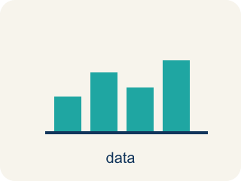
Statistical Questions and Data (Preguntas estadísticas y datos) — A statistical question expects varied answers that can be collected as data.
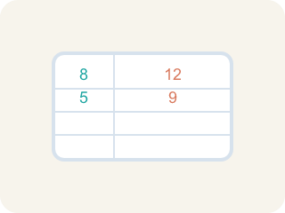
Statistical Question (Pregunta estadística) — A question where the answers will be different for different people.

Non-statistical Question (Pregunta no estadística) — A question that has just one fixed answer that is the same no matter who you ask, so there is no data to collect.

Data (Datos) — Facts and numbers you collect, like answers to a survey.
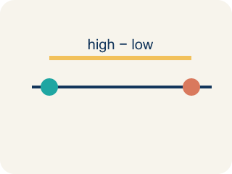
Variability (Variabilidad) — How spread out the numbers are.

Survey (Encuesta) — Collecting facts by asking people questions.
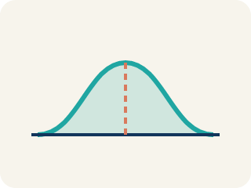
Data distribution (Distribución de datos) — How the data looks: where it sits and how spread out it is.

Practice
Show your work. Use the blank space under each problem.
1. A coach asks: "How many hours does each athlete on the track team sleep the night before a meet?" Why is this a statistical question?
A. Because the answers will vary from athlete to athlete
B. Because it is about sports
C. Because it has a numerical answer
D. Because the coach asked it
______________________________________________________________________
2. Spot the Common Mistake
Step 1 (Question): How many points does the team need to win a game?
Step 2 (Student decision): This IS a statistical question.
Step 3 (Student reason): It is about basketball and the answer is a number, so it must be statistical.
Which step has the mistake? Explain and fix it:
______________________________________________________________________
______________________________________________________________________
______________________________________________________________________
3. Which of these is a statistical question?
A. What time is it right now?
B. How tall are the students in my class?
C. What is my shoe size?
D. What is 7 × 8?
______________________________________________________________________
4. Which of these would collect data that VARIES (making it a statistical question)?
A. How many days are in one week?
B. How many siblings does each student in the class have?
C. How many minutes are in one hour?
D. What is 12 + 12?
______________________________________________________________________

Answer Key (Teacher)
1. A. Because the answers will vary from athlete to athlete
A statistical question anticipates variability. Different athletes sleep different amounts, so the data collected will vary.
Watch for: A common mistake in Statistical Questions and Data is judging a question by its topic or its numbers instead of its variability. Students see a question about ONE player, ONE game, or ONE fixed fact — like "How many points does the team need to win a game?" — and call it statistical just because it has a number or is about sports. Or they see a question about a single player's whole season, like "How many touchdowns did the quarterback throw this season?", and call it NOT statistical because only one player is named, forgetting that a season covers many games with a different result each time. Both errors skip the real test: will the answers actually differ from case to case (game to game, player to player)? If yes, it is a statistical question; if there is one fixed answer, it is not.
2. Spot the Common Mistake
The mistake is in Step 3.
Correct work: The reason is wrong. Being about basketball or having a number does not make a question statistical. "How many points does the team need to win a game?" has one fixed answer — you only need to score more than the other team — so the answers do not vary. This is NOT a statistical question.
Watch for: The reasoning step says a basketball topic and a numerical answer make a question statistical, but neither one does. The points needed to win has a single fixed answer — more than the other team — so nothing varies, and the question is not statistical.
3. B. How tall are the students in my class?
A statistical question anticipates variability — students' heights differ, so the data will vary.
Watch for: A common mistake in Statistical Questions and Data is judging a question by its topic or its numbers instead of its variability. Students see a question about ONE player, ONE game, or ONE fixed fact — like "How many points does the team need to win a game?" — and call it statistical just because it has a number or is about sports. Or they see a question about a single player's whole season, like "How many touchdowns did the quarterback throw this season?", and call it NOT statistical because only one player is named, forgetting that a season covers many games with a different result each time. Both errors skip the real test: will the answers actually differ from case to case (game to game, player to player)? If yes, it is a statistical question; if there is one fixed answer, it is not.
4. B. How many siblings does each student in the class have?
Number of siblings varies from student to student, so the collected data will vary — that makes it statistical. The others each have one fixed answer.
Watch for: A common mistake in Statistical Questions and Data is judging a question by its topic or its numbers instead of its variability. Students see a question about ONE player, ONE game, or ONE fixed fact — like "How many points does the team need to win a game?" — and call it statistical just because it has a number or is about sports. Or they see a question about a single player's whole season, like "How many touchdowns did the quarterback throw this season?", and call it NOT statistical because only one player is named, forgetting that a season covers many games with a different result each time. Both errors skip the real test: will the answers actually differ from case to case (game to game, player to player)? If yes, it is a statistical question; if there is one fixed answer, it is not.

