2.10 Small Group · Group 1 — Homework
Lesson 2-10-group1 • Standard 6.DS.6d
Name: ______________________ Period: ______ Date: ____________

Today's Goals
Content: With my small group, I can choose the best measure of center for a data set based on its shape — one step at a time, with support.
Language: I can talk through each step out loud using a sentence frame and the lesson's key words.

Key Words
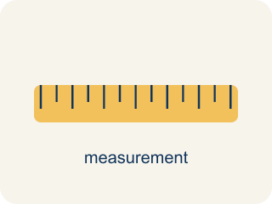
Appropriate Measures of Center (Medidas de centro apropiadas) — A mean, median, or mode chosen because it describes a data set fairly.
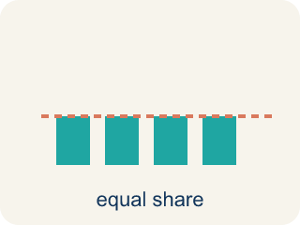
Mean (Media) — The average. Add all the numbers, then divide by how many there are.
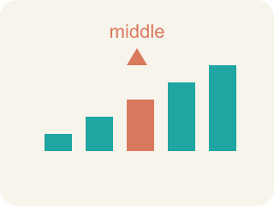
Median (Mediana) — The middle number when you put them in order.
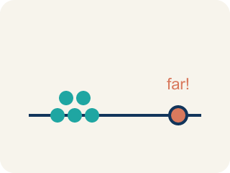
Outlier (Valor atípico) — A number that is much bigger or smaller than the rest.
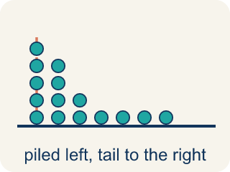
Skewed (Sesgado) — When most data sits on one side with a tail on the other.
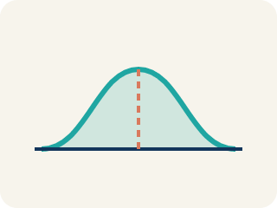
Data distribution (Distribución de datos) — How the data looks: where it sits and how spread out it is.
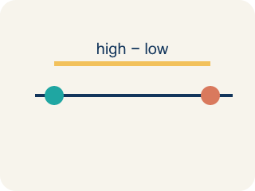
Variability (Variabilidad) — How spread out the numbers are.

Practice
Show your work. Use the blank space under each problem.
1. A gymnast's scores are: 8.5, 8.8, 8.7, 8.6, 8.9. There are no outliers. Which measure best represents a typical score?
A. Mean
B. Median
C. Neither — the data is too small
D. Both are equally bad
______________________________________________________________________
2. A runner's mile times are: 7:10, 7:15, 7:12, 7:20, 12:00. The 12:00 was due to a cramp. Which measure best represents a typical mile?
A. Median — the outlier 12:00 pulls the mean too high
B. Mean — it uses all the data
C. Mode — it shows the most common time
D. Neither measure works
______________________________________________________________________
3. A scout records points per game: 14, 16, 15, 17, 16, 58. To report a TYPICAL game, which measure of center is best?
A. Median, because 58 is an outlier that pulls the mean up
B. Mean, because it uses every game
C. Range, because it shows the highest game
D. Mode, because 16 appears twice
______________________________________________________________________
4. The equipment manager needs to order the MOST COMMON jersey size from this list: M, L, M, S, M, L, M. Which measure answers the question?
A. Mode, because it names the value that appears most
B. Mean, because it averages the sizes
C. Median, because it finds the middle size
D. Range, because it shows the size gap
______________________________________________________________________
5. A coach wants to know how SPREAD OUT the team's free-throw makes are: 6, 7, 6, 8, 18. Which measure of spread is most affected by the lone 18?
A. Range, because it is the highest minus the lowest value
B. Median, because it is in the middle
C. Mode, because it is the most common
D. Mean absolute deviation only, never the range
______________________________________________________________________
6. Level 2 Extension — The Analyst's Wrong Measure
Step 1 (Data): A player's points per game: 19, 21, 20, 22, 23, 2 (the 2 was a game cut short by an early ejection).
Step 2 (Find mean): Sum = 107, Count = 6, Mean = 107 ÷ 6 ≈ 17.8
Step 3 (Find median): Ordered: 2, 19, 20, 21, 22, 23 → Median = (20 + 21) ÷ 2 = 20.5
Step 4 (Analyst's choice): The analyst reports the mean (17.8) as the player's typical scoring because it uses all the data.
Which step has the mistake? Explain and fix it:
______________________________________________________________________
______________________________________________________________________
______________________________________________________________________
7. Find the Reasoning Error
Step 1 (Data): Player minutes per game: 32, 34, 30, 35, 33, 5
Step 2 (Find mean): Sum = 169, Count = 6, Mean = 28.2
Step 3 (Find median): Ordered: 5, 30, 32, 33, 34, 35 → Median = (32+33) ÷ 2 = 32.5
Step 4 (Conclusion): The mean (28.2) is the best measure because it uses all the data.
Which step has the mistake? Explain and fix it:
______________________________________________________________________
______________________________________________________________________
______________________________________________________________________
8. A local newspaper reports that the average home price in a neighborhood is $450,000. The actual prices are: $180K, $200K, $190K, $210K, $195K, $1,725K. Is the reporter's claim misleading? Calculate the mean and median and explain which better represents a 'typical' home price.
Sentence starter: Mean = ___. Median = ___. The reporter's claim is ___ because the outlier ($1,725K) pulls the mean ___. The ___ (about $___) better represents a typical home price because ___.
______________________________________________________________________
______________________________________________________________________
______________________________________________________________________
______________________________________________________________________

Answer Key (Teacher)
1. A. Mean
The data is symmetric with no outliers, so the mean (8.7) best represents the typical score.
Watch for: A common mistake in Appropriate Measures is defaulting to the mean just because "it uses all the data," without first checking whether an outlier or skewed shape is present. For example, given a player's points per game 14, 16, 15, 17, 16, 58, a student calculates the mean (136 ÷ 6 ≈ 22.7) and reports that as the typical game — but 58 is far from the cluster of 14–17, so it pulls the mean above 5 of the 6 games. The median (16) actually represents a typical game here. Before choosing a measure, always scan the data for an outlier or a long tail first: only use the mean once you've confirmed the data has neither.
2. A. Median — the outlier 12:00 pulls the mean too high
The 12:00 is an outlier that pulls the mean up. The median (7:15) better represents the runner's typical time.
Watch for: A common mistake in Appropriate Measures is defaulting to the mean just because "it uses all the data," without first checking whether an outlier or skewed shape is present. For example, given a player's points per game 14, 16, 15, 17, 16, 58, a student calculates the mean (136 ÷ 6 ≈ 22.7) and reports that as the typical game — but 58 is far from the cluster of 14–17, so it pulls the mean above 5 of the 6 games. The median (16) actually represents a typical game here. Before choosing a measure, always scan the data for an outlier or a long tail first: only use the mean once you've confirmed the data has neither.
3. A. Median, because 58 is an outlier that pulls the mean up
The 58-point game is an outlier. It pulls the mean above 5 of the 6 games, so the median (16) better shows a typical game.
Watch for: A common mistake in Appropriate Measures is defaulting to the mean just because "it uses all the data," without first checking whether an outlier or skewed shape is present. For example, given a player's points per game 14, 16, 15, 17, 16, 58, a student calculates the mean (136 ÷ 6 ≈ 22.7) and reports that as the typical game — but 58 is far from the cluster of 14–17, so it pulls the mean above 5 of the 6 games. The median (16) actually represents a typical game here. Before choosing a measure, always scan the data for an outlier or a long tail first: only use the mean once you've confirmed the data has neither.
4. A. Mode, because it names the value that appears most
The mode is the value that shows up most often. Here size M appears 4 times, so the mode (M) tells the manager what to order most.
Watch for: A common mistake in Appropriate Measures is defaulting to the mean just because "it uses all the data," without first checking whether an outlier or skewed shape is present. For example, given a player's points per game 14, 16, 15, 17, 16, 58, a student calculates the mean (136 ÷ 6 ≈ 22.7) and reports that as the typical game — but 58 is far from the cluster of 14–17, so it pulls the mean above 5 of the 6 games. The median (16) actually represents a typical game here. Before choosing a measure, always scan the data for an outlier or a long tail first: only use the mean once you've confirmed the data has neither.
5. A. Range, because it is the highest minus the lowest value
Range = max − min = 18 − 6 = 12. Because it uses only the two most extreme values, one outlier (18) changes the range a lot.
Watch for: A common mistake in Appropriate Measures is defaulting to the mean just because "it uses all the data," without first checking whether an outlier or skewed shape is present. For example, given a player's points per game 14, 16, 15, 17, 16, 58, a student calculates the mean (136 ÷ 6 ≈ 22.7) and reports that as the typical game — but 58 is far from the cluster of 14–17, so it pulls the mean above 5 of the 6 games. The median (16) actually represents a typical game here. Before choosing a measure, always scan the data for an outlier or a long tail first: only use the mean once you've confirmed the data has neither.
6. Level 2 Extension — The Analyst's Wrong Measure
The mistake is in Step 4.
Correct work: The analyst should report the median (20.5), not the mean. The score of 2 is an outlier from the cut-short game. It pulls the mean down to 17.8, which is lower than 5 of the 6 games, so it does not represent a typical performance. The median (20.5) is resistant to the outlier and better describes a typical game.
Watch for: The 2-point game was cut short by an ejection, so it is an outlier, and it drags the mean down to about 17.8 — lower than five of the six games. The median 20.5 sits among the 19-to-23 point games, so it describes the player's typical scoring much better.
7. Find the Reasoning Error
The mistake is in Step 4.
Correct work: The median (32.5) is the better measure. The value 5 is an outlier (the player was injured that game) that pulls the mean down to 28.2, which is lower than any of the player's healthy games. The median (32.5) better represents typical minutes played.
Watch for: The value 5 is an outlier from an injury game, and it drags the mean down to 28.2 — lower than every healthy game in the set. The median 32.5 sits among the 30-to-35 minute games, so it describes typical minutes far better. Using all the data is not an advantage when one value is that extreme.
8. Open response — answers will vary.
Look for key words: mean, median, outlier, misleading, pulls, higher, typical, skewed.

