2.10 Small Group · Group 2 — Homework
Lesson 2-10-group2 • Standard 6.DS.6d
Name: ______________________ Period: ______ Date: ____________

Today's Goals
Content: I can choose the best measure of center for a data set based on its shape, explain why the method works, and use it on a problem I have not seen before.
Language: I can justify my answer to a skeptic and connect it to a second strategy or representation.

Key Words
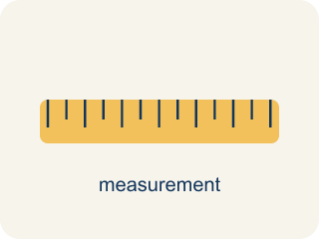
Appropriate Measures of Center (Medidas de centro apropiadas) — A mean, median, or mode chosen because it describes a data set fairly.
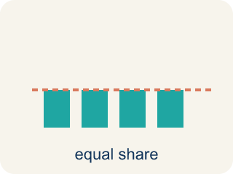
Mean (Media) — The average. Add all the numbers, then divide by how many there are.
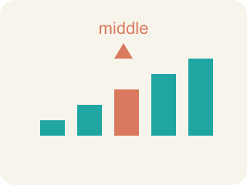
Median (Mediana) — The middle number when you put them in order.
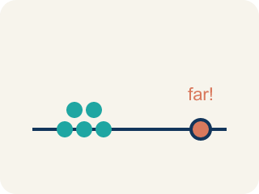
Outlier (Valor atípico) — A number that is much bigger or smaller than the rest.
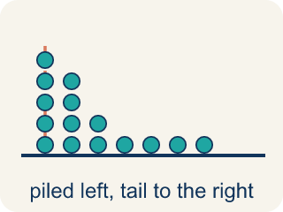
Skewed (Sesgado) — When most data sits on one side with a tail on the other.
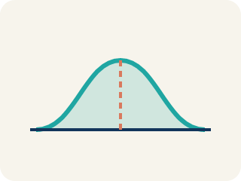
Data distribution (Distribución de datos) — How the data looks: where it sits and how spread out it is.
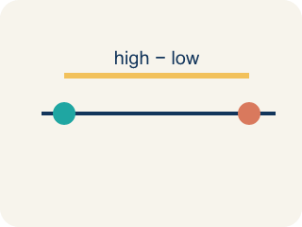
Variability (Variabilidad) — How spread out the numbers are.

Practice
Show your work. Use the blank space under each problem.
1. A baseball player's batting averages over 6 seasons are: .280, .295, .290, .285, .300, .110. The .110 was an injury-shortened season. Which measure better represents the player's typical batting average?
A. Median, because the .110 outlier pulls the mean down
B. Mean, because it uses all the data
C. Mean, because .110 is a real season
D. Neither measure works
______________________________________________________________________
2. Spot the Mistake — Choosing the Mean Despite an Outlier
Step 1 (Data): A receiver's catches per game: 12, 14, 13, 15, 11, 60 (the 60 was a record-setting playoff game).
Step 2 (Find the mean): Sum = 125, Count = 6, Mean = 125 ÷ 6 ≈ 20.8.
Step 3 (Find the median): Ordered: 11, 12, 13, 14, 15, 60 → Median = (13 + 14) ÷ 2 = 13.5.
Step 4 (Choose a measure): The student reports the mean (≈ 20.8) as the typical number of catches because it uses every game.
Which step has the mistake? Explain and fix it:
______________________________________________________________________
______________________________________________________________________
______________________________________________________________________
3. Find the Reasoning Error
Step 1 (Data): Player minutes per game: 32, 34, 30, 35, 33, 5
Step 2 (Find mean): Sum = 169, Count = 6, Mean = 28.2
Step 3 (Find median): Ordered: 5, 30, 32, 33, 34, 35 → Median = (32+33) ÷ 2 = 32.5
Step 4 (Conclusion): The mean (28.2) is the best measure because it uses all the data.
Which step has the mistake? Explain and fix it:
______________________________________________________________________
______________________________________________________________________
______________________________________________________________________
4. A local newspaper reports that the average home price in a neighborhood is $450,000. The actual prices are: $180K, $200K, $190K, $210K, $195K, $1,725K. Is the reporter's claim misleading? Calculate the mean and median and explain which better represents a 'typical' home price.
Sentence starter: Mean = ___. Median = ___. The reporter's claim is ___ because the outlier ($1,725K) pulls the mean ___. The ___ (about $___) better represents a typical home price because ___.
______________________________________________________________________
______________________________________________________________________
______________________________________________________________________
______________________________________________________________________

Answer Key (Teacher)
1. A. Median, because the .110 outlier pulls the mean down
The .110 is an outlier that pulls the mean down to .260. The median (.2875) better represents typical performance because it isn't affected by the extreme value.
Watch for: A common mistake in Appropriate Measures is defaulting to the mean just because "it uses all the data," without first checking whether an outlier or skewed shape is present. For example, given a player's points per game 14, 16, 15, 17, 16, 58, a student calculates the mean (136 ÷ 6 ≈ 22.7) and reports that as the typical game — but 58 is far from the cluster of 14–17, so it pulls the mean above 5 of the 6 games. The median (16) actually represents a typical game here. Before choosing a measure, always scan the data for an outlier or a long tail first: only use the mean once you've confirmed the data has neither.
2. Spot the Mistake — Choosing the Mean Despite an Outlier
The mistake is in Step 4.
Correct work: The student should report the median (13.5), not the mean. The 60-catch game is an outlier that pulls the mean up to about 20.8 — higher than 5 of the 6 games. The median (13.5) is resistant to that outlier and better represents a typical game.
Watch for: Using every value is exactly the problem here: the 60-catch playoff game pulls the mean up to about 20.8, which is higher than five of the six games. The median 13.5 sits inside the cluster of 11 to 15 and is not moved by that extreme value, so it is the better report of a typical game.
3. Find the Reasoning Error
The mistake is in Step 4.
Correct work: The median (32.5) is the better measure. The value 5 is an outlier (the player was injured that game) that pulls the mean down to 28.2, which is lower than any of the player's healthy games. The median (32.5) better represents typical minutes played.
Watch for: The value 5 is an outlier from an injury game, and it drags the mean down to 28.2 — lower than every healthy game in the set. The median 32.5 sits among the 30-to-35 minute games, so it describes typical minutes far better. Using all the data is not an advantage when one value is that extreme.
4. Open response — answers will vary.
Look for key words: mean, median, outlier, misleading, pulls, higher, typical, skewed.

