UNIT 2 · LESSON 10 STANDARD 6.DS.6D

Choose Appropriate Measures
Student Notes Packet
Name: ______________________ Date: ____________ Period: ________

Today's Goals
Content: I can choose the best measure of center for a data set based on its shape.
Language: I can explain my choice using the words mean, median, outlier, and skewed.

Key Vocabulary
Look at the picture, read the word, then read what it means.
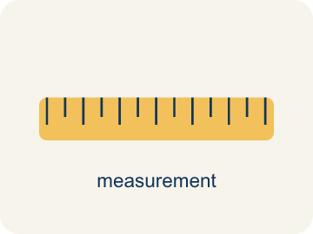 | Appropriate Measures of Center Medidas de centro apropiadas  A mean, median, or mode chosen because it describes a data set fairly.  Example: Use the median when an outlier would pull the mean too far.
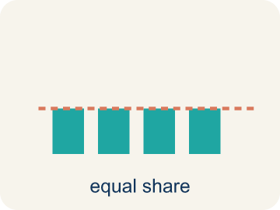 | Mean Media  The average. Add all the numbers, then divide by how many there are.  Example: Mean of 10, 20, 30 = (10+20+30) ÷ 3 = 20
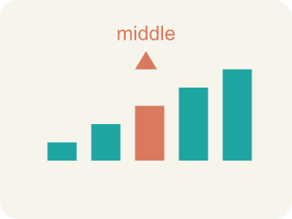 | Median Mediana  The middle number when you put them in order.  Example: Data: 5, 8, 12, 15, 20 → median is 12 (the 3rd of 5 values)
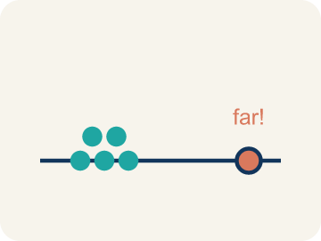 | Outlier Valor atípico  A number that is much bigger or smaller than the rest.  Example: Data: 12, 14, 13, 15, 45 → 45 is far from the cluster, so it is an outlier
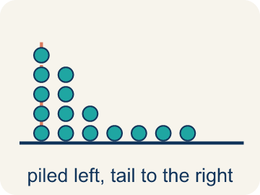 | Skewed Sesgado  When most data sits on one side with a tail on the other.  Example: Scores: 5, 6, 7, 8, 8, 35 → most scores are low, but 35 creates a tail to the right (skewed right)
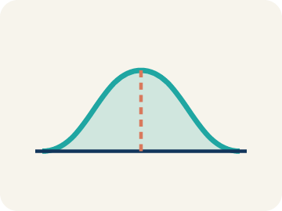 | Data distribution Distribución de datos  How the data looks: where it sits and how spread out it is.  Example: Symmetric = even on both sides. Skewed = bunched on one side with a tail
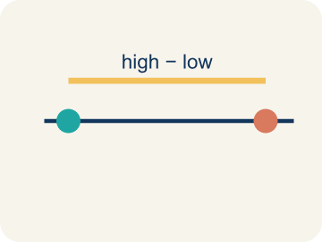 | Variability Variabilidad  How spread out the numbers are.  Example: 88, 90, 89, 91 (low variability) vs. 50, 70, 95, 100 (high variability)

Guided Notes
Fill in each blank as we go. Use the Word Bank to help you.
WORD BANK
Appropriate Measures of Center • Mean • Median • Outlier • Skewed • Data distribution • Variability

1. __________ — A mean, median, or mode chosen because it describes a data set fairly.
2. The average of a data set is the ___.
3. The middle value when data is in order, often best when there is an outlier, is the ___.
4. A value far from the rest of the data, which can pull the mean, is an ___.
5. Data that is bunched on one side with a tail on the other is ___.
6. The way data values are spread out is the ___.
7. How much the data values differ is the ___.

Write About the Math
Use the support level you need. Every level answers the same math question.

1. Understand the Question describe
Is $85 a fair way to describe a 'typical' ticket price? What measure should the reporter use?
Your job: Answer the question. Use math evidence. Explain how the evidence proves your answer.
Responde la pregunta. Usa evidencia matemática. Explica cómo la evidencia demuestra tu respuesta.

2. Plan Your Math Words check at least two
☐ Appropriate Measures of Center — A mean, median, or mode chosen because it describes a data set fairly.
Medidas de centro apropiadas — Una media, mediana o moda elegida porque describe un conjunto de datos de manera justa.
☐ Mean — The average. Add all the numbers, then divide by how many there are.
Media — El promedio. Suma todos los números y divide entre cuántos hay.
☐ Median — The middle number when you put them in order.
Mediana — El número del medio cuando los pones en orden.
☐ Outlier — A number that is much bigger or smaller than the rest.
Valor atípico — Un número mucho mayor o menor que los demás.
☐ Skewed — When most data sits on one side with a tail on the other.
Sesgado — Cuando la mayoría de los datos está de un lado con una cola del otro.
Say it first: Say your idea to a partner or quietly to yourself before you write.
The reporter used the ___, which is ___. A better measure would be the ___ (about ___) because ___. The courtside seat at $260 is an ___ that pulls the mean ___.
Di tu respuesta primero: Mi respuesta es ___ porque ___.

3. Build Your Explanation choose your support
This model shows the parts of an explanation. It does not answer your writing question.
Claim: An outlier can pull the mean away from what is typical, making the median a better choice.
Evidence: Students choose the median (23) and identify 58 as an outlier that pulls the mean up to 27.6, making it unrepresentative.
Reasoning: This evidence connects the definition of appropriate measures of center to the mathematical claim.

Start Most language support
Complete the frames. Use the word bank.
Completa las oraciones. Usa el banco de palabras.
The reporter used the ___, which is ___. A better measure would be the ___ (about ___) because ___. The courtside seat at $260 is an ___ that pulls the mean ___.
My answer is ___.
Mi respuesta es ___.

Build Some language support
Write two connected sentences. Use because, so, or but.
Escribe dos oraciones conectadas. Usa porque, entonces o pero.
My claim is ___.
Mi afirmación es ___.
I know because ___.
Lo sé porque ___.
So ___.
Entonces ___.

Explain Light language support
Write a claim, give math evidence, and explain your reasoning.
Escribe una afirmación, da evidencia matemática y explica tu razonamiento.
My claim is ___.
Mi afirmación es ___.
My math evidence is ___.
Mi evidencia matemática es ___.
This proves ___ because ___.
Esto demuestra ___ porque ___.

4. Check Your Explanation five quick checks
☐ I answered the question.
Respondí la pregunta.
☐ I used math evidence: numbers, an equation, a model, or a comparison.
Usé evidencia matemática: números, una ecuación, un modelo o una comparación.
☐ I explained how the evidence proves my answer.
Expliqué cómo la evidencia demuestra mi respuesta.
☐ I used at least two math words.
Usé por lo menos dos palabras matemáticas.
☐ I reread complete sentences and punctuation.
Volví a leer mis oraciones completas y la puntuación.

Worked Example

Watch & Read I Do — follow along with your teacher
Stats Report Decision
The league is creating awards for the season. For the scoring title, they need to pick the best measure of a typical game. Here are the top scorer's points per game: 22, 24, 20, 25, 23, 21, 58. That 58-point game was a record-breaker! Should the league report the mean (27.6) or the median (23) as the player's typical scoring?

Think about:
• How does the 58-point game compare to the other scores?
• What is the mean? What is the median?
• Which measure is closer to what this player usually scores?
• When does an outlier make the mean misleading?
• Is there a rule for when to use mean vs. median?

Solved Example I Do — watch each step
Problem: A gymnast's scores are: 8.5, 8.8, 8.7, 8.6, 8.9. There are no outliers. Which measure best represents a typical score?
A) Mean
B) Median
C) Neither — the data is too small
D) Both are equally bad
Step 1: The data is symmetric with no outliers, so the mean (8.7) best represents the typical score.
Answer: A. Mean

Guided Practice

Solve Together We Do — work with your class
Problem: A runner's mile times are: 7:10, 7:15, 7:12, 7:20, 12:00. The 12:00 was due to a cramp. Which measure best represents a typical mile?
A) Median — the outlier 12:00 pulls the mean too high
B) Mean — it uses all the data
C) Mode — it shows the most common time
D) Neither measure works
Step 1:

Step 2:

Answer:

A sports reporter writes: 'The average ticket price for the playoffs is $85.' The actual prices are: $45, $50, $48, $52, $55, $260. The $260 ticket is a courtside seat.
Is $85 a fair way to describe a 'typical' ticket price? What measure should the reporter use?

Sentence frame: The reporter used the ___, which is ___. A better measure would be the ___ (about ___) because ___. The courtside seat at $260 is an ___ that pulls the mean ___.

Turn & Talk discuss with a partner
1. [Launch] A top scorer's points were 22, 24, 20, 25, 23, 21, 58. The mean is 27.6 but the median is 23. Which should the league report as the 'typical' game, and why?
Start with: The league should report the ___ because ___.
La liga debería reportar la ___ porque ___.
Word bank: mean, median, outlier, skewed, measure of center
2. [Explore] As you sort scenarios into 'Use Mean' or 'Use Median,' what clue tells you a data set needs the median instead of the mean?
Start with: I use the median when the data has ___.
Uso la mediana cuando los datos tienen ___.
Word bank: mean, median, outlier, skewed, measure of center
3. [Connect] A reporter writes 'the average playoff ticket is $85,' but prices are $45, $50, $48, $52, $55, $260. Is $85 a fair 'typical' price? What measure should the reporter use?
Start with: $85 is / is not fair because the $260 ticket ___.
$85 es / no es justo porque el boleto de $260 ___.
Word bank: mean, median, outlier, skewed, measure of center
4. [Reflect] For the data set 15, 18, 16, 17, 15, 72, which measure of center best represents the data, and why?
Start with: The ___ best represents the data because ___.
La ___ representa mejor los datos porque ___.
Word bank: mean, median, outlier, skewed, measure of center
5. [Practice] During practice on Appropriate Measures, what strategy did you use when a problem felt tricky?
Start with: I use the median when the data has ___.
Uso la mediana cuando los datos tienen ___.
Word bank: Mean, Median, Outlier, Skewed

Independent Practice

On Your Own You Do — show your work
Solve each problem. Show your thinking in the work box.

Level 1 Support extra scaffolding
1. Match each data description with the best measure of center.
2. Data set: 5, 6, 7, 7, 8, 50. The mean is about 13.8 and the median is 7. Which better represents the typical value?
A) Median (7) — the outlier 50 inflates the mean
B) Mean (13.8) — it includes all values
C) Both are equally good
D) Neither works for this data

On Level grade-level practice
3. A baseball player's batting averages over 6 seasons are: .280, .295, .290, .285, .300, .110. The .110 was an injury-shortened season. Which measure better represents the player's typical batting average?
A) Median, because the .110 outlier pulls the mean down
B) Mean, because it uses all the data
C) Mean, because .110 is a real season
D) Neither measure works

4. Match the reason with whether to use mean or median.

Exit Ticket
Answer on your own. This shows what you learned today.
★ Data set: 15, 18, 16, 17, 15, 72. Which measure of center best represents the data?
A) Median, because 72 is an outlier
B) Mean, because it uses all values
C) Mean, because it is always best
D) Neither works for this data

