Choose Appropriate Measures — Homework
Lesson 2-10 • Standard 6.DS.6d
Name: ______________________ Period: ______ Date: ____________

Today's Goals
Content: I can choose the best measure of center for a data set based on its shape.
Language: I can explain my choice using the words mean, median, outlier, and skewed.

Key Words
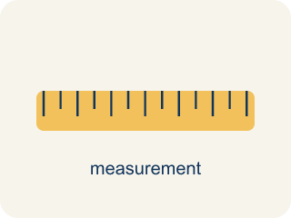
Appropriate Measures of Center (Medidas de centro apropiadas) — A mean, median, or mode chosen because it describes a data set fairly.
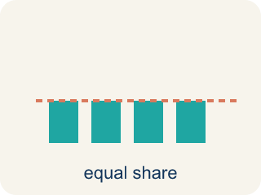
Mean (Media) — The average. Add all the numbers, then divide by how many there are.
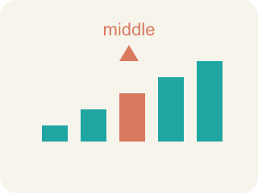
Median (Mediana) — The middle number when you put them in order.
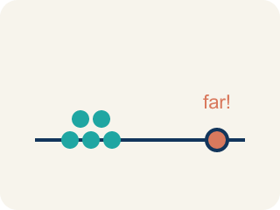
Outlier (Valor atípico) — A number that is much bigger or smaller than the rest.
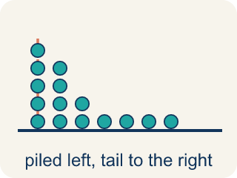
Skewed (Sesgado) — When most data sits on one side with a tail on the other.
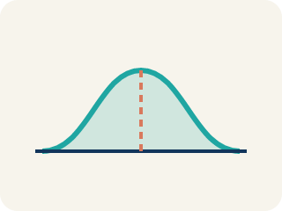
Data distribution (Distribución de datos) — How the data looks: where it sits and how spread out it is.
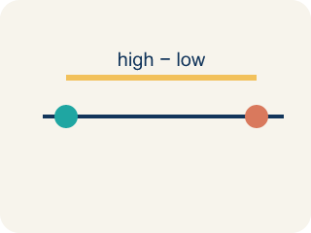
Variability (Variabilidad) — How spread out the numbers are.

Practice
Show your work. Use the blank space under each problem.
1. A gymnast's scores are: 8.5, 8.8, 8.7, 8.6, 8.9. There are no outliers. Which measure best represents a typical score?
A. Mean
B. Median
C. Neither — the data is too small
D. Both are equally bad
______________________________________________________________________
2. A runner's mile times are: 7:10, 7:15, 7:12, 7:20, 12:00. The 12:00 was due to a cramp. Which measure best represents a typical mile?
A. Median — the outlier 12:00 pulls the mean too high
B. Mean — it uses all the data
C. Mode — it shows the most common time
D. Neither measure works
______________________________________________________________________
3. A baseball player's batting averages over 6 seasons are: .280, .295, .290, .285, .300, .110. The .110 was an injury-shortened season. Which measure better represents the player's typical batting average?
A. Median, because the .110 outlier pulls the mean down
B. Mean, because it uses all the data
C. Mean, because .110 is a real season
D. Neither measure works
______________________________________________________________________
4. Complete the table.
Data Set | Mean | Median | Outlier? | Best Measure
15, 18, 16, 17, 15
15, 18, 16, 17, 72
______________________________________________________________________
5. Spot the Mistake — Choosing the Mean Despite an Outlier
Step 1 (Data): A receiver's catches per game: 12, 14, 13, 15, 11, 60 (the 60 was a record-setting playoff game).
Step 2 (Find the mean): Sum = 125, Count = 6, Mean = 125 ÷ 6 ≈ 20.8.
Step 3 (Find the median): Ordered: 11, 12, 13, 14, 15, 60 → Median = (13 + 14) ÷ 2 = 13.5.
Step 4 (Choose a measure): The student reports the mean (≈ 20.8) as the typical number of catches because it uses every game.
Which step has the mistake? Explain and fix it:
______________________________________________________________________
______________________________________________________________________
______________________________________________________________________
6. A scout records points per game: 14, 16, 15, 17, 16, 58. To report a TYPICAL game, which measure of center is best?
A. Median, because 58 is an outlier that pulls the mean up
B. Mean, because it uses every game
C. Range, because it shows the highest game
D. Mode, because 16 appears twice
______________________________________________________________________
7. The equipment manager needs to order the MOST COMMON jersey size from this list: M, L, M, S, M, L, M. Which measure answers the question?
A. Mode, because it names the value that appears most
B. Mean, because it averages the sizes
C. Median, because it finds the middle size
D. Range, because it shows the size gap
______________________________________________________________________
8. A coach wants to know how SPREAD OUT the team's free-throw makes are: 6, 7, 6, 8, 18. Which measure of spread is most affected by the lone 18?
A. Range, because it is the highest minus the lowest value
B. Median, because it is in the middle
C. Mode, because it is the most common
D. Mean absolute deviation only, never the range
______________________________________________________________________
9. Match each scouting question to the measure that answers it.
Item | Answer choices
____ What was a typical game when one score is a record-breaking outlier? | D. Range
____ Which shoe size do most players wear? | C. Mean
____ On a symmetric, outlier-free set, what is the average score? | B. Mode
____ How far apart are the highest and lowest sprint times? | A. Median
______________________________________________________________________
10. Sort each measure into whether it describes the CENTER of the data or the SPREAD of the data.
Groups: Measure of Center | Measure of Spread
• Mean → __________________
• Median → __________________
• Mode → __________________
• Range → __________________
• Mean absolute deviation (MAD) → __________________
______________________________________________________________________

Answer Key (Teacher)
1. A. Mean
The data is symmetric with no outliers, so the mean (8.7) best represents the typical score.
Watch for: A common mistake in Appropriate Measures is defaulting to the mean just because "it uses all the data," without first checking whether an outlier or skewed shape is present. For example, given a player's points per game 14, 16, 15, 17, 16, 58, a student calculates the mean (136 ÷ 6 ≈ 22.7) and reports that as the typical game — but 58 is far from the cluster of 14–17, so it pulls the mean above 5 of the 6 games. The median (16) actually represents a typical game here. Before choosing a measure, always scan the data for an outlier or a long tail first: only use the mean once you've confirmed the data has neither.
2. A. Median — the outlier 12:00 pulls the mean too high
The 12:00 is an outlier that pulls the mean up. The median (7:15) better represents the runner's typical time.
Watch for: A common mistake in Appropriate Measures is defaulting to the mean just because "it uses all the data," without first checking whether an outlier or skewed shape is present. For example, given a player's points per game 14, 16, 15, 17, 16, 58, a student calculates the mean (136 ÷ 6 ≈ 22.7) and reports that as the typical game — but 58 is far from the cluster of 14–17, so it pulls the mean above 5 of the 6 games. The median (16) actually represents a typical game here. Before choosing a measure, always scan the data for an outlier or a long tail first: only use the mean once you've confirmed the data has neither.
3. A. Median, because the .110 outlier pulls the mean down
The .110 is an outlier that pulls the mean down to .260. The median (.2875) better represents typical performance because it isn't affected by the extreme value.
Watch for: A common mistake in Appropriate Measures is defaulting to the mean just because "it uses all the data," without first checking whether an outlier or skewed shape is present. For example, given a player's points per game 14, 16, 15, 17, 16, 58, a student calculates the mean (136 ÷ 6 ≈ 22.7) and reports that as the typical game — but 58 is far from the cluster of 14–17, so it pulls the mean above 5 of the 6 games. The median (16) actually represents a typical game here. Before choosing a measure, always scan the data for an outlier or a long tail first: only use the mean once you've confirmed the data has neither.
4. Table
15, 18, 16, 17, 15 — Mean: 16.2
15, 18, 16, 17, 15 — Median: 16
15, 18, 16, 17, 15 — Outlier?: No
15, 18, 16, 17, 15 — Best Measure: Mean (no outlier, data is clustered)
15, 18, 16, 17, 72 — Mean: 27.6
15, 18, 16, 17, 72 — Median: 17
15, 18, 16, 17, 72 — Outlier?: Yes (72)
15, 18, 16, 17, 72 — Best Measure: Median (72 pulls the mean to 27.6, higher than 4 of 5 values)

5. Spot the Mistake — Choosing the Mean Despite an Outlier
The mistake is in Step 4.
Correct work: The student should report the median (13.5), not the mean. The 60-catch game is an outlier that pulls the mean up to about 20.8 — higher than 5 of the 6 games. The median (13.5) is resistant to that outlier and better represents a typical game.
Watch for: Using every value is exactly the problem here: the 60-catch playoff game pulls the mean up to about 20.8, which is higher than five of the six games. The median 13.5 sits inside the cluster of 11 to 15 and is not moved by that extreme value, so it is the better report of a typical game.
6. A. Median, because 58 is an outlier that pulls the mean up
The 58-point game is an outlier. It pulls the mean above 5 of the 6 games, so the median (16) better shows a typical game.
Watch for: A common mistake in Appropriate Measures is defaulting to the mean just because "it uses all the data," without first checking whether an outlier or skewed shape is present. For example, given a player's points per game 14, 16, 15, 17, 16, 58, a student calculates the mean (136 ÷ 6 ≈ 22.7) and reports that as the typical game — but 58 is far from the cluster of 14–17, so it pulls the mean above 5 of the 6 games. The median (16) actually represents a typical game here. Before choosing a measure, always scan the data for an outlier or a long tail first: only use the mean once you've confirmed the data has neither.
7. A. Mode, because it names the value that appears most
The mode is the value that shows up most often. Here size M appears 4 times, so the mode (M) tells the manager what to order most.
Watch for: A common mistake in Appropriate Measures is defaulting to the mean just because "it uses all the data," without first checking whether an outlier or skewed shape is present. For example, given a player's points per game 14, 16, 15, 17, 16, 58, a student calculates the mean (136 ÷ 6 ≈ 22.7) and reports that as the typical game — but 58 is far from the cluster of 14–17, so it pulls the mean above 5 of the 6 games. The median (16) actually represents a typical game here. Before choosing a measure, always scan the data for an outlier or a long tail first: only use the mean once you've confirmed the data has neither.
8. A. Range, because it is the highest minus the lowest value
Range = max − min = 18 − 6 = 12. Because it uses only the two most extreme values, one outlier (18) changes the range a lot.
Watch for: A common mistake in Appropriate Measures is defaulting to the mean just because "it uses all the data," without first checking whether an outlier or skewed shape is present. For example, given a player's points per game 14, 16, 15, 17, 16, 58, a student calculates the mean (136 ÷ 6 ≈ 22.7) and reports that as the typical game — but 58 is far from the cluster of 14–17, so it pulls the mean above 5 of the 6 games. The median (16) actually represents a typical game here. Before choosing a measure, always scan the data for an outlier or a long tail first: only use the mean once you've confirmed the data has neither.
9. Matches:
What was a typical game when one score is a record-breaking outlier? → Median
Which shoe size do most players wear? → Mode
On a symmetric, outlier-free set, what is the average score? → Mean
How far apart are the highest and lowest sprint times? → Range

10. Correct groups:
Mean → Measure of Center
Median → Measure of Center
Mode → Measure of Center
Range → Measure of Spread
Mean absolute deviation (MAD) → Measure of Spread

