2.11 Small Group · Group 1 — Homework
Lesson 2-11-group1 • Standard 6.NOS.3
Name: ______________________ Period: ______ Date: ____________

Today's Goals
Content: With my small group, I can add and subtract decimals by lining up the place values and the decimal points — one step at a time, with support.
Language: I can talk through each step out loud using a sentence frame and the lesson's key words.

Key Words
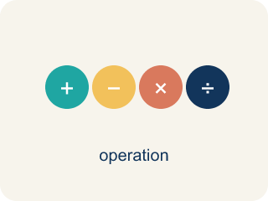
Add and Subtract Decimals (Sumar y restar decimales) — Combine or find the difference between decimals by lining up equal place values.
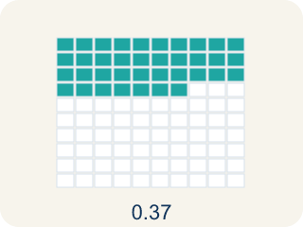
Decimal (Decimal) — A number with a dot, like 0.5, that shows a part less than one.
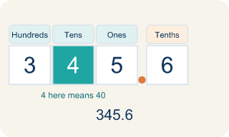
Place value (Valor posicional) — What a digit is worth based on where it sits in a number.
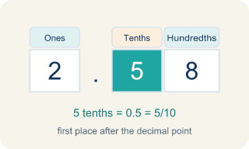
Tenths (Décimas) — The first spot after the decimal point. It shows parts out of 10.
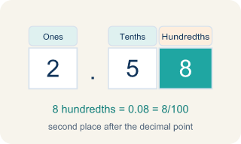
Hundredths (Centésimas) — The second spot after the decimal point. It shows parts out of 100.

Annex zeros (Agregar ceros) — Adding zeros at the end of a decimal so numbers line up evenly.

Practice
Show your work. Use the blank space under each problem.
1. What is 14.6 + 3.85?
A. 18.45
B. 18.35
C. 17.45
D. 18.55
______________________________________________________________________
2. What is 20.3 − 7.48?
A. 12.82
B. 13.82
C. 12.92
D. 12.18
______________________________________________________________________
3. Spot the Mistake — Subtracting Without a Placeholder
Step 1 (Problem): Subtract 12.5 − 3.45
Step 2 (Set up): Left 12.5 as one decimal place instead of annexing a zero
Step 3 (Subtract): 12.5 − 3.45 = 9.5
Step 4 (Final answer): 9.5
Which step has the mistake? Explain and fix it:
______________________________________________________________________
______________________________________________________________________
______________________________________________________________________
4. Case File: A crew member's snack receipt shows $27.60 for dried fruit and $15.45 for protein bars. What is the total on the receipt?
A. $43.05
B. $42.05
C. $43.15
D. $42.95
______________________________________________________________________
5. Case File: The oxygen gauge dropped from 9.6 units to a new reading after the crew used 4.75 units. How much oxygen is left?
A. 4.85
B. 5.85
C. 4.95
D. 5.15
______________________________________________________________________
6. Case File: A supply log started the shift with $48.00 in the station snack fund. By the end, $31.27 had been spent. How much is left in the fund?
A. $16.73
B. $17.73
C. $16.83
D. $17.27
______________________________________________________________________
7. Level 2 Extension — The Misaligned Receipt
Step 1 (Problem): A receipt adds a $12.40 part and a $3.75 part: 12.4 + 3.75
Step 2 (Set up): Lined up the right edges so the 4 sits under the 5
Step 3 (Add): 12.4 + 3.75 = 12.79
Step 4 (Final answer): $12.79
Which step has the mistake? Explain and fix it:
______________________________________________________________________
______________________________________________________________________
______________________________________________________________________
8. Find Tasha's Mistake
Step 1 (Problem): 15.7 − 8.36
Step 2 (Set up): 15.7 − 8.36
Step 3 (Subtract): 15.7 − 8.36 = 7.41
Step 4 (Final answer): 7.41
Which step has the mistake? Explain and fix it:
______________________________________________________________________
______________________________________________________________________
______________________________________________________________________

Answer Key (Teacher)
1. A. 18.45
Line up decimals: 14.60 + 3.85. Hundredths: 0 + 5 = 5. Tenths: 6 + 8 = 14, write 4 carry 1. Ones: 4 + 3 + 1 = 8. Tens: 1. Answer: 18.45.
Watch for: A common mistake in Add and Subtract Decimals is lining up the last digits (the right edges) of each number instead of lining up the decimal points — for example, adding 8.3 and 2.45 as if the 3 and the 5 belong in the same column. Before you add or subtract, add zeros so every number has the same number of decimal places (write 8.3 as 8.30), then check that the decimal points sit directly above one another.
2. A. 12.82
Rewrite as 20.30 − 7.48. Annex a zero so both have two decimal places. Work carefully with borrowing: 20.30 − 7.48 = 12.82.
Watch for: A common mistake in Add and Subtract Decimals is lining up the last digits (the right edges) of each number instead of lining up the decimal points — for example, adding 8.3 and 2.45 as if the 3 and the 5 belong in the same column. Before you add or subtract, add zeros so every number has the same number of decimal places (write 8.3 as 8.30), then check that the decimal points sit directly above one another.
3. Spot the Mistake — Subtracting Without a Placeholder
The mistake is in Step 2.
Correct work: The student did not annex a zero, so the hundredths place had nothing to subtract from. Write 12.5 as 12.50, then line up the decimal points: 12.50 − 3.45. Hundredths: 0 − 5 → borrow → 10 − 5 = 5. Tenths: 4 − 4 = 0 (after borrowing). Ones: 2 − 3 → borrow → 12 − 3 = 9. Tens: 0 (after borrowing). The correct difference is 9.05.
Watch for: The Set up step is the problem: 12.5 was left with one decimal place while 3.45 has two, so the hundredths column had nothing to subtract from. Write 12.5 as 12.50 and subtract with the points aligned — 0 − 5 needs a borrow, giving 5 hundredths, then 4 − 4 = 0 tenths and 12 − 3 = 9 ones. The correct difference is 9.05, not 9.5.
4. A. $43.05
Line up the decimal points: 27.60 + 15.45. Hundredths: 0 + 5 = 5. Tenths: 6 + 4 = 10, write 0 carry 1. Ones: 7 + 5 + 1 = 13, write 3 carry 1. Tens: 2 + 1 + 1 = 4. Total: $43.05.
Watch for: A common mistake in Add and Subtract Decimals is lining up the last digits (the right edges) of each number instead of lining up the decimal points — for example, adding 8.3 and 2.45 as if the 3 and the 5 belong in the same column. Before you add or subtract, add zeros so every number has the same number of decimal places (write 8.3 as 8.30), then check that the decimal points sit directly above one another.
5. A. 4.85
Annex a zero so 9.6 becomes 9.60, then subtract: 9.60 − 4.75 = 4.85 units. Borrow in the hundredths and tenths places to subtract correctly.
Watch for: A common mistake in Add and Subtract Decimals is lining up the last digits (the right edges) of each number instead of lining up the decimal points — for example, adding 8.3 and 2.45 as if the 3 and the 5 belong in the same column. Before you add or subtract, add zeros so every number has the same number of decimal places (write 8.3 as 8.30), then check that the decimal points sit directly above one another.
6. A. $16.73
Write 48.00 − 31.27 with points lined up. Hundredths: 0 − 7 → borrow → 10 − 7 = 3. Tenths: 9 − 2 = 7 (after borrowing). Ones: 7 − 1 = 6. Tens: 4 − 3 = 1. Answer: $16.73.
Watch for: A common mistake in Add and Subtract Decimals is lining up the last digits (the right edges) of each number instead of lining up the decimal points — for example, adding 8.3 and 2.45 as if the 3 and the 5 belong in the same column. Before you add or subtract, add zeros so every number has the same number of decimal places (write 8.3 as 8.30), then check that the decimal points sit directly above one another.
7. Level 2 Extension — The Misaligned Receipt
The mistake is in Step 2.
Correct work: The detective lined up the right edges instead of the decimal points. You must line up the decimal points and annex a zero: 12.40 + 3.75. Hundredths: 0 + 5 = 5. Tenths: 4 + 7 = 11, write 1 carry 1. Ones: 2 + 3 + 1 = 6. Tens: 1. The correct total is $16.15.
Watch for: The Set up step lines up the right edges, which puts the 4 of 12.4 (four tenths, or 40 cents) under the 5 of 3.75 (five hundredths, or 5 cents). Money makes the error visible: annex a zero for 12.40 + 3.75, add 0 + 5 = 5 hundredths, 4 + 7 = 11 tenths so write 1 and carry, then 2 + 3 + 1 = 6 ones. The correct total is $16.15, not $12.79.
8. Find Tasha's Mistake
The mistake is in Step 3.
Correct work: Tasha did not write 15.7 as 15.70 before subtracting. With proper alignment: 15.70 − 8.36 = 7.34. She got 7.41 because she subtracted hundredths incorrectly without the placeholder zero.
Watch for: The Subtract step is where Tasha's answer goes wrong. She treated 15.7 as if it already had a hundredths digit, so her hundredths column was invented rather than computed. Written as 15.70 − 8.36, the hundredths need a borrow: 10 − 6 = 4, then 6 − 3 = 3 tenths and 15 − 8 = 7 ones, so the difference is 7.34, not 7.41.

